COMP255 Report

By Group Seven

Brogan Creasey, Ronald Hancock, Sarah Heimlich, Chris Kettle, and James Moss

Contents

1. System Requirements Specification 3

1.1 Introduction 3

1.1.1 Purpose 3

1.1.2 Scope 3

1.1.3 Definitions, Acronyms, and Abbreviations 4

1.1.4 References 5

1.2 Overall Description 6

1.2.1 Product Perspective 6

1.2.2 User Classes and Characteristics 7

1.2.3 Operating Environment and Interfaces 7

1.2.4 User Documentation 8

1.3 Requirements 9

1.3.1 Functional Requirements 9

1.3.2 Non-Functional Requirements 12

1.3.3 Design and Implementation Requirements/Constraints 14

2. Develop User Stories 15

3. Use Case Diagram 17

4. Use Case Descriptions 18

4.1 Educator Interacts with system to set trigger conditions 18

4.2 Time interacts with system to generate tecommendations 20

4.3 Time interacts with system to generate pending interventions 21

4.4 Educator interacts with system to view student details 22

4.5 Educator interacts with system to initiate intervention 24

4.6 Educator interacts with system to review open intervention 25

4.7 Student interacts with system to create an opt-out request 27

4.8 Time interacts with system to generate weekly reports 29

4.9 Educator and administrator interact with system to create ad-hoc mugss reports 31

4.10 Student interacts with the system to provide feedback 32

4.11 Department head interacts with system to respond to an opt-out request 33

5. Analysis Class Diagram 34

6. Sequence Diagrams 38

6.1 Educator sets Trigger Conditions 38

6.2 Time generates Recommendations 39

6.3 Time generates pending Interventions 39

6.4 Educator views Student Details 40

6.5 Educator initiates Intervention 40

6.6 Educator reviews open Intervention 41

6.7 Student creates an opt-out request 41

6.8 Time generates Weekly Reports 42

6.9 Educator and Administrator interact with system to create Ad-Hoc MUGSS reports 42

6.10 Educator responds to an opt-out request 43

7. Requirements Traceability Matrix 44

8. Acceptance Testing 48

9. User Interface Evaluation 52

10. Systems Design 55

11. Design Level Class Diagram 56

12. One Design Level Sequence Diagram 62

13. State Diagram 63

13.1 Trigger state diagram 63

13.2 Recommendation state diagram 64

13.3 Intervention state diagram 65

14. Complex Algorithm Specification 66

15. Quality 68

16. Project Management 69

17. List of Assumptions 75

Apendix A - Student questionnaire 76

Appendix B – Student questionnaire summary of responces 79

Appendix C – Student questionnaire complete Responces 84

Appendix D – Student questionnaire Statistics 89

Appendix E – Staff questionnaire 90

Appendix F - Staff questionnaire summary of responces 93

Appendix G – Staff questionnaire complete Responces 97

Appendix H – Staff questionnaire Statistics 104

Appendix I – Questions for interviews 105

Appendix J – Notes from interview with Daniel 107

Appendix K – Interview with Garry Lawson 110

Appendix L – Analysis Diagrams 111

Appendix M – Design Diagrams 113

# 1. System Requirements Specification

## Introduction

### 1.1.1 Purpose

The purpose of this Software Requirements Specification (SRS) is to document and communicate the functional and non-functional requirements for the Macquarie University Guidance & Support System (MUGSS). This SRS defines the planned system features and capabilities, establishing an understanding between the system developers and the system stakeholders of the MUGSS software that will be produced.

The MUGSS system stakeholders include Macquarie University Informatics Staff, EDUCATORS, STUDENTS and GOVERNMENT AGENCIES.

This document conforms with IEEE Std 830-1998, IEEE Guide to Software Requirements Specification, as modified in the 2013 COMP255 Assignment One Brief.

### Scope

The goal of the Macquarie University Guidance & Support System (MUGSS) is to assist EDUCATORS support STUDENTS at risk of failing, encourage excelling STUDENTS to continued excellence, and aid EDUCATORS in tailoring content to STUDENTS' needs. To achieve this, the system will generate reports for ADMINISTRATORS and EDUCATORS and will be an online service accessible to STAFF and STUDENTS on and off campus. The final objective of the system is to increase student retention, particularly for STUDENTS in their first year. However, because the system has to be implemented incrementally and separately from current systems, its initial overall effectiveness will be lower than its expected final level of effectiveness.

There are a number of stakeholders in the system. While most are quite obvious, such as STUDENTS and STAFF, there are some secondary stakeholders that are less evident. In particular, GOVERNMENT AGENCIES have a stake in the system as they can request reports via ADMINISTRATORS. Additionally, the Commonwealth Government has a target for "...40 per cent of 25- to 34-year-olds will have attained at least a bachelor-level qualification by 2020. This will be quite testing for Australia as current attainment is 29 per cent." (2008, Bradley Report) Thus, the government has an interest in any system that will impact student retention.

This report outlines the planned initial release of the system. As MUGSS is "expected to grow in functionality" (2013, COMP255 Assignment One Brief), the initial system is understood to be a basis for which these additional uses can be built upon. This initial base system (called MUGSS V 1.0) comprises two core applications "Predicting Student Performance" and "Monitoring Students at Risk" which represent the foundation for achieving the above benefits and objectives. Potential requirements for the second iteration (called MUGSS V 2.0) have been included in this SRS, where relevant.

### Definitions, Acronyms, and Abbreviations

The following definitions apply in regards to the system. When these terms appear in the SRS capitalised, the following context is implied.

ADMINISTRATOR - a STAFF member who does not have an EDUCATOR's role, but who needs access to the system.

EDUCATOR - any TUTOR, LECTURER, or HEAD OF DEPARTMENT

GOVERNMENT AGENCIES - such regulatory bodies concerned with university issues, and to whom universities supply reports and other information.

HEAD OF DEPARTMENT - a STAFF member with the same access as a LECTURER but also has the role of head of department

INTERVENTION - a series of communications (email, text, phone call, and meetings) between a STUDENT and EDUCATOR, with the EDUCATOR having responsibility to see the intervention through to completion.

LA - Learning Analytics

LECTURER - a STAFF member who conducts lectures classes and/or tutorial classes

MUGSS - Macquarie University Guidance & Support System

MUGSS V 1.0 - The first generation of MUGSS as outlined in the assignment brief

MUGSS V 2.0 - The second generation of MUGSS using further requirements found through the course of the assignment.

STAFF - Any staff member of Macquarie University with access to the SYSTEM

STUDENT(S) - Students who use the MUGSS system

SYSTEM – MUGSS

TUTOR - a STAFF member who conducts tutorial classes

### References

* IEEE Standard 830-1998 : IEEE Recommended Practice for Software Requirements Specifications
  + http://ieeexplore.ieee.org/stamp/stamp.jsp?tp=&arnumber=720574&tag=1
* Assignment brief modifications to IEEE standard
  + http://ilearn.mq.edu.au/mod/resource/view.php?id=1868491 p. 7
* Resources
  + Assignment resources provided on iLearn, at <http://ilearn.mq.edu.au/course/view.php?id=13757>, including specifically:
    - PPDP Contact Management System (CMS) at <http://comp.mq.edu.au/units/comp365/CMSSRS.pdf>
    - Requirements Specification for the Fare Selling System for London Underground at<http://comp.mq.edu.au/units/comp365/SRSLU.pdf>
    - Complex Algorithm Example at <http://ilearn.mq.edu.au/mod/resource/view.php?id=1868520>
* References
  + The Bradley Report (A Review of Australian Higher Education)<http://www.innovation.gov.au/HigherEducation/Documents/Review/PDF/Higher%20Education%20Review_one%20document_02.pdf>
  + UML Package Diagram Examples <http://www.uml-diagrams.org/package-diagrams-examples.html>
* Problem description : background reading on topic of Learning Analytics
  + Michael Atkinson - Learning Analytics: A house without a foundation? <http://tinyurl.com/n8dah6b>
  + Craig Bach - Learning Analytics: Targeting Instruction, Curricula and Student Support<http://tinyurl.com/n22u4ed>
  + Ed Futures - Learning Analytics <http://tinyurl.com/ld2ay63>
  + Wolfgang Greller & Hendrik Drachsler - Translating learning into numbers: A generic framework for learning analytics <http://tinyurl.com/m4pvtnz>
  + Martin Olmos & Linda Corring - Academic analytics in a medical curriculum: enabling educational excellence<http://tinyurl.com/mauncxn>
  + Katrien Verbert, Nikos Manouselis, Hendrik Drachsler and Erik Duval - Dataset Driven Research to support learning and knowledge analytics <http://tinyurl.com/lmkb473>
  + Learning Analytics: Envisioning a Research Discipline and a Domain of Practice <http://tinyurl.com/lkptwdc>
  + 7 Things you should know about learning analytics <http://tinyurl.com/y62t6or>
* Problem description : background reading on topics other than Learning Analytics
  + Privacy Statement <http://www.mq.edu.au/privacy/privacy.html>
  + iLearn Privacy <http://www.mq.edu.au/iLearn/student_info/confidentiality.htm>
  + Macquarie University Acceptable Use Policy <http://www.mq.edu.au/policy/docs/acceptable_use/policy.html>
  + Macquarie University staff Code of Conduct<http://staff.mq.edu.au/human_resources/about_hr/forms_and_policies/code_of_conduct/>
  + Top 10 algorithms in data mining <http://www.cs.uvm.edu/~icdm/algorithms/10Algorithms-08.pdf>

## 1.2 Overall Description

### 1.2.1 Product Perspective

The MUGSS is designed to be a web browser based LA system that provides an alert based administration system for identifying STUDENTS that are or may soon be at risk of failing a unit so that appropriate actions can be taken by the EDUCATORS concerned. It will monitor the activity of students enrolled in Macquarie University, including test marks, assignment marks & feedback, workshop & tutorial attendance, and forum activity. Using the data collected, the SYSTEM will generate alerts and recommend appropriate actions for EDUCATORS to help the STUDENTS that pose a risk of failing, performing unsatisfactorily, or excelling. This data can be queried and sorted by ADMINISTRATORS and EDUCATORS, including monitoring INTERVENTIONS for STUDENTS that are currently receiving help from their EDUCATORS. The MUGSS will also allow STUDETNS to keep an accurate track of their progress in a course and allow them to make quick and easy contact with EDUCATORS responsible for their units.

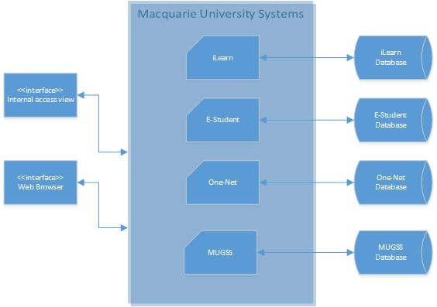

Diagram 1 – Block Diagram of MUGSS Structure

The MUGSS is designed to be integrated with both e-student and iLearn, two systems already functional and integrated. The SYSTEM should interface seamlessly with the aforementioned systems to extend and complement their current functionality, as outlined in this specification. Such interfaces will consist of data flows from the eStudent and iLearn systems to MUGSS for the purpose of avoiding duplication of data entry among the systems. The MUGSS will also interface with the Macquarie University email system via the generation of electronic mail messages. Such interfaces must be available on a daily basis.

### 1.2.2 User Classes and Characteristics

There are three main different types of users in the MUGSS system:

Type 1 - EDUCATORS: EDUCATORS can include, TUTORS, LECTURERS, HEADS OF DEPARTMENT, and ADVISERS. They are responsible for teaching, convening courses, and assisting students with their successful completion of their course. These users vary considerably in their knowledge of using computer and web based interfaces, though they should have some basic knowledge from the other integrated systems at Macquarie University. Specifically HEADS OF DEPARTMENTS give final say if a STUDENT requests to be removed from this system.

Type 2 - ADMINISTRATORS: The ADMINISTRATORS will be the most familiar and knowledgeable of the system as they should all be relatively trained in computer operations and applications and be familiar with the other, currently integrated systems at Macquarie University. They will have access to the database internally (computer based) and be able to make any necessary changes to information. They are also responsible for organizing and delivery reports to outside organisations that may require metadata for research purposes.

Type 3 - STUDENTS: STUDENTS will have minimal usage of the system and will vary considerably in their knowledge of using web based interfaces. The system will be easily accessed through the Macquarie University website.

### 1.2.3 Operating Environment and Interfaces

The MUGSS must be accessible from both personal and public computers/tablets running any of the following standard web-browsers:

* Internet Explorer
* Firefox
* Chrome
* Safari
* Opera

Support for web browsers will also include those for mobile devices. Support for Android and iPhone will be provided.

This allows for all software and hardware platforms to access the system without compatibility issues and will also prevent vendor lock in and support future upgrades. It must also have an application based interface that is accessible from university computers running either Windows or OS-X.

The MUGSS must be compatible with the current hardware, software and network infrastructure that is currently being used at Macquarie University including:

* iLearn
* e-Student
* OneID login
* Student email
* University servers/databases

The MUGSS server-side components (e.g. web server, application server, database server) will require a dedicated server machine within the Macquarie University computer facilities. It is not anticipated that the MUGSS server-side components will place an onerous strain on server resources such as memory, and therefore this dedicated server machine is expected to be of a minimal equipment configuration, but will still be able to service all MUGSS server-side components. A backup server machine will also be required to ensure continuous service and proof against hardware based data loss. MUGSS server-side components will require daily back up and off-site storage in line with Macquarie University standards for such.

The MUGSS ought to be available for use between 7am and midnight 6 days with 98% certainty, and outside such times with 80% certainty.

Note that future versions of MUGSS may demand enhanced hardware and/or the separation of the web server component onto its own server machine.

### 1.2.4 User Documentation

A tutorial will be created for ADMINISTRATORS that handle the data on an application based interface that includes in-depth details on data manipulation and validation. A basic in-built help system will be available to provide assistance with the application. Both STUDENTS and EDUCATORS, and any other user that uses the web based interface will be provided with a short web-based tutorial on first use of the SYSTEM. This tutorial will show tool tips that provide pointers to accessing the material relevant to their current tasks. A basic online help system will be available to provide assistance with each screen of the application.

## 1.3 Requirements

### 1.3.1 Functional Requirements

**MUGSS V 1.0 Functional Requirements**

* R1.1: The SYSTEM **shall**alert EDUCATORS and ADVISORS if an INTERVENTION is needed
  + Purpose: To allow needed INTERVENTIONS to take place
  + Test: Out of 1,000 test cases entered into the SYSTEM, 95% of those needed INTERVENTION must be caught for INTERVENTION while 95% of those not needing INTERVENTION must not receive INTERVENTION.
* R1.2: The SYSTEM **shall**be able to identify at risk STUDENTS
  + Purpose: To Identify STUDENTS before they require an INTERVENTION
  + Test: 95% of 1000 test must have identified STUDENTS that were showing poor performance were identified as being at risk
* R1.3 : The SYSTEM **shall** allow EDUCATORS to set trigger conditions for a recommendation and/or INTERVENTION
  + Purpose: To allow the SYSTEM to identify under which circumstances either a INTERVENTION or recommendation are to take place
  + Test: 95% of 1000 test cases triggered with the appropriate conditions
* R1.4: The SYSTEM **shall** allow EDUCATORS to specify relevant conditions based on unit assessments and activities for a trigger
  + Purpose: To better allow for correct trigger conditions for the situation
* R1.5 : The SYSTEM **shall** allow EDUCATORS to edit and remove triggers to their units
  + Purpose: To ensure the trigger conditions are up to date based on all relevant information
  + Test: 95% of 1000 test cases report no removed triggers still fire and edited triggers are correctly fire
* R1.6 : The SYSTEM **shall** allow STUDENTS to view their INTERVENTION and recommendation logs
  + Purpose: To allow STUDENTS to review the issue they may have encountered and any advice that was given in the logs
* R1.7: The SYSTEM **shall**provide a summary of current marks within iLearn/eStudent
  + Purpose: To allow STUDENTS to better understand where they are currently at within a course
  + Test: 95% of 1000 tested cases summaries must reflect correctly the marks within the other systems
* R1.8: The SYSTEM **shall**generate a report weekly, for university ADMINISTRATORS, of all INTERVENTIONS that have taken place across all units
  + Purpose: To identify high risk areas within the curriculum
  + Test: 95% of 1000 test cases show correct and complete reports
* R1.9: The SYSTEM **shall**generate a report weekly, for each MUGSS EDUCATOR, of all INTERVENTIONS that have taken place within a unit applicable to the EDUCATOR
  + Purpose: To identify and monitor high risk students within the unit
  + Test: 95% of 1000 test reports are accurate for the interventions that have taken place
* R1.10: The SYSTEM **shall**allow STUDENTS to request exclusion (i.e. opt-out) from the MUGSS system
  + Purpose: To allow STUDENTS to decide how much personal information will be provided/ not provided to EDUCATORS
* R1.11: The SYSTEM **shall**allow STUDENTS to provide feedback to EDUCATORS and university ADMINISTRATORS
  + Purpose: To allow gathering of meaningful information for decision-making regarding future SYSTEM development and/or SYSTEM usage
* R1.12: The SYSTEM **shall**allow EDUCATORS to view relevant STUDENT details regarding STUDENTS at risk
  + Purpose: To allow EDUCATORS to engage meaningfully with the MUGSS system and with the STUDENTS at risk
  + Test: 95% of 1000 test cases show student data that is correct and complete
* R1.13: The SYSTEM **shall**allow EDUCATORS to initiate an intervention with a STUDENT at risk
  + Purpose: To allow EDUCATORS means to assist students at risk
* R1.14: The SYSTEM **shall**allow EDUCATORS to email a STUDENT at risk regarding an intervention
  + Purpose: To allow EDUCATORS to contact STUDENTS at risk
* R1.15: The SYSTEM **shall**allow EDUCATORS to enter meeting comments regarding a meeting with a STUDENT at risk
  + Purpose: To allow sharing among EDUCATORS and ADMINISTRATORS of information regarding the progress of INTERVENTIONS with STUDENTS at risk
* R1.16: The SYSTEM **shall**allow EDUCATORS to define the conditions relevant to their study unit for considering a STUDENT to be at risk
  + Purpose: To allow EDUCATORS to use their knowledge of the study unit to partly determine what "at risk" means and to control the number of STUDENTS falling into at risk category
* R1.17: The SYSTEM **shall**identify STUDENTS that require an INTERVENTION
  + Purpose: To allow the STUDENTS that require assistance to receive it
* R1.18: The SYSTEM **shall**suggest to STUDENT relevant learning resources
  + Purpose: To guide STUDENTS at risk before they get to the stage of requiring an INTERVENTION
* R1.21: The SYSTEM **shall**identify STUDENTS who have not viewed any forum posts for a certain time period
  + Purpose: Used as a factor in determining STUDENT risk

**MUGSS V 2.0 Functional Requirements**

* R1.19: The SYSTEM **shall**allow for peer assisted learning
  + Purpose: To allow for multiple avenues of support for STUDENTS from the SYSTEM
* R1.20: The SYSTEM **shall**allow for live Instant Messenger chat with an appropriate representative
  + Purpose: To allow for STUDENTS to seek support from the SYSTEM
* R1.22: The SYSTEM **shall**prioritize information provided to STUDENT based on STUDENT history
  + Purpose: To tailor the system for each STUDENT’S needs
* R1.23: The SYSTEM **should**identify and monitor STUDENTS at risk of dropping out
  + Purpose: To assist increasing STUDENT retention by early prevention and intervention
  + Test: 25% decrease in STUDENT dropout rates
* R1.24: The SYSTEM **shall**provide a calendar of due dates
  + Purpose: To allow STUDENTS to manage their time
* R1.25: The SYSTEM **should**send notifications on due dates through calendar support
  + Purpose: To allow STUDENTS to not miss an assignment
* R1.26: The SYSTEM **shall**provide a clear merged view of data pulled from existing systems
  + Purpose: To allow easier understanding of the data
* R1.27: The SYSTEM **shall**provide a clear view of current course progress
  + Purpose: To allow the STUDENT to quickly understand what they have to do to pass the course
* R1.28: The SYSTEM **shall**provide forums for all units
  + Purpose: To allow STUDENTS and EDUCATORS a place for discussion on the unit
* R1.29: The SYSTEM **shall**analyse workload for each unit
  + Purpose: To identify any issues with the unit that may be increasing risk for STUDENTS in the unit
* R1.30: The SYSTEM  **shall**generate a weekly report of at risk STUDENTS for EDUCATORS, ADVISORS and ADMINISTRATORS
  + Purpose: To allow STAFF to identify courses in which there are a high number of at risk STUDENTS.

### 1.3.2 Non-Functional Requirements

**MUGSS V 1.0 Non-Functional Requirements**

* R2.1: The SYSTEM **shall**include features that assist in improving course design and delivery
  + Purpose: To improve STUDENTS’ grades and attendance
  + Test: Out of 90% of 1000 tests the STUDENT averages must have increased by 10%
* R2.2: The SYSTEM **shall**function and update at near real time
  + Purpose: to have up to date statistics of STUDENT performance
  + Test: Out of 1000 test cases 95% of STUDENT’S statistics must have updated in the system within 5 minutes.
* R2.3: The SYSTEM **shall**allow access to data only to authenticated users.
  + Purpose: This is to ensure data security
  + Test: In 100% of test cases the SYSTEM  shall refuse to provide or accept data to/from an unauthenticated user
* R2.4: The SYSTEM  **shall**track the user identity of any user that adds or alters database data
  + Purpose: This is to ensure data integrity and security
* R2.5: The SYSTEM  **shall**require the database ADMINISTRATOR to back up the MUGSS database on a daily basis, in line with existing Macquarie University database back up procedures
  + Purpose: This is to prevent/minimise potential for data loss
* R2.6: The SYSTEM  **shall**require the backup copies of the MUGSS database to be stored off site, in line with existing Macquarie University database back up procedures
  + Purpose: This is to prevent/minimise potential for data loss
* R2.7: The SYSTEM **shall**be available to users for normal use between 7am and midnight, 6 days per week, with 98% reliability.
  + Purpose: This is to ensure users are not inconvenienced by deprivation of the benefits of the MUGSS system
* R2.8: The SYSTEM **shall**be available to users without any requirement to install additional software.
  + Purpose: This is to ensure users may easily access the SYSTEM
* R2.9: The SYSTEM **shall**conform sufficiently to existing Macquarie University systems that users shall require only minimal training to learn the system.
  + Purpose: This is to ensure users may easily access the SYSTEM
  + Test: 95% of trained users must be able to perform all allocated SYSTEM tasks after 1 hour of training.
* R2.10: The SYSTEM  **shall**improve STUDENT retention rates
  + Purpose: To prove that the need for the SYSTEM
  + Test: Dropout rate tested yearly and must see a 20% decrease in dropouts and an increase in graduation rates by the same amount.
* R2.11: The SYSTEM  **shall**assist in interpretation of meaning in data
  + Purpose: To allow all users to find meaning in the data and interpret the data correctly
* R2.12: The SYSTEM  **shall**allow for improved decision making and informing resource allocation
  + Purpose: To allow STAFF to focus on areas where it is most needed
* R2.13: The SYSTEM  **shall**assist in highlighting institutional successes and challenges
  + Purpose: To allow STAFF to identify what is being done correctly and what may be a problem area
* R2.14: The SYSTEM  **shall**assist in increasing organisational productivity
  + Purpose: To allow the resources to be better managed and thus improving efficiency
* R2.15: The SYSTEM  **should**assist in monitoring student participation and how this relates to grades
  + Purpose: To identify how much of an impact participation is having and factor this into the risks
* R2.16: The SYSTEM  **should**increase STUDENT reflection and awareness
  + Purpose: To makes STUDENTS identify on their own areas that may require improvement without STAFF intervention
* R2.17: The SYSTEM  **shall**increase STUDENT’S insight into their own learning
  + Purpose: To allow STUDENTS to learn their own habits within the scope of a learning environment
* R2.18: The SYSTEM  **shall**reduce STUDENT attrition
* R2.19: The SYSTEM  **shall**monitor and predict STUDENT performance
  + Purpose: To confirm the SYSTEM’S analysis model is correct.
  + Test: Out of 1000 tests 95% must match up with the actual SYSTEM’S results
* R2.20: The SYSTEM  **shall**allow STUDENTS, EDUCATORS, ADVISORS and ADMINISTRATORS to get an insight into engagement with teaching and learning technology
  + Purpose: To allow STAFF to better understand levels of engagement and improve upon problem areas
* R2.21: The SYSTEM  **shall**allow for future functionality to be added
  + Purpose: To allow for the SYSTEM  to be changed and updated simply
* R2.22: The SYSTEM  **shall**be able to extract required data from the existing I-Learn and E-Student systems
  + Purpose: To be able to interact with the existing systems without interfering with their function
  + Test: out of 1000 test cases 95% of calculations made based on I-Learn and E-Student must be accurate
* R2.23: The SYSTEM  **should**be easy to use for STUDENTS, EDUCATORS, ADVISORS and ADMINISTRATORS
  + Purpose: Allows users to easily interact with the SYSTEM
* R2.24: The SYSTEM  **shall**keep data secure
  + Purpose: This is to keep trust of the SYSTEM  so fewer users choose opt out of the SYSTEM  thus decreasing the sample base
* R2.25: The SYSTEM  **shall**keep data private
  + Purpose: This is to keep trust of the SYSTEM  so no users opt out of the system thus decreasing the sample base

**MUGSS V 2.0 Functional Requirements**

* R2.26: The SYSTEM  **shall**allow for STUDENT to get and insight into their own learning
  + Purpose: Allowing the STUDENTS to self-assess will allow them to better understand their problem areas and possibly solve the issues themselves
* R2.27: The SYSTEM  **should**detect students emotional state
  + Purpose: To Identify STUDENTS that might be at risk
* R2.28: The SYSTEM  **should**detect undesirable learning behaviour
  + Purpose: To allow STUDENTS and EDUCATORS to identify this behaviour and assist in changing it

### 1.3.3 Design and Implementation Requirements/Constraints

Limitations on design and implementation of the system are listed below

* University Policies for privacy, acceptable use, and code of conduct and state and federal legislation
* The system must keep student data confidential
* The system must utilise existing OneID for login
* The system must interact with I-Learn and E-Student without any changes of functionality of either system
* The System must have Designs completed by 4th of October 2013
* The system must be usable for staff with only an hour of training and for students with no training
* The system must have an interface that is consistent with the colour scheme and layout of I-Learn
* The system must be usable via a web browser
* The system must be able to perform without performance degradation when being used by up to 500 concurrent users

# 2. Develop User Stories

Note: that acceptance stories are not included here, as they are specified in the assignment brief for inclusion under Task 8.

These stories were created based upon the responses to questionnaires and interviews along with the material from the assignment brief.

1) As a "the Persister" type STUDENT, I want to receive a reminder by email one week prior to the due date of a major assignment, so that I do not overlook an assignment when the workload is at its heaviest.

2) As a "the Stop-out" type STUDENT, I want to receive a reminder by email one week prior to the due date of a major assignment, so that I do not overlook an assignment while getting used to being a student again.

3) As a "the Transfers" type STUDENT, I want to receive unit prerequisite information detailed at the topic level, so that I may ascertain which topics, if any, I have not yet covered.

4) As a "the Attainer" type STUDENT, I want to be informed about the benefits of completing my degree, so that I may make the best decisions about my education.

5) As a "the Drop-out" or "Leaver" type STUDENT, I want to receive information about postgraduate courses relevant to my degree, so that I may decide upon further study.

6) As a "the Slow-down" or "Part-time" type STUDENT, I want to receive a reminder by email one week prior to the due date of a major assignment, so that I do not overlook an assignment when I have work commitments.

7) As a STUDENT, I want to be told when I have misunderstood unit material, so that I may look at it again.

8) As a STUDENT, I want to be told about additional unit resources when I struggle, so that I may use them to improve my performance.

9) As a STUDENT, I want to receive assistance from staff when I struggle, so that I may overcome my difficulties.

10) As a STUDENT, I want to be informed about problems in my work, so that I may take action to address them.

11) As a STUDENT, I want to receive information about my strengths and weaknesses, so that I may better manage my performance.

12) As a STUDENT, I want staff to address the areas where I am weak, so that I receive information about my strengths and weaknesses, so that I may better manage my performance.

13) As an EDUCATOR, I want to be told when students are struggling with a particular unit topic, so that I may provide additional and/or revision material for them.

14) As an EDUCATOR, I want to be told when students are consistently absent from classes, so that I may intervene.

15) As an EDUCATOR, I want to be told when students are consistently performing poorly in weekly submissions, so that I may intervene.

16) As an EDUCATOR, I want to be told when students do not access study materials I post on iLearn, so that I may intervene.

17) As an EDUCATOR, I want to be told when students do not attend mid-semester or diagnostic exams, so that I may intervene.

18) As an EDUCATOR, I want to be told when students perform poorly in mid-semester or diagnostic exams, so that I may intervene.

19) As an EDUCATOR, I want to be told when students who normally do very well receive a very poor result in a submission or exam, so that I may intervene.

20) As an EDUCATOR, I want to be able to find out how often a student has accessed study materials I post on iLearn, so that I may gain insight to that student's questions.

21) As an EDUCATOR, I want to be told when students consistently answer incorrectly a particular online quiz question, so that I may check it for problems.

22) As an EDUCATOR, I want to receive weekly reports which monitor students who are at risk of not passing the unit, so that I may better manage their education.

23) As an ADMINISTRATION OFFICER, I want to receive weekly reports which summarise MUGSS activities, so that I may perform my administrative tasks.

24) As an ADMINISTRATION OFFICER, I want to obtain ad-hoc reports which summarise MUGSS specific activities, so that I may service the authorised requests I receive.

# 3. Use Case Diagram

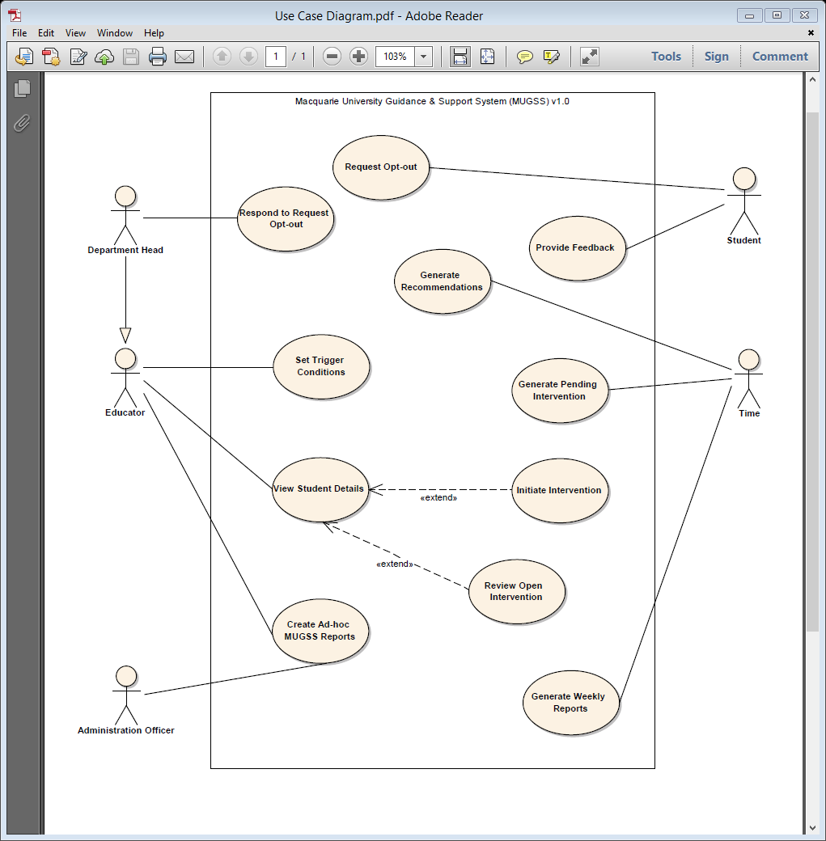

# 4. Use Case Descriptions

### 4.1 Educator Interacts with System to Set trigger conditions

|  |  |  |
| --- | --- | --- |
| **Project** | Macquarie University Guidance and Support System (**MUGSS**) v1.0 | |
| **Use Case** | **Set Trigger Conditions** | |
| **System** | MUGSS | |
| **Actors** | **Educator** | |
| **Goal**  <a longer statement of the goal in context if needed> | The definition of the basis upon which the system will, for a study unit, generate recommendations and generate pending interventions, i.e. the definition of the conditions upon which MUGSS will trigger such events. | |
| **Trigger**  <the action upon the system that starts use case> | The educator loads a screen which permits and supports the setting (i.e. CRUD) of MUGSS trigger conditions for a unit applicable to the educator. | |
| **Preconditions**  <what we expect is already the state of the world> | 1. A ‘master’ list of usable MUGSS triggers has been set up. 2. Each usable MUGSS trigger has a list of applicable parameters defined 3. Each applicable parameter has pro forma email body text 4. Each unit has identifiable potential email recipients (i.e. the unit staff, and unit students) | |
| **Success End Condition**  <the state of the world upon successful completion> | The MUGSS trigger conditions desired by the educator are defined for the unit. | |
| **Failed End Condition**  <the state of the world if goal abandoned> | The previously existing MUGSS trigger conditions, if any, remain unchanged. | |
| **Primary Actors;**  **Secondary Actors** | Educator  n/a | |
| **Description / Main Success Scenario**  <the steps of the scenario from trigger to goal delivery and any clean up after. Indicate sub steps using numbering> | **Step** | **Action** |
| 1.a | The system displays the study unit and the existing MUGSS trigger conditions for the study unit. |
| 1.b | The educator may choose to add a(nother) MUGSS trigger condition for the study unit. |
| 1.b.1 | The educator selects the add command |
| 1.b.2 | The system responds by displaying the ‘master’ list of usable MUGSS triggers. |
| 1.b.3 | The educator selects a usable MUGSS trigger |
| 1.b.4 | The system responds by displaying a list of the parameters applicable to the selected MUGSS trigger, a list of potential email recipients, and pro forma email body text |
| 1.b.5 | The educator selects a parameter from the list. |
| 1.b.5.1 | The educator types a value for the selected parameter, if such is applicable to the selected parameter |
| 1.b.5.2 | The educator selects the email recipients who will be notified if/when this trigger is triggered |
| 1.b.5.3 | The educator assigns suitable text to form the email body. |
| 1.b.5.4 | The educator selects the save command |
| 1.b.5.5 | The system responds by saving the entry |
| 1.c | The educator may choose to view and/or change an existing MUGSS trigger condition for the study unit |
| 1.c.1 | The educator selects an existing MUGSS trigger condition |
| 1.c.2 | The system responds by displaying a list of the parameters applicable to the selected MUGSS trigger, as well as the existing saved parameter for the selected MUGSS trigger, its value if any, the list of potential email recipients, the existing saved email recipient(s), and the existing saved assigned text for the email body |
| 1.c.3 | The educator may change the parameter for the selected MUGSS trigger to any of those in the displayed list |
| 1.c.3.1 | The educator may change the parameter value if any |
| 1.c.3.2 | The educator may change the email recipient(s) |
| 1.c.3.3 | The educator may change the text assigned for the email body |
| 1.c.3.4 | The educator selects the save command and confirms such |
| 1.c.3.5 | The system responds by saving the entry |
| 1.d | The educator may choose to delete an existing MUGSS trigger condition for the study unit. |
| 1.d.1 | The educator selects an existing MUGSS trigger condition. |
| 1.d.2 | The system responds by displaying the parameter for the selected MUGSS trigger, its value if any, and the applicable email recipient(s) and email body. |
| 1.d.3 | The educator selects the delete command, and confirms such |
| 1.d.4 | The system responds by deleting the entry |
| **Alternative Flows**  <a: condition causing branching>  <a1: action or name of sub use case> | **Step** | **Branching Action** |
| 1.b.5.2 | The system refuses to proceed when the selected email recipients are a mix of unit students and educators(i.e. 1.b.5.2) |
| 1.b.5.5 | The system displays the study unit and the amended MUGSS trigger conditions for the study unit. (i.e. 1.a) |
| 1.c.3.2 | The system refuses to proceed when the selected email recipients are a mix of unit students and educators (i.e. 1.c.3.2) |
| 1.c.3.5 | The system displays the study unit and the MUGSS trigger conditions for the study unit. (i.e. 1.a) |
| 1.d.4 | The system displays the study unit and the amended MUGSS trigger conditions for the study unit. (i.e. 1.a) |

### 4.2 tIME INTERACTS WITH sYSTEM TO GENERATE RECOMMENDATIONS

|  |  |  |
| --- | --- | --- |
| **Project** | Macquarie University Guidance and Support System (**MUGSS**) v1.0 | |
| **Use Case** | **Generate Recommendations** | |
| **System** | MUGSS | |
| **Actors** | **Time** | |
| **Goal**  <a longer statement of the goal in context if needed> | The conditional distribution of email messages to unit students. | |
| **Trigger**  <the action upon the system that starts use case> | Once daily at a designated time. | |
| **Preconditions**  <what we expect is already the state of the world> | 1. An educator has set up the email messages and their trigger conditions for a study unit via the actions described in use case "Set Trigger Conditions" 2. Such set up of email messages is designated for distribution to unit students 3. An up-to-date list of students enrolled in the unit, and their email addresses, is available | |
| **Success End Condition**  <the state of the world upon successful completion> | All trigger conditions have been tested and all resulting email messages have been distributed to unit students | |
| **Failed End Condition**  <the state of the world if goal abandoned> | Trigger condition testing and/or email message distribution remains incomplete. An attempt to rectify this should automatically occur during the next scheduled attempt of this use case | |
| **Primary Actors;**  **Secondary Actors** | Time  Students | |
| **Description / Main Success Scenario**  <the steps of the scenario from trigger to goal delivery and any clean up after. Indicate sub steps using numbering> | **Step** | **Action** |
| 1.a | The system obtains a list (the "List") of all trigger conditions for all units which have unit students as the designated email recipients |
| 1.b | The system tests each trigger condition on the "List", in turn |
| 1.b.1 | The system applies each test to each unit student |
| 1.b.2 | The system generates and distributes the designated email message to each unit student that matches the test condition |
| 1.b.3 | The system includes in each email message a link which the student may select in order to provide feedback |
| 1.b.4 | The system flags as completed each test that has met its completion criteria |
| 1.c | The system logs execution status to an audit trail |
| **Alternative Flows**  <a: condition causing branching>  <a1: action or name of sub use case> | **Step** | **Branching Action** |
| 1.c | The system recovers from an incomplete execution automatically at next subsequent execution (i.e. 1.a) |

### 4.3 TIME INTERACTS WITH SYSTEM TO GENERATE PENDING INTERVENTIONS

|  |  |  |
| --- | --- | --- |
| **Project** | Macquarie University Guidance and Support System (**MUGSS**) v1.0 | |
| **Use Case** | **Generate Pending Intervention** | |
| **System** | MUGSS | |
| **Actors** | **Time** | |
| **Goal**  <a longer statement of the goal in context if needed> | 1) The conditional creation of intervention events, having pending status  2) The conditional distribution of email messages to educators. | |
| **Trigger**  <the action upon the system that starts use case> | Once daily at a designated time. | |
| **Preconditions**  <what we expect is already the state of the world> | 1. An educator has set up the email messages and their trigger conditions for a study unit via the actions described in use case "Set Trigger Conditions" 2. Such set up of email messages is designated for distribution to educators 3. An up-to-date list of educators, and their email addresses, is available | |
| **Success End Condition**  <the state of the world upon successful completion> | All trigger conditions have been tested, any resulting intervention events have been created and all resulting email messages have been distributed to educators | |
| **Failed End Condition**  <the state of the world if goal abandoned> | Trigger condition testing and/or intervention event creation and/or email message distribution remains incomplete. An attempt to rectify this should automatically occur during the next scheduled attempt of this use case | |
| **Primary Actors;**  **Secondary Actors** | Time  Educators | |
| **Description / Main Success Scenario**  <the steps of the scenario from trigger to goal delivery and any clean up after. Indicate sub steps using numbering> | **Step** | **Action** |
| 1.a | The system obtains a list (the "List") of all trigger conditions for all units which have educators as the designated email recipients |
| 1.b | The system tests each trigger condition on the "List", in turn |
| 1.b.1 | The system applies each test to each unit student |
| 1.b.2 | The system generates an intervention event, having pending status, for each unit student that matches the test condition |
| 1.b.3 | The system generates and distributes the designated email message to the designated educators. The email message will include a list of all unit students that match the test condition |
| 1.b.4 | The system flags as completed each test that has met its completion criteria |
| 1.c | The system logs execution status to an audit trail |
| **Alternative Flows**  <a: condition causing branching>  <a1: action or name of sub  use case> | **Step** | **Branching Action** |
| 1.c | The system recovers from an incomplete execution automatically at next subsequent execution (i.e. 1.a) |

### 4.4 EDUCATOR INTERACTS WITH SYSTEM TO VIEW STUDENT DETAILS

|  |  |  |
| --- | --- | --- |
| **Project** | Macquarie University Guidance and Support System (**MUGSS**) v1.0 | |
| **Use Case** | **View Student Details** | |
| **System** | MUGSS | |
| **Actors** | **Educator** | |
| **Goal**  <a longer statement of the goal in context if needed> | The system displays to an educator the relevant details of a unit student in regards to the intervention process. | |
| **Trigger**  <the action upon the system that starts use case> | 1) The educator selects the student from a list of students provided by an email generated via the actions described in use case "Generate Pending Intervention"  OR  2) The educator loads a screen which permits and supports the review of details of students enrolled in a unit applicable to the educator. | |
| **Preconditions**  <what we expect is already the state of the world> | 1) The educator has received then relevant email message from the system  OR  2) The educator knows the name and/or id number of the student  RESPECTIVELY | |
| **Success End Condition**  <the state of the world upon successful completion> | The system displays relevant student details to the educator | |
| **Failed End Condition**  <the state of the world if goal abandoned> | The system does not display student details to the educator | |
| **Primary Actors;**  **Secondary Actors** | Educator  Student, Time | |
| **Description / Main Success Scenario**  <the steps of the scenario from trigger to goal delivery and any clean up after. Indicate sub steps using numbering> | **Step** | **Action** |
| 1.a.1 | The system displays student details for the student selected by the educator |
| 1.a.2 | The system allows the educator to optionally choose to initiate or review (as applicable) an intervention |
| 1.a.3 | The system allows the educator to optionally close this pending intervention without initiating it |
| 2.a | The system allows the educator to enter a(nother) student name and/or id number for a unit student |
| 2.b | The educator enters a(nother) student name and/or id number for a unit student |
| 2.c | The system verifies the entered student name and/or id number is valid and is for a student enrolled in a unit applicable to the educator |
| **Alternative Flows**  <a: condition causing branching>  <a1: action or name of sub use case> | **Step** | **Branching Action** |
| 1.a.2 | When the educator chooses to initiate an intervention, this initiates extension use case "Initiate Intervention" |
| 1.a.2 | When the educator chooses to review an intervention, this initiates extension use case "Review Open Intervention" |
| 1.a.3 | When the educator closes a pending intervention, the system responds by actioning such command and then prompting for another student (i.e. 2.a) |
| 2.c | Condition: Entry is not valid. The system refuses to proceed (i.e. 2.c) |
| 2.c | Condition: Entry is valid. The system proceeds, displaying student details (i.e. 1.a.1) |

### 4.5 EDUCATOR INTERACTS WITH SYSTEM TO INITIATE INTERVENTION

|  |  |  |
| --- | --- | --- |
| **Project** | Macquarie University Guidance and Support System (**MUGSS**) v1.0 | |
| **Use Case** | **Initiate Intervention** | |
| **System** | MUGSS | |
| **Actors** | **Educator** | |
| **Goal**  <a longer statement of the goal in context if needed> | The system sends an email message to the student subject to intervention. | |
| **Trigger**  <the action upon the system that starts use case> | An educator, upon viewing details regarding a student, chooses to initiate an intervention. | |
| **Preconditions**  <what we expect is already the state of the world> | EITHER: the student has been included in an email to the educator generated via the actions described in use case "Generate Pending Intervention"  OR: the student has come to the attention of the educator by other means | |
| **Success End Condition**  <the state of the world upon successful completion> | a) The student receives an email advising of the initiation of this intervention  b) If previously pending, the status of this intervention is converted from pending to initiated  c) If not previously pending, this intervention is generated | |
| **Failed End Condition**  <the state of the world if goal abandoned> | No email AND no change in status for the intervention AND no generation for this intervention | |
| **Primary Actors;**  **Secondary Actors** | Educator  Student | |
| **Description / Main Success Scenario**  <the steps of the scenario from trigger to goal delivery and any clean up after. Indicate sub steps using numbering> | **Step** | **Action** |
| 1.a | The system displays the student name and id number, and draft text for email body |
| 1.b.a | The educator may amend the draft text as desired |
| 1.b.2 | The educator confirms initiation of the intervention |
| 1.c.1 | The system amends the status of the intervention from pending to initiated (if previously existing) OR The system generates this intervention (if not previously existing), for this student, for this study unit. |
| 1.c.2 | The system confirms success |
| 1.c.3 | The system closes the screen |
| **Alternative Flows**  <a: condition causing branching>  <a1: action or name of sub use case> | **Step** | **Branching Action** |
| n/a | n/a |

### 4.6 EDUCATOR INTERACTS WITH SYSTEM TO REVIEW OPEN INTERVENTION

|  |  |  |
| --- | --- | --- |
| **Project** | Macquarie University Guidance and Support System (**MUGSS**) v1.0 | |
| **Use Case** | **Review Open Intervention** | |
| **System** | MUGSS | |
| **Actors** | **Educator** | |
| **Goal**  <a longer statement of the goal in context if needed> | The system stores relevant details of the proceedings of an intervention meeting between an educator and a student. | |
| **Trigger**  <the action upon the system that starts use case> | An educator and a student meet regarding an intervention. | |
| **Preconditions**  <what we expect is already the state of the world> | 1) The educator has used the MUGSS to initiate an intervention for this student  AND  2) The student and the educator have conversed and mutually agreed upon an appointment for the meeting  AND  3) EITHER  a) The meeting is being (or has just been) held  OR  b) The meeting has not and never will take place | |
| **Success End Condition**  <the state of the world upon successful completion> | The system stores relevant details regarding the intervention meeting | |
| **Failed End Condition**  <the state of the world if goal abandoned> | The system remains unchanged | |
| **Primary Actors;**  **Secondary Actors** | Educator  Student | |
| **Description / Main Success Scenario**  <the steps of the scenario from trigger to goal delivery and any clean up after. Indicate sub steps using numbering> | **Step** | **Action** |
| 1.a | The system displays the student name and id number, and a history of the entries for this intervention |
| 1.b.1 | The educator enters the date and time of the meeting |
| 1.b.2 | The educator enters free-format notes describing:  a) the proceedings of the meeting  b) actions resolved to be taken by the parties |
| 1.b.3 | The educator nominates whether or not another meeting will be held, and optionally its appointed date and time |
| 1.b.4 | The educator selects the save command |
| 1.c.1 | The system stores the details entered by the educator |
| 1.c.2 | The system will change the status of the intervention to completed when the educator indicates that there will be no further meetings |
| 1.c.3 | The system will generate and send an email to the student requesting feedback, when the educator indicates that there will be no further meetings |
| 1.c.4 | The system confirms success |
| 1.c.5 | The system closes the screen |
| **Alternative Flows**  <a: condition causing branching>  <a1: action or name of sub use case> | **Step** | **Branching Action** |
| n/a | n/a |

### 4.7 STUDENT INTERACTS WITH SYSTEM TO CREATE AN OPT-OUT REQUEST

|  |  |  |
| --- | --- | --- |
| **Project** | Macquarie University Guidance and Support System (**MUGSS**) v1.0 | |
| **Use Case** | **Create Opt-out Request** | |
| **System** | MUGSS | |
| **Actors** | **Student** | |
| **Goal**  <a longer statement of the goal in context if needed> | The system generates an email to the department head of the unit for which the student no longer wishes to receive emails from the MUGSS and/or to be no longer a subject for the generation of a pending intervention  OR  The reverse (i.e. cancelling an Opt-out such that the student will again receive emails from the MUGSS for the study unit and/or will again be a subject for the generation of a pending intervention for the study unit) | |
| **Trigger**  <the action upon the system that starts use case> | The student loads a screen which permits and supports the entry of a request to opt-out for a study unit | |
| **Preconditions**  <what we expect is already the state of the world> | The student has decided to not receive email messages from the MUGSS for a study unit and/or not participate in interventions for a study unit  OR  The student has decided upon a change of mind and wishes to reverse (or cancel) a previous opt-out entry | |
| **Success End Condition**  <the state of the world upon successful completion> | The system generates and distributes an email to the department head regarding the student’s request  OR  The student is no longer flagged to not receive email messages from the MUGSS for the study unit and/or not be subject for the generation of a pending intervention for the study unit | |
| **Failed End Condition**  <the state of the world if goal abandoned> | The status of the student in regard to opt-out has not changed, and no email is generated | |
| **Primary Actors;**  **Secondary Actors** | Student  Department Head | |
| **Description / Main Success Scenario**  <the steps of the scenario from trigger to goal delivery and any clean up after. Indicate sub steps using numbering> | **Step** | **Action** |
| 1.a | The system displays a list of the currently enrolled study units for the current student login |
| 1.b | The student selects a study unit from the list |
| 1.c | The system displays whether or not, or whether pending, the student has opted-out for each of:   1. Receiving email messages from the MUGSS 2. Participating in interventions   … for the study unit |
| 1.d.1 | The student may select whether or not to receive email messages from the MUGSS for this study unit, provided that such is not currently pending |
| 1.d.2 | The student may select whether or not to participate in interventions for this study unit, provided that such is not currently pending |
| 1.d.3 | The student must, when opting-out only, enter a reason for the opt-out using free-format text |
| 1.d.4 | The student selects the save command |
| 1.e.1 | The system stores the entry made by the student |
| 1.e.1.1 | A request to opt-out is marked as pending |
| 1.e.1.2 | A request to opt-in (i.e. the reverse, or a cancellation of a previous opt-out) is not marked as pending, but immediately re-instated |
| 1.e.2 | A request to opt-out generates an email to the Department Head, requesting approval, containing the free-format reason text, and containing two links for such request – one to approve the request and the other to reject the request. |
| 1.e.3 | The system confirms success |
| **Alternative Flows**  <a: condition causing branching>  <a1: action or name of sub use case> | **Step** | **Branching Action** |
| 1.e.3 | The system displays the list of the currently enrolled study units (i.e. 1.a) |

### 4.8 TIME INTERACTS WITH SYSTEM TO GENERATE WEEKLY REPORTS

|  |  |  |
| --- | --- | --- |
| **Project** | Macquarie University Guidance and Support System (**MUGSS**) v1.0 | |
| **Use Case** | **Generate Weekly Reports** | |
| **System** | MUGSS | |
| **Actors** | **Time** | |
| **Goal**  <a longer statement of the goal in context if needed> | The system has generated and stored report information for the week, and generated an email to the report recipients containing a web server link to access the report. | |
| **Trigger**  <the action upon the system that starts use case> | Once per week upon a designated day and time. | |
| **Preconditions**  <what we expect is already the state of the world> | A semester is in progress | |
| **Success End Condition**  <the state of the world upon successful completion> | Report information for the week has been stored and a link to access it has been emailed to report recipients | |
| **Failed End Condition**  <the state of the world if goal abandoned> | EITHER:   1. The generation of emails to report recipients is incomplete and must be restarted from where it left off   OR:   1. Both the above a) and: report information for the week is missing and must be attempted again | |
| **Primary Actors;**  **Secondary Actors** | Time  Educators, Administration Officers | |
| **Description / Main Success Scenario**  <the steps of the scenario from trigger to goal delivery and any clean up after. Indicate sub steps using numbering> | **Step** | **Action** |
| 1.a | The system obtains a list (the "List") of all pending, initiated and completed interventions in the MUGSS |
| 1.b.1 | The system identifies for each intervention in the “List”, those educators who received an email in regard to the intervention when it was pending, as described in use case “Generate Pending Intervention” |
| 1.b.2 | The system identifies for each initiated and completed-this-week intervention in the “List”, any additional educators who have participated in the intervention, as described in use cases “Initiate Intervention” and “Review Open Intervention” |
| 2.a.1 | The system will generate a weekly report for each educator for each study unit applicable to the educator |
| 2.a.2 | The system will include in this report a line item for each intervention, to comprise: student name, id number, intervention status, initiated date and educator (if any), and last intervention review date and educator (if any). |
| 2.a.3 | The system will generate and send via email to each educator one link per study unit, which the educator may use to access the weekly report |
| 3.a.1 | The system will generate a weekly report for designated administration officers |
| 3.a.2 | The system will include in this report a line item for each study unit, to comprise: unit code and name, number of interventions grouped by newly-pending-this-week, pending-in-total, initiated-this-week, initiated-in-total, completed-this-week and completed-in-total |
| 3.a.3 | The system will generate and send via email to each designated administration officer a link which may be used to access the weekly report |
| 4.a | The system logs execution status to an audit trail |
| **Alternative Flows**  <a: condition causing branching>  <a1: action or name of sub use case> | **Step** | **Branching Action** |
| 2.a.3 | The system recovers from an incomplete execution by restarting at the point it left off, in order that emails are not duplicated (i.e. 2.a.3) |
| 3.a.3 | The system recovers from an incomplete execution by restarting at the point it left off, in order that emails are not duplicated (i.e. 3.a.3) |

### 4.9 eDUACTOR and ADMINISTRATOR INTERACT WITH SYSTEM TO CREATE AD-HOC MUGSS REPORTS

|  |  |  |
| --- | --- | --- |
| **Project** | Macquarie University Guidance and Support System (**MUGSS**) v1.0 | |
| **Use Case** | **Create Ad-hoc MUGSS Reports** | |
| **System** | MUGSS | |
| **Actors** | **Educator, Administration Officer** | |
| **Goal**  <a longer statement of the goal in context if needed> | The educator/administration officer may view in a web browser any of a range of simple queries upon MUGSS data. | |
| **Trigger**  <the action upon the system that starts use case> | The educator/administration officer loads a screen which permits and supports the selection and execution of a range of simple queries upon MUGSS data | |
| **Preconditions**  <what we expect is already the state of the world> | The educator/administration officer is seeking knowledge from the MUGSS | |
| **Success End Condition**  <the state of the world upon successful completion> | The results of the query are displayed upon the screen of the educator/administration officer | |
| **Failed End Condition**  <the state of the world if goal abandoned> | There are no results for the query, and it (or another query) must be attempted again | |
| **Primary Actors;**  **Secondary Actors** | Educators, Administration Officers | |
| **Description / Main Success Scenario**  <the steps of the scenario from trigger to goal delivery and any clean up after. Indicate sub steps using numbering> | **Step** | **Action** |
| 1.a.1 | The system displays a range of options for generating the query / ad-hoc report |
| 1.a.2 | The system limits query / ad-hoc report generation for educator actors to only those units applicable to the educator |
| 1.b | The system will allow the educator/administration officer to enter query / ad-hoc report parameters for the following: study unit, student id number, date or date range for intervention and intervention status |
| 1.c.1 | The educator/administration officer enters desired parameters |
| 1.c.2 | The educator/administration officer selects execute |
| 1.d | The system generates and displays the results for the query / ad-hoc report |
| **Alternative Flows**  <a: condition causing branching>  <a1: action or name of sub use case> | **Step** | **Branching Action** |
| 1.d | The system, on successful display of results, allows the educator/administration officer to request another (i.e. 1.b) |

### 4.10 STUDENT INTERACTS WITH THE SYSTEM TO PROVIDE FEEDBACK

|  |  |  |
| --- | --- | --- |
| **Project** | Macquarie University Guidance and Support System (**MUGSS**) v1.0 | |
| **Use Case** | **Provide Feedback** | |
| **System** | Auto Email Communications System | |
| **Actors** | **Student** | |
| **Goal**  <a longer statement of the goal in context if needed> | The student provides feedback to a 3rd party survey tool, making it available for regular retrieval by a designated Administration Officer | |
| **Trigger**  <the action upon the system that starts use case> | The student selects a feedback link in a MUGSS-generated email, as described in use cases “Generate Recommendations” and “Review Open Intervention” | |
| **Preconditions**  <what we expect is already the state of the world> | The student has received a MUGSS-generated email which contains a link for providing feedback | |
| **Success End Condition**  <the state of the world upon successful completion> | The 3rd party survey tool stored the feedback | |
| **Failed End Condition**  <the state of the world if goal abandoned> | The feedback is lost, as it is unlikely that the student will be notified of failure or attempt again | |
| **Primary Actors;**  **Secondary Actors** | Student  Administration Officer | |
| **Description / Main Success Scenario**  <the steps of the scenario from trigger to goal delivery and any clean up after. Indicate sub steps using numbering> | **Step** | **Action** |
| 1.a.1 | The feedback link will open a web page for the student using a designated free internet 3rd party survey tool. |
| 1.a.2 | The 3rd party survey tool will contain a predetermined survey |
| 1.a.2.1 | The 3rd party survey tool will initially simply allow the student to choose answers from among strongly agree, agree, neutral, disagree, strongly disagree |
| 1.a.2.2 | The 3rd party survey tool will initially simple allow the student to respond regarding whether the recommendation / intervention (as applicable) was helpful / beneficial |
| 1.b.1 | The student enters feedback |
| 1.b.2 | The student selects save |
| 1.c.1 | The 3rd party survey tool stores the feedback |
| 1.c.2 | The 3rd party survey tool confirms success |
| **Alternative Flows**  <a: condition causing branching>  <a1: action or name of sub use case> | **Step** | **Branching Action** |
| n/a | n/a |

### 4.11 DEPARTMENT HEAD INTERACTS WITH SYSTEM TO RESPOND TO AN OPT-OUT REQUEST

|  |  |  |
| --- | --- | --- |
| **Project** | Macquarie University Guidance and Support System (**MUGSS**) v1.0 | |
| **Use Case** | **Respond to An Opt-out Request** | |
| **System** | MUGSS | |
| **Actors** | **Department Head** | |
| **Goal**  <a longer statement of the goal in context if needed> | The system has registered and stored the department head’s response, and generated an email message to the requesting student advising of the response | |
| **Trigger**  <the action upon the system that starts use case> | The department head has received an email resulting from a student requesting to opt-out of participation in MUGSS for a study unit, and has selected a link contained in the email | |
| **Preconditions**  <what we expect is already the state of the world> | The student has decided to not receive email messages from the MUGSS for a study unit and/or not participate in interventions for a study unit | |
| **Success End Condition**  <the state of the world upon successful completion> | The department head’s response is stored in the MUGSS and the student is advised of the response via email | |
| **Failed End Condition**  <the state of the world if goal abandoned> | The department head’s response is not stored, and no email is sent | |
| **Primary Actors;**  **Secondary Actors** | Department Head  Student | |
| **Description / Main Success Scenario**  <the steps of the scenario from trigger to goal delivery and any clean up after. Indicate sub steps using numbering> | **Step** | **Action** |
| 1.a.1 | The system displays the student name and id number, and the unit code and name relevant to the email link selected by the department head |
| 1.a.2 | The system displays whether or not the student has requested to opt-out for each of:   1. Receiving email messages from the MUGSS 2. Participating in interventions |
| 1.b.1 | The department head must select to approve or reject each part of the opt-out request |
| 1.b.2 | The department head may also enter a reason using free-format text |
| 1.b.3 | The department head selects the save command |
| 1.c.1 | The system stores the entry made by the department head |
| 1.c.2 | The system generates an email message to the student advising of the response by the department head |
| 1.c.3 | The system confirms success to the department head |
| 1.c.4 | The system closes the screen |
| **Alternative Flows**  <a: condition causing branching>  <a1: action or name of sub use case> | **Step** | **Branching Action** |
| n/a | n/a |

# 5. ANalysis Class Diagram

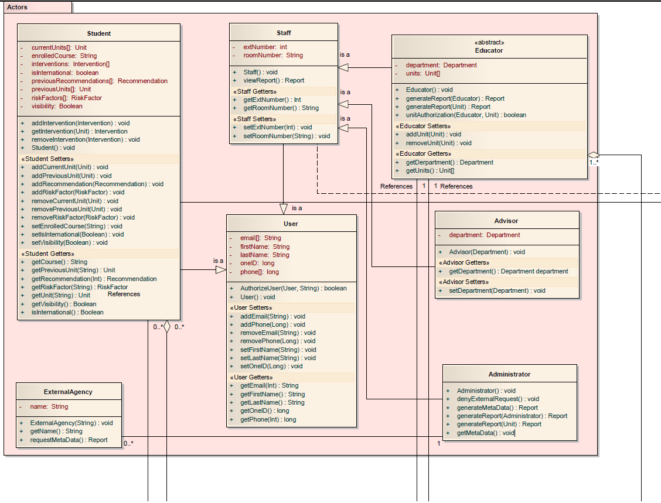Below represents a high-level class diagram to visually describe the structure of our design for the SYSTEM. It is separated into packages for convenience; however a larger diagram that is not separated is included in this document (refer to Appendix M).

*Analysis Diagram part1*

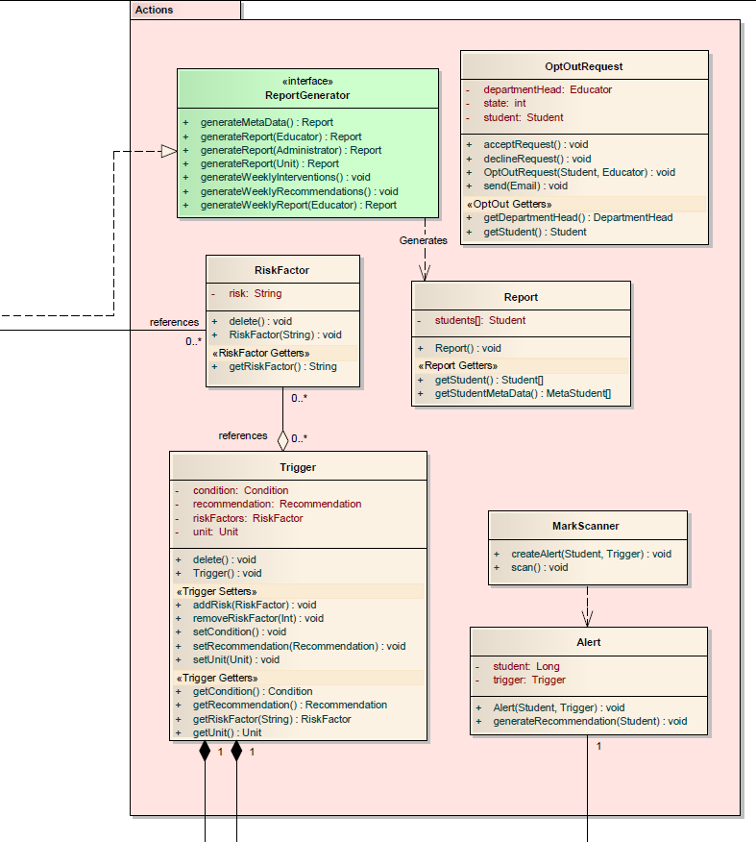

*Analysis Diagram part2*

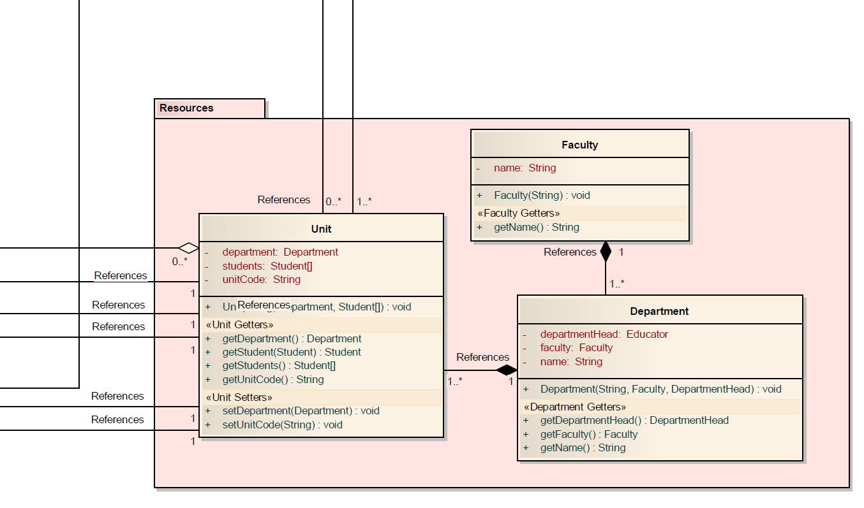

*Analysis Diagram part3*

*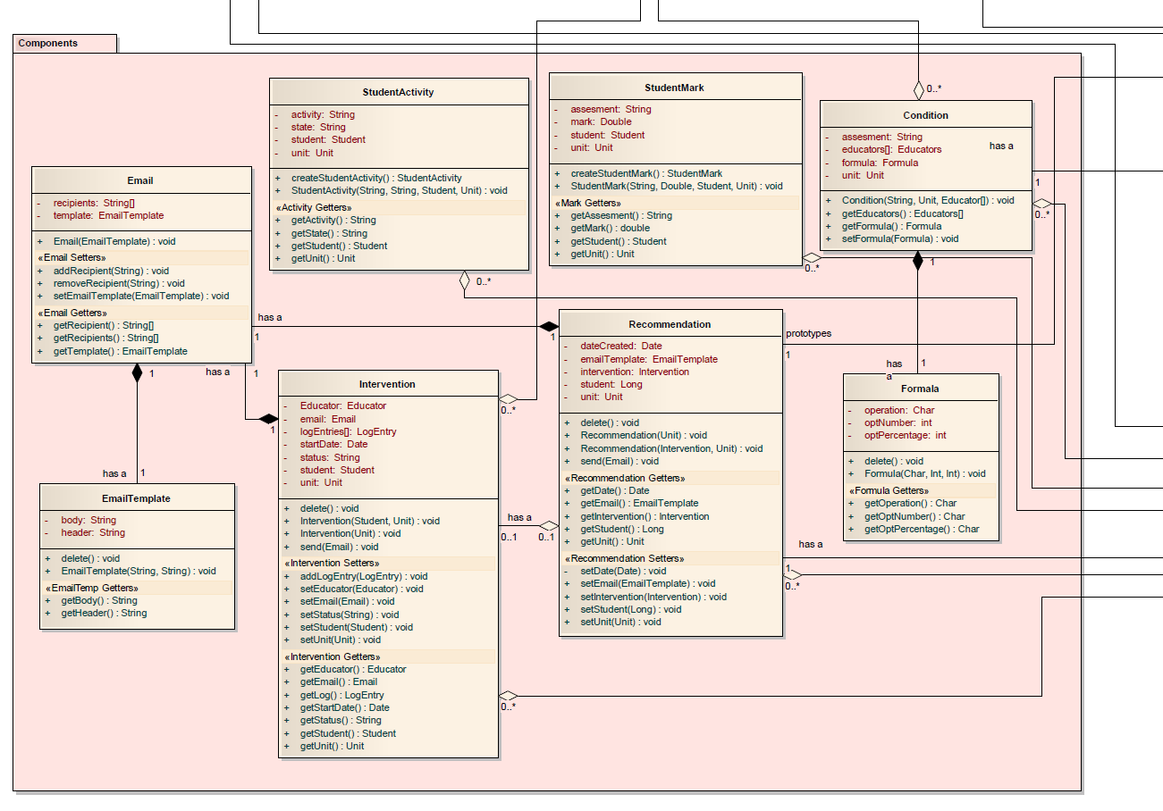Analysis Diagram part4*

# 6. Sequence Diagrams

### 6.1 Educator Sets Trigger Conditions

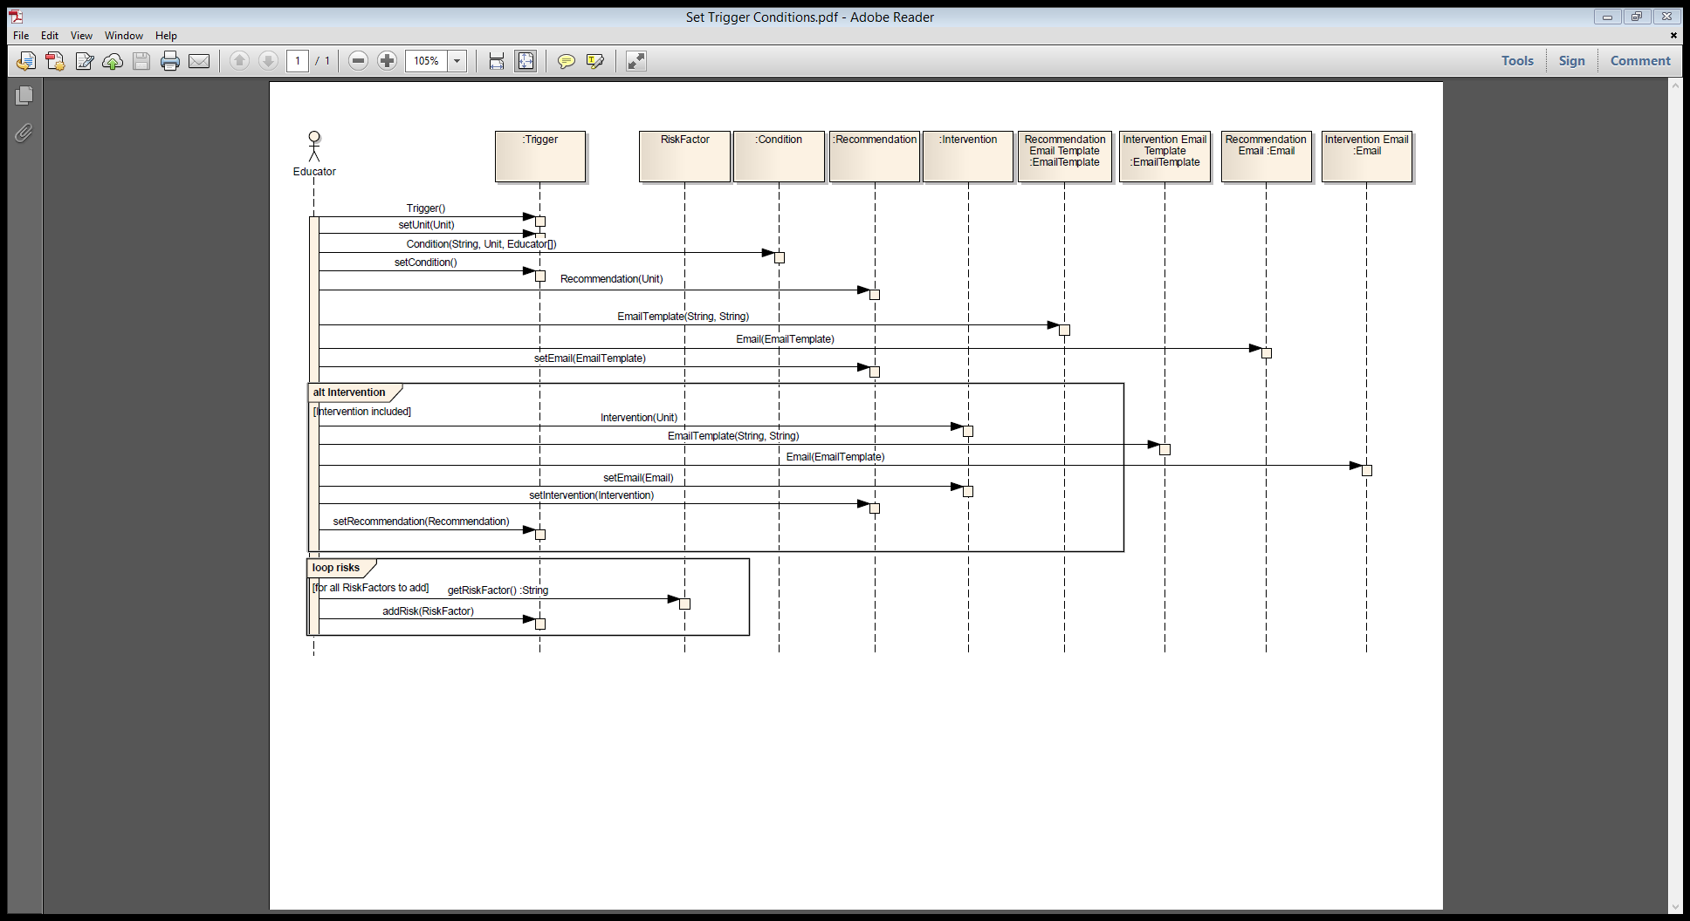

### 6.2 tIME GENERATEs RECOMMENDATIONS

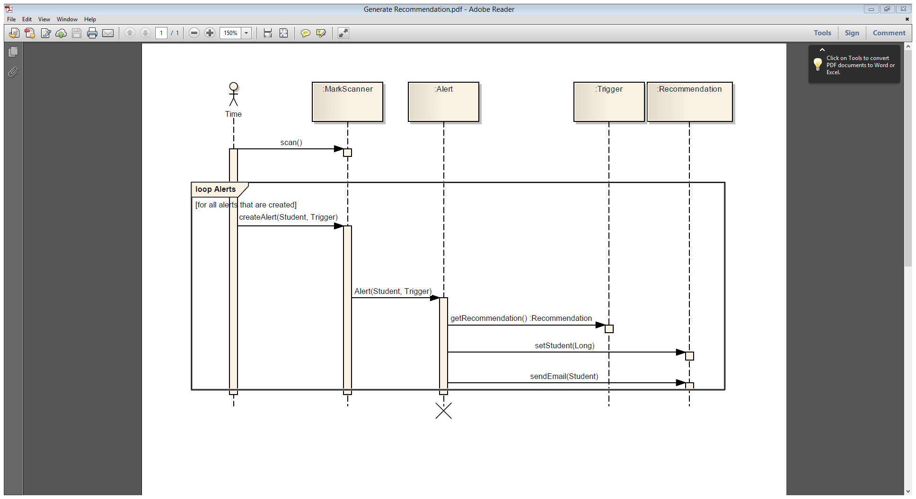

### 6.3 TIME GENERATEs PENDING INTERVENTIONS

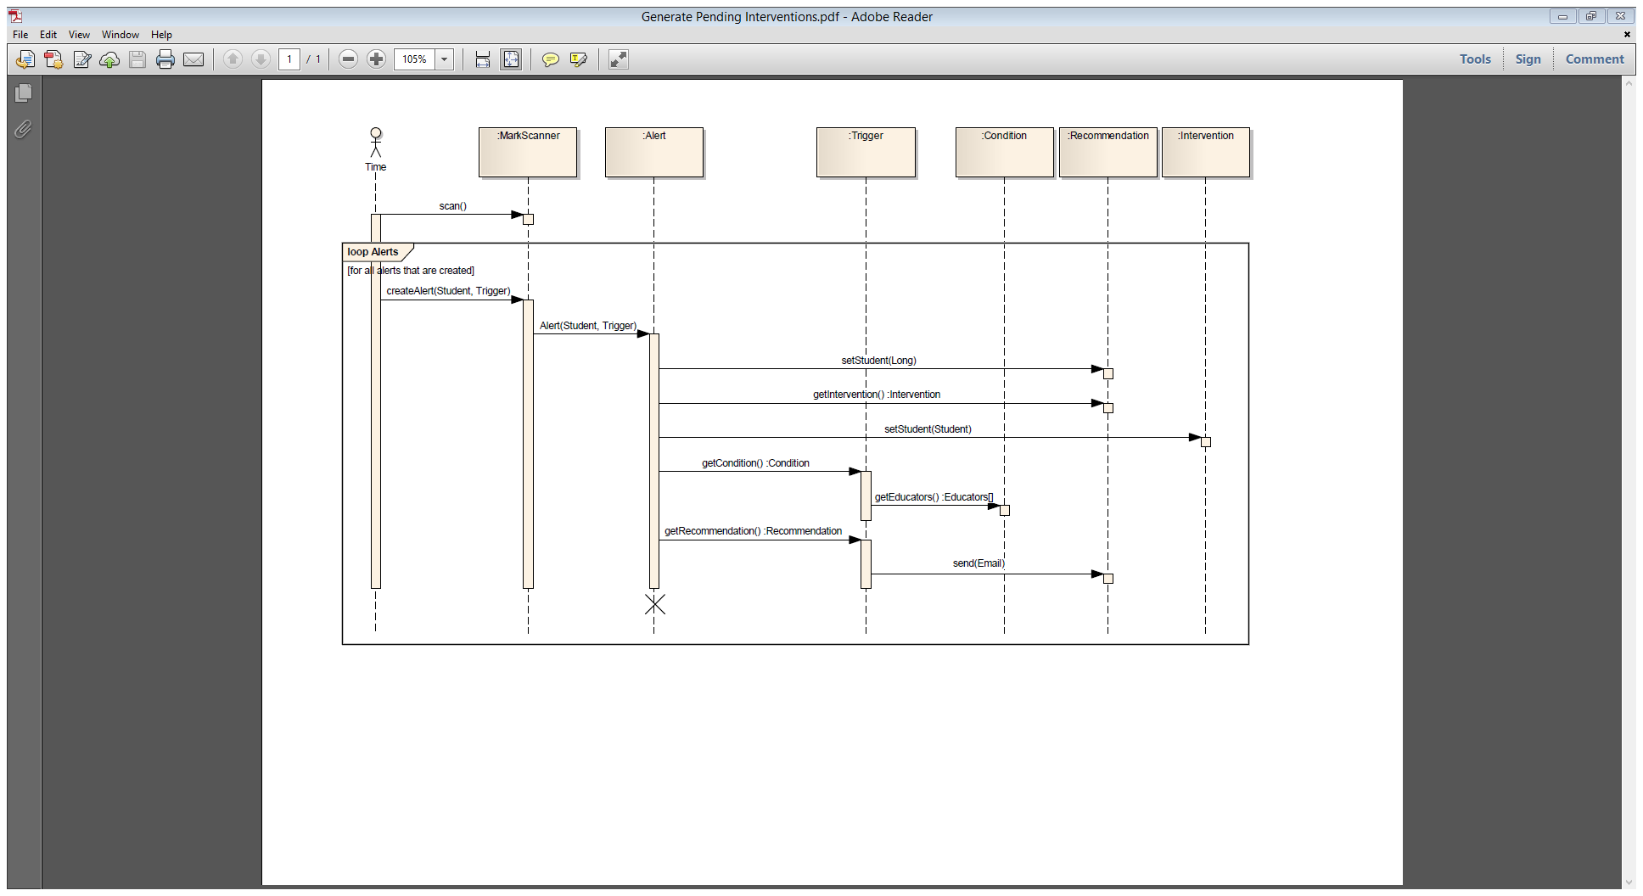

### 6.4 EDUCATOR VIEWs STUDENT DETAILS

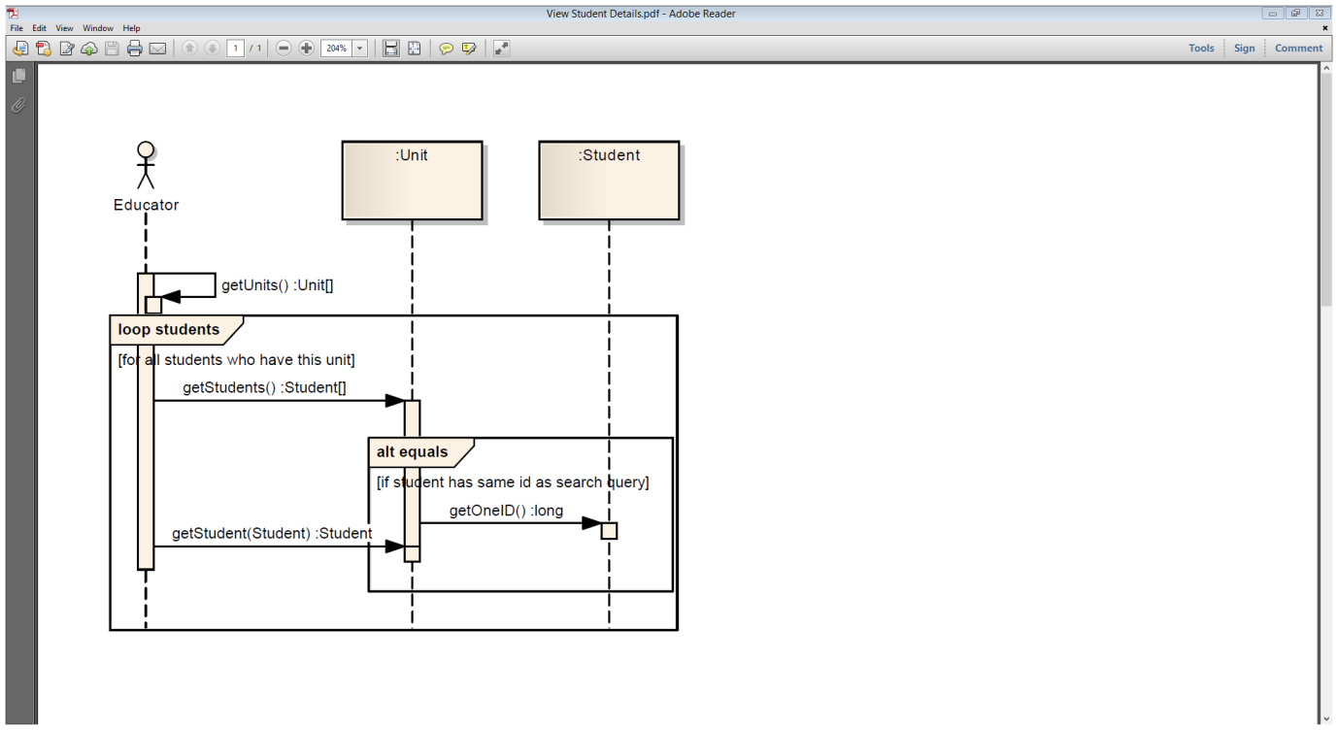

### 6.5 EDUCATOR INITIATEs INTERVENTION

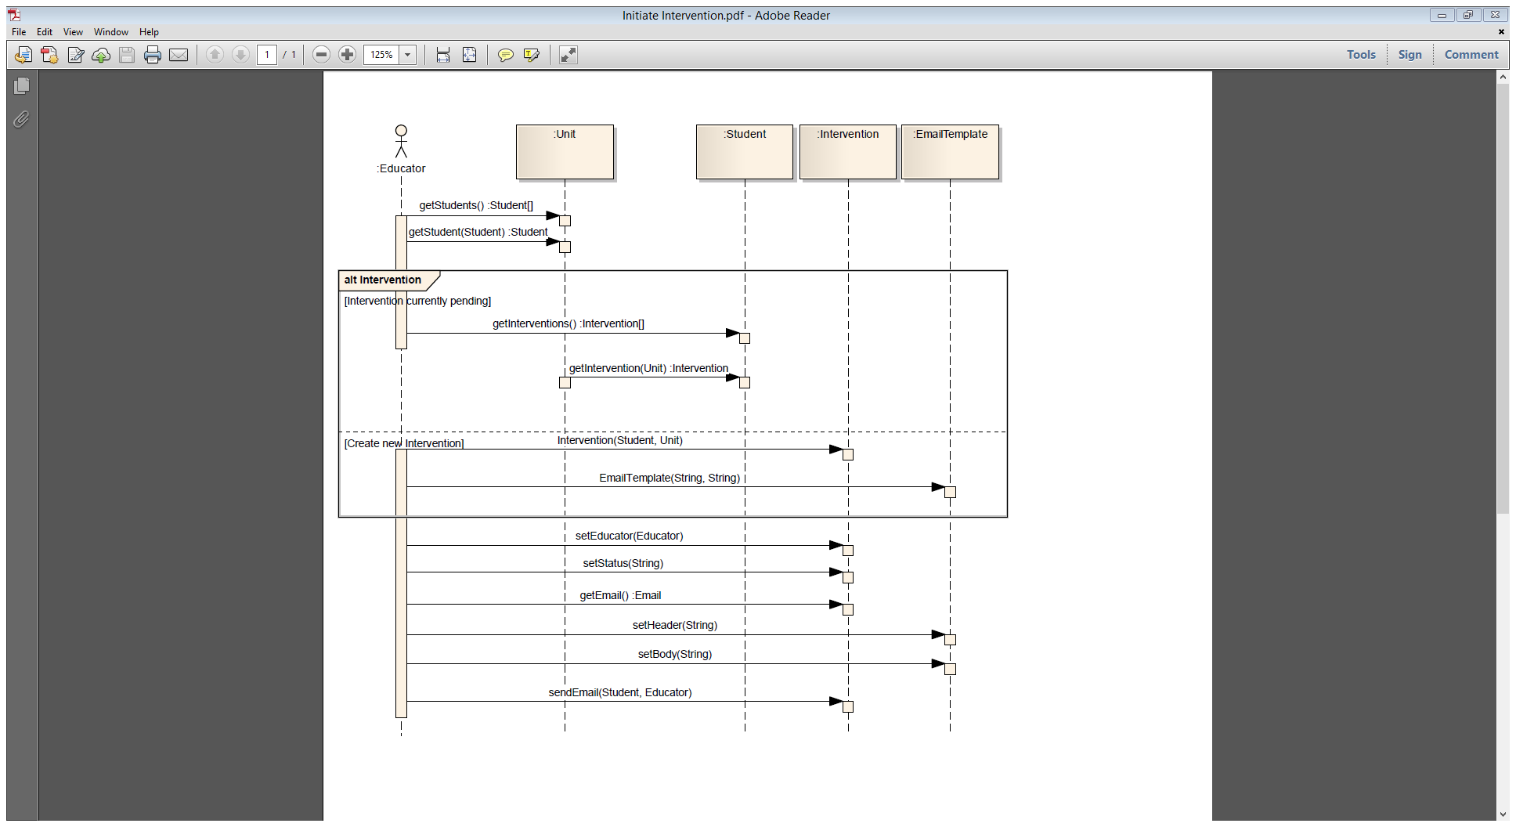

### 6.6 EDUCATOR REVIEWs OPEN INTERVENTION

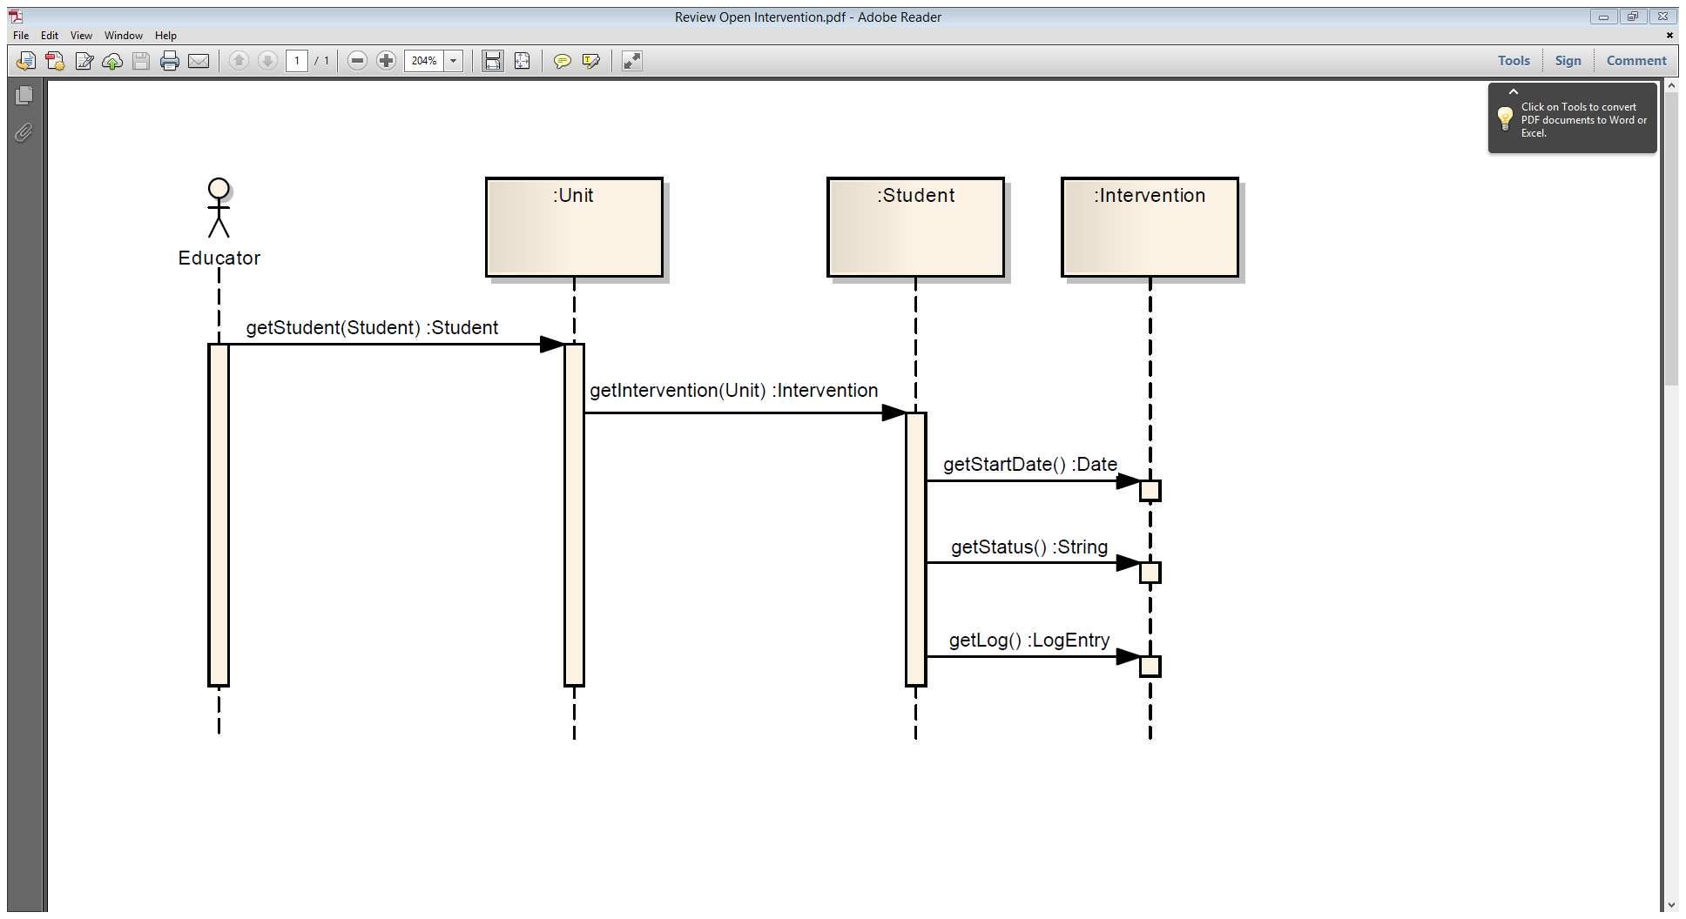

### 6.7 STUDENT CREATEs AN OPT-OUT REQUEST

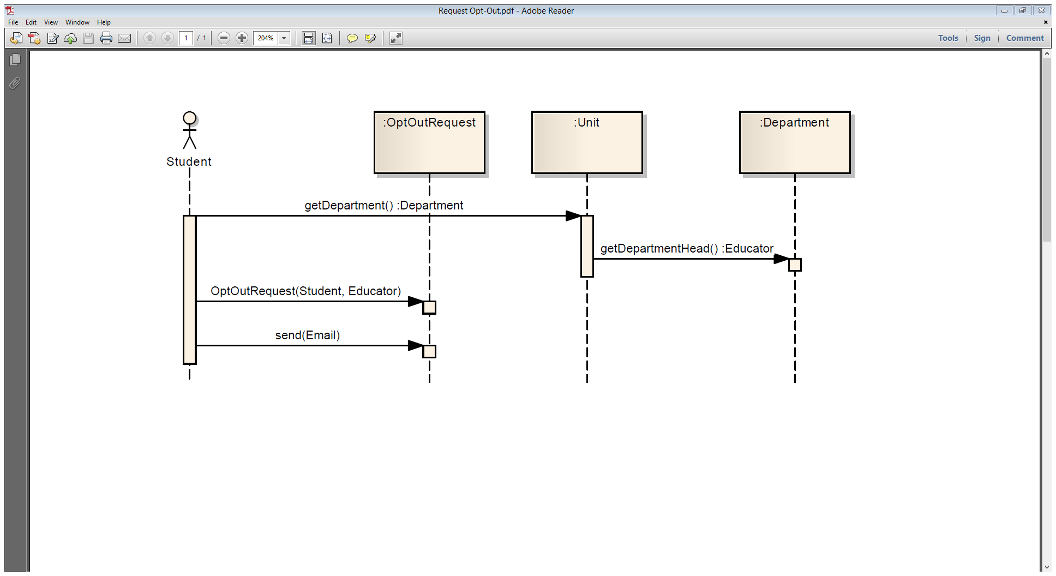

### 6.8 TIME GENERATEs WEEKLY REPORTS

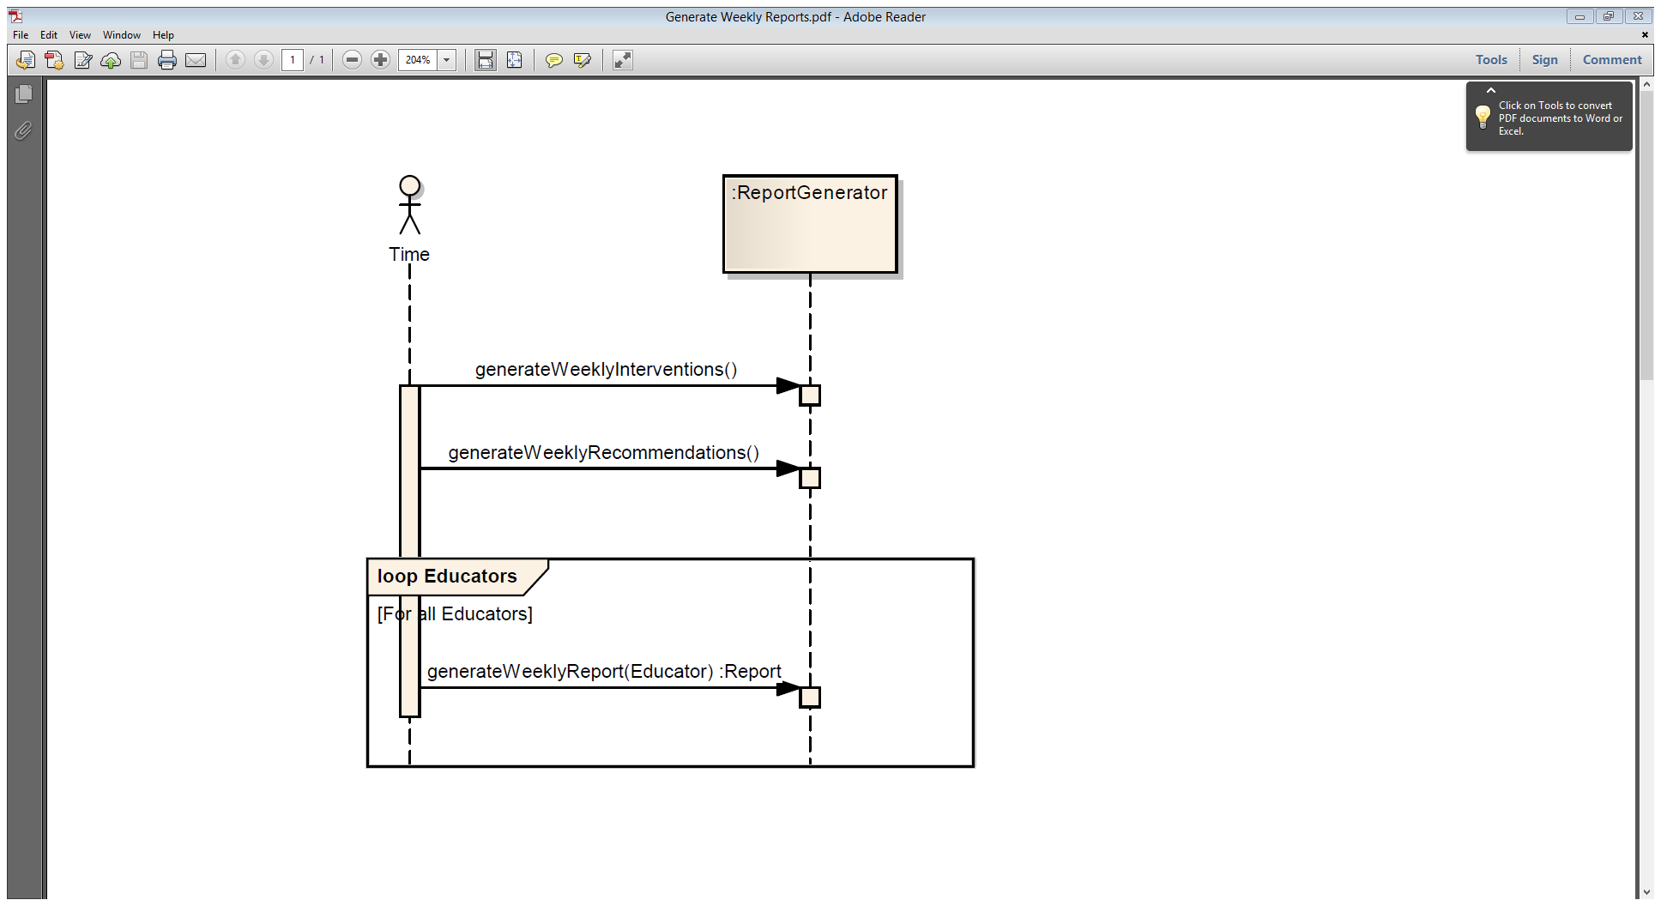

### 6.9 eDUACTOR and ADMINISTRATOR INTERACT WITH SYSTEM TO CREATE AD-HOC MUGSS REPORTS

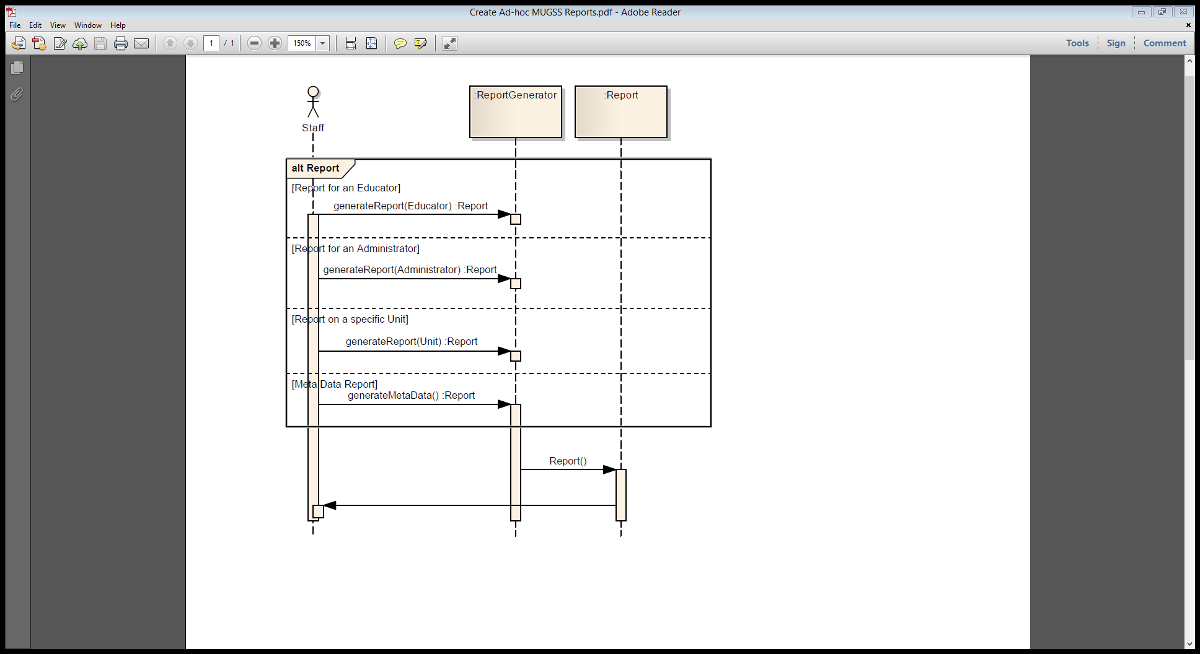

### 6.10 Educator RESPONDs TO AN OPT-OUT REQUEST

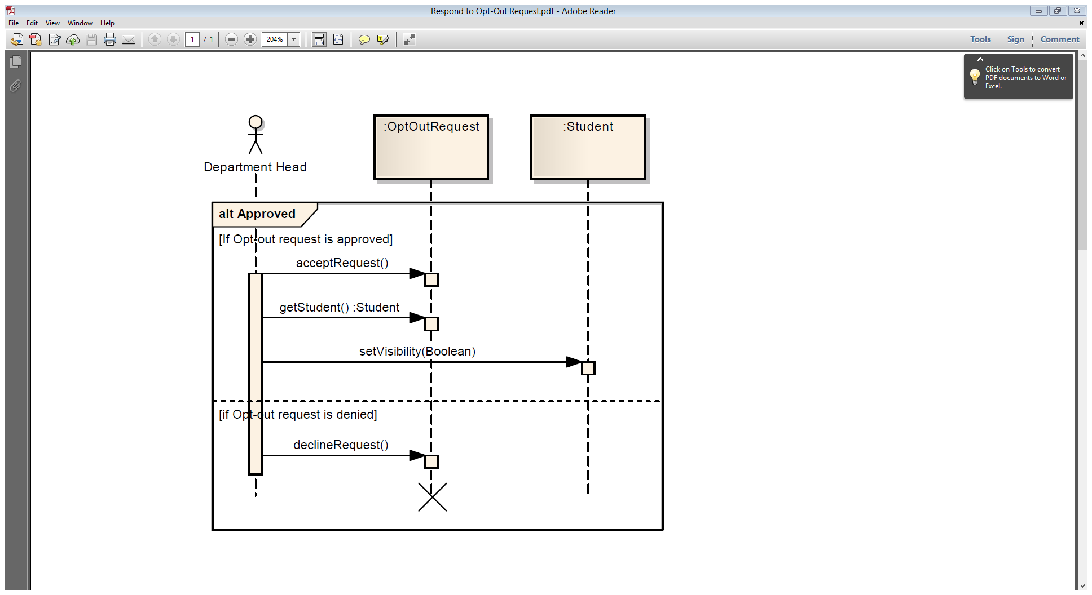

# 7. Requirements Traceability Matrix

|  |  |  |  |  |  |  |  |
| --- | --- | --- | --- | --- | --- | --- | --- |
| Requirement ID | From Requirement ID | To Requirement ID | Type | Use Case/s | Classes | Build No | Remarks |
| R1.1 | R1.17 | R1.13 | Essential | Generate Pending Intervention | Alert, Intervention, Email | V1.0 |  |
| R1.2 |  |  | Essential | Generate Recommendations | MarkScanner | V1.0 |  |
| R1.3 | R1.4 | R1.5 | Essential | Set Trigger Conditions | Trigger, Recommendation, Intervention, Unit | V1.0 |  |
| R1.4 |  | R1.3, R1.5 | Essential | Set Trigger Conditions | Condition, Formula, Unit | V1.0 |  |
| R1.5 | R1.3,R1.4 |  | Essential | Set Trigger Conditions | Trigger, Unit | V1.0 |  |
| R1.6 |  |  | Essential | View Student Details | Student, Intervention, Recommendation | V1.0 |  |
| R1.7 | R1.7 |  | Essential | View Student Details | StudentMark, StudentActivity, Student | V1.0 |  |
| R1.8 |  |  | Essential | Generate Weekly Reports | ReportGenerator, Report, Student, Administrator | V1.0 |  |
| R1.9 |  |  | Essential | Generate Weekly Reports | ReportGenerator, Report, Student, Educator, Unit | V1.0 |  |
| R1.10 |  |  | Essential | Request Opt-Out | Student, OptOutRequest, Email | V1.0 |  |
| R1.11 |  |  | Essential | Provide Feedback | Email | V1.0 |  |
| R1.12 |  |  | Essential | View Student Details | Educator, Student | V1.0 |  |
| R1.13 | R1.1 |  | Essential | Initiate Intervention | Educator, Student, Intervention | V1.0 |  |
| R1.14 |  |  | Essential | Initiate Intervention | Educator, Student, Intervention, Email | V1.0 |  |
| R1.15 |  | R1.7 | Essential | Review Open Intervention | Educator, Intervention | V1.0 |  |
| R1.16 |  |  | Essential | Set Trigger Conditions | Educator, Condition, Unit | V1.0 |  |
| R1.17 |  | R1.1 | Essential | Generate Pending Intervention | MarkScanner, Alert, Student, Educator, Intervention, Email | V1.0 |  |
| R1.18 |  |  | Essential | Generate Recommendations | MarkScanner, Alert, Student, Recommendation, Email | V1.0 |  |
| R1.19 |  |  | Extensional |  |  | V2.0 |  |
| R1.20 |  |  | Extensional |  |  | V2.0 |  |
| R1.21 |  |  | Extensional | Generate Pending Intervention | Student, StudentActivity, MarkScanner | V1.0 | Moved To Build 1.0 From 2.0 |
| R1.22 |  |  | Extensional |  | Student | V2.0 |  |
| R1.23 |  |  | Extensional |  | Student | V2.0 |  |
| R1.24 |  |  | Extensional |  | User, Unit | V2.0 |  |
| R1.25 |  |  | Extensional |  |  | V2.0 |  |
| R1.26 |  |  | Extensional |  |  | V2.0 |  |
| R1.27 |  |  | Extensional |  |  | V2.0 |  |
| R1.28 |  |  | Extensional |  |  | V2.0 |  |
| R1.29 |  |  | Extensional |  |  | V2.0 |  |
| R1.30 |  |  | Extensional |  | Educator, Student | V2.0 |  |
| R2.1 |  | R2.11,R2.14,R2.20, R2.17 | Essential |  |  | V1.0 |  |
| R2.2 |  |  | Essential |  |  | V1.0 |  |
| R2.3 |  |  | Essential |  |  | V1.0 |  |
| R2.4 |  |  | Essential |  |  | V1.0 |  |
| R2.5 |  |  | Essential |  |  | V1.0 |  |
| R2.6 |  | R2.22 | Essential |  |  | V1.0 |  |
| R2.7 |  |  | Essential |  |  | V1.0 |  |
| R2.8 |  |  | Essential |  |  | V1.0 |  |
| R2.9 |  |  | Essential |  |  | V1.0 |  |
| R2.10 |  |  | Essential |  |  | V1.0 |  |
| R2.11 | R2.1 |  | Essential |  |  | V1.0 |  |
| R2.12 |  |  | Essential |  |  | V1.0 |  |
| R2.13 |  |  | Essential |  |  | V1.0 |  |
| R2.14 | R2.1 |  | Essential |  |  | V1.0 |  |
| R2.15 |  |  | Essential |  |  | V1.0 |  |
| R2.16 |  |  | Essential |  |  | V1.0 |  |
| R2.17 | R2.1 |  | Essential |  |  | V1.0 |  |
| R2.18 |  |  | Essential |  |  | V1.0 |  |
| R2.19 |  |  | Essential |  |  | V1.0 |  |
| R2.20 | R2.1 |  | Essential |  |  | V1.0 |  |
| R2.21 |  |  | Essential |  |  | V1.0 |  |
| R2.22 | R2.6 |  | Essential |  |  | V1.0 |  |
| R2.23 |  |  | Essential |  |  | V1.0 |  |
| R2.24 |  |  | Essential |  |  | V1.0 |  |
| R2.25 |  |  | Essential |  |  | V1.0 |  |
| R2.26 |  |  | Essential |  |  | V1.0 |  |
| R2.27 |  |  | Extensional |  |  | V2.0 |  |
| R2.28 |  |  | Extensional |  |  | V2.0 |  |
| R2.29 |  |  | Extensional |  |  | V2.0 |  |

# 8. Acceptance Testing

Please note that 7 tests have been included, instead of the 5 tests specified in the assignment brief, in order that a ‘build up’ of data be achieved to highlight the various CRUD functionality of use case 1 – Set Trigger Conditions.

***Use Case 1 - Set Trigger Conditions - Acceptance Test***

|  |  |  |  |
| --- | --- | --- | --- |
| **ID** | **Description** | **Expected Results** | **Actual Results** |
| Test #1  Step 1.a  loadScreen | **Preconditions:**   1. “Diagnostic Assignment” and “Mid-Semester Exam” are usable MUGSS triggers 2. “TEST111” is the study unit applicable to the load of the screen 3. “TEST111” has no MUGSS triggers assigned 4. “TEST111” has the following unit staff: “GEORGE”, “JANE”, “JUDY”, “ELROY” 5. “GEORGE” is the educator who has loaded the screen   **Steps:** 1. The system displays the screen | The system displays a screen containing:   1. Study Unit “TEST111” 2. An empty list of assigned MUGSS Triggers |  |
| Test #2  Step 1.b.1  Step 1.b.2  addTriggerToUnit | **Preconditions:**   1. “Diagnostic Assignment” and “Mid-Semester Exam” are usable MUGSS triggers 2. “TEST111” is the study unit context 3. “TEST111” has no MUGSS triggers assigned 4. “TEST111” has the following unit staff: “GEORGE”, “JANE”, “JUDY”, “ELROY” 5. “GEORGE” is the educator who has loaded the screen   **Steps:**  1. GEORGE selects (i.e. clicks) the “Add” command | The system amends the display to prompt for a usable MUGSS trigger to add.  The system displays a screen containing:   1. Study Unit “TEST111” 2. An empty list of assigned MUGSS Triggers 3. A list of unassigned (usable) MUGSS Triggers, comprising “Diagnostic Assignment” and “Mid-Semester Exam” |  |
| Test #3  Step 1.b.3  Step 1.b.4  addTriggerToUnit | **Preconditions:**   1. “Diagnostic Assignment” and “Mid-Semester Exam” are usable MUGSS triggers 2. “No Submission” and “Grade Less Than” are parameters applicable to “Diagnostic Assignment” 3. “Grade Less Than” and “Not Passed” are parameters applicable to “Mid-Semester Exam” 4. “TEST111” is the study unit context 5. “TEST111” has no MUGSS triggers assigned 6. “TEST111” has the following unit staff: “GEORGE”, “JANE”, “JUDY”, “ELROY” 7. “Diagnostic Assignment” has pro forma email body text defined “Dear Student, to assist your performance in unit XXXXnnn, you will find it helpful to review the following material: … Best Regards EDUCATOR” 8. “GEORGE” is the educator who has loaded the screen 9. “GEORGE” has selected the “Add” command   **Steps:**  1. GEORGE selects (i.e. clicks) the “Diagnostic Assignment” list item | The system amends the display to prompt for an applicable parameter to add.  The system displays a screen containing:   1. Study Unit “TEST111” 2. An empty list of assigned MUGSS Triggers 3. A list of unassigned (usable) MUGSS Triggers, comprising “Diagnostic Assignment” and “Mid-Semester Exam”, of which “Diagnostic Assignment” is highlighted as selected 4. A list of potential email recipients, comprising “GEORGE”, “JANE”, “JUDY”, “ELROY” and “UNIT STUDENTS” 5. Pro forma email body text: “Dear Student, to assist your performance in unit TEST111, you will find it helpful to review the following material: … Best Regards GEORGE” |  |
| Test #4  Step 1.b.5.n  addTriggerToUnit | **Preconditions:**   1. “Diagnostic Assignment” and “Mid-Semester Exam” are usable MUGSS triggers 2. “No Submission” and “Grade Less Than” are parameters applicable to “Diagnostic Assignment” 3. “Grade Less Than” and “Not Passed” are parameters applicable to “Mid-Semester Exam” 4. “TEST111” is the study unit context 5. “TEST111” has no MUGSS triggers assigned 6. “TEST111” has the following unit staff: “GEORGE”, “JANE”, “JUDY”, “ELROY” 7. “Diagnostic Assignment” has pro forma email body text defined “Dear Student, to assist your performance in unit XXXXnnn, you will find it helpful to review the following material: … Best Regards EDUCATOR” 8. “GEORGE” is the educator who has loaded the screen 9. “GEORGE” has selected the “Add” command 10. “GEORGE” has selected the “Diagnostic Assignment” list item   **Steps:**  1. GEORGE selects (i.e. clicks) the “Grade Less Than” parameter  2. GEORGE types “64” for the parameter value associated with “Grade Less Than”  3. GEORGE selects “UNIT STUDENTS” from the list of potential email recipients  4. GEORGE selects “GEORGE” from the list of potential email recipients  5. GEORGE amends the pro forma email body text to replace “…” with “Chapters 1, 2, 4, and 6 of the Astro &Scoobie text”  6. GEORGE selects (i.e. clicks) the “Save” command | The system rejects the entry and returns an error message: “Please do not combine Staff and Students as recipients in the same email”  The system redisplays the screen without making any changes to it. |  |
| Test #5  Step 1.b.5.n  addTriggerToUnit | **Preconditions:**   1. “Diagnostic Assignment” and “Mid-Semester Exam” are usable MUGSS triggers 2. “No Submission” and “Grade Less Than” are parameters applicable to “Diagnostic Assignment” 3. “Grade Less Than” and “Not Passed” are parameters applicable to “Mid-Semester Exam” 4. “TEST111” is the study unit context 5. “TEST111” has no MUGSS triggers assigned 6. “TEST111” has the following unit staff: “GEORGE”, “JANE”, “JUDY”, “ELROY” 7. “Diagnostic Assignment” has pro forma email body text defined “Dear Student, to assist your performance in unit XXXXnnn, you will find it helpful to review the following material: … Best Regards EDUCATOR” 8. “GEORGE” is the educator who has loaded the screen 9. “GEORGE” has selected the “Add” command 10. “GEORGE” has selected the “Diagnostic Assignment” list item   **Steps:** 1. GEORGE selects (i.e. clicks) the “Grade Less Than” parameter  2. GEORGE types “64” for the parameter value associated with “Grade Less Than”  3. GEORGE selects “UNIT STUDENTS” from the list of potential email recipients  4. GEORGE amends the pro forma email body text to replace “…” with “Chapters 1, 2, 4, and 6 of the Astro &Scoobie text”  5. GEORGE selects (i.e. clicks) the “Save” command | The system saves the entry and resets the screen to its initial load state.  The system displays a screen containing:   1. Study Unit “TEST111” 2. A list of assigned MUGSS Triggers comprising only “Diagnostic Assignment” |  |
| Test #6  1.c.1  1.d.1  viewTriggerOnUnit | **Preconditions:**   1. Test #5 has just been performed. 2. The preconditions of Test #5 are all applicable to this Test #6   **Steps:** 1. GEORGEselects (i.e. clicks) the “Diagnostic Assignment” list item | The system amends the display to show the details which were saved during Test #5.  The system displays a screen containing:   1. Study Unit “TEST111” 2. A list of assigned MUGSS Triggers comprising only “Diagnostic Assignment” 3. The parameter “Grade Less Than” 4. The parameter value “64” 5. A list of potential email recipients, comprising “GEORGE”, “JANE”, “JUDY”, “ELROY” and “UNIT STUDENTS”, of which “UNIT STUDENTS” is marked as selected 6. Pro forma email body text: “Dear Student, to assist your performance in unit TEST111, you will find it helpful to review the following material: Chapters 1, 2, 4, and 6 of the Astro &Scoobie text Best Regards GEORGE” |  |
| Test #7  1.d.3  1.d.4  deleteTriggerOnUnit | **Preconditions:**   1. Test #6 has just been performed. 2. The preconditions of Test #6 are all applicable to this Test #7   **Steps:** 1. GEORGEselects (i.e. clicks) the “Delete” command  2. The system prompts for confirmation  3. GEORGE confirms deletion | The system deletes the entry and resets the screen to its initial load state.  The system displays a screen containing:   1. Study Unit “TEST111” 2. An empty list of assigned MUGSS Triggers |  |

# 9. User Interface Evaluation

The basis of the User Interface is shown below:

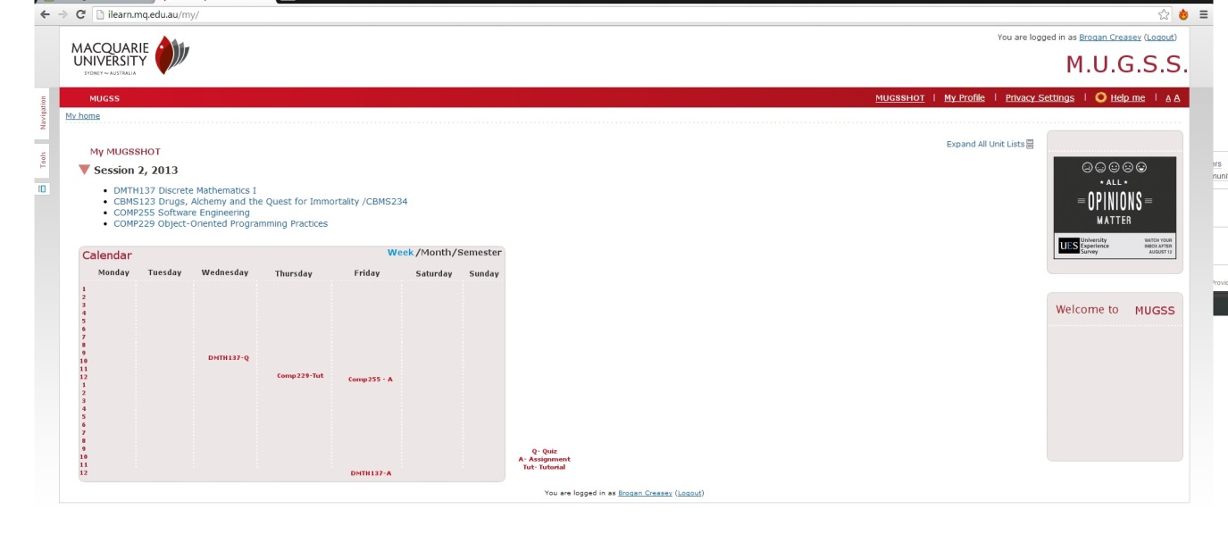

**Usability**

To assess the User Interface Design, we focused on five attributes of usability we considered crucial - learnability, speed of operation, robustness, recoverability and adaptability / portability. We consider these five attributes essential as together they ensure the system will perform at a satisfactory level. Further explanation of each attribute is provided below.

Usability is important in any context for ensuring the user's needs are being considered. A key aspect of this is ensuring all users of the system are taken into account. In terms of MUGSS, this means considering how students, administrators, advisers and educators will use the system. As many of the Macquarie University sites and systems have the same look and feel, we would be using this as a platform to jumpstart MUGSS. To measure the usability of the system, we would create a focus group that consists of all major users, provide them with the appropriate training, and allow them to use the system. Afterwards, we would interview the participants for feedback.

As shown in the prior diagram, we can see that the Macquarie University Logo and colour scheme are the same as current systems. The calendar added in MUGSS V2.0 sits directly below the links to subjects. This new feature will link all important dates from each subject and display them directly on the main page. This is an essential part User Interface of MUGSS as it shows the simplistic UI from the first page the user sees. All the usual login / log-out and other setting options are present and function in a similar manner to the other systems. The consistency from one system to another is clearly demonstrated and will be a bonus in the learnability of the system.

**Learnability**

Learnability is a key attribute of any system as it allows the user to operate MUGSS with ease and confidence, even if they use the system periodically. With any software, training is essential to understand the system's uses and the underlying power. To measure this attribute, we would examine how many errors a user would make with the appropriate amount of training. (Refer to 2.4) To ensure the system is acting as intended, our objective is to minimize mistakes to one per thirty minutes of use.

**Speed of operation**

To duly consider speed of operation, we need to examine how the MUGSS responds to user input. In particular, we will need to test a single user along with volume testing on the system. Speed of operation is crucial to adoption as no one wants to use a system that is slow and unresponsive. However, some operations do not affect the user's speed of operation as they are not performed while the user is actively waiting. (i.e., the weekly generated reports.) Thus, when we consider this attribute, our true concern is with speed of operations performed by a user. Considering this, to measure the speed of the system, we will look at one hour of operation and ensure each user-entered command has been processed in under a second. This test will be performed twice, once with low user load and again with high volume.

**Robustness**

Robustness in any system is essential as it is the ability of a system to cope with the unexpected. In terms of MUGSS, the vital part of operation is how the system adapts and changes when events outside the scope come into play. MUGSS has various options where outside data is accessed and it is essential that it can handle any input. The user whom is unfamiliar will always tend to guess and the system needs to be prepared to understand that the user is unsure, might enter incorrect data, and so the system adjusts accordingly. Consider if, a user tries to access their marks for the semester, but do not know their unit code. The system must be able to generate another way to communicate understanding or even present alternative ideas for the user to be able to generate desired results.

**Recoverability**

While the aforementioned attributes are important, recoverability is the safety net above which they all operate. Recoverability protects the user from their self, allowing them to change decisions made and restore previous data. This, in a way, makes recoverability hard to test as the user must make an error. Instead of taking a user-test approach, we will evaluate it with multiple generated test cases. We will create tests that mimic a user deleting data and recovering it and changing settings. Together, these test cases will ensure users can undo or redo errors made.

Additionally, the recoverability of MUGSS must extend to dealing with error conditions. In this regard, the system must track and maintain the state of the user interaction when an error occurs, such that the system minimises disruption to the user upon an error event.

**Adaptability / Portability**

As users continue to progress towards more mobile computing devices, we must ensure our solutions meet their needs. Thus, adaptability/portability is becoming a very important part of the user interface. We need to unsure our system will work not just on computer web browsers, but also on tablet and smartphone web browsers. The measurement of this is quite simple; the online implementation of the system must work on tablets and smartphones as well as on computers. This means we will need to test the system on iOS and Android and provide support for these platforms. This also includes testing and adaption to all main browser programs (refer to 2.3)

# 10. Systems Design

The system is broken into five layers.  Each layer provides an additional buffer between the user and the data to ensure security and cohesion while reducing coupling and dependency.  This architecture ensures strict control over information flow so that data is protected and interaction with the system returns accurate data.  The package diagram (refer to System Architecture Diagram) represents the different functionalities the system provides and where in the encapsulation process they belong.

The system will be divided up into two servers. The primary server will be responsible for all user communications, for implementing application specific logic, information storage and retrieval requests, and the moving of information to and from the databases. The user Interface will be implemented using a web browser for students and educators, and an application specific program for administrators.

The second server will be a backup server for all persistent data, and application based information and logic.

The basic concept behind our User Interface (UI) strategy is quite simple--put the user’s needs first.  As part of this, we considered several attributes (refer to Task 9).  At a higher level, the intention is to have a simple, clean, and elegant UI that mimics other Macquarie University systems.  This will allow for consistency and utilize the users experience with other Macquarie web services.

The only expected concurrent processes occur when there is high volume traffic or multiple reports are being created.  In cases where the load goes beyond what the first server can handle, the second can alleviate the strain on the first.

 With MUGSS V1.0, there are relatively few trade-offs that need to be made.  The system is relatively small.  However, some trade-offs are inevitable.  In the case of MUGSS, the most common trade-off faced during design was simplicity versus additional functionality.  As the design progressed, a simpler design was decided upon for MUGSS V1.0.  For MUGSS 2.0, the additional features added would require a re-examination of this trade-off.

In addition, trade-offs had to be made in regards to cost versus speed.  This trade-off manifested when examining how many servers the system should contain.  To ensure the system can handle large traffic loads, there should be a large number of servers.  However each server comes with costs, from purchase through to maintenance.  Thus, each of these components must be considered.  In the end two servers were chosen to allow for redundancy.  If the system has more simultaneous users than expected or additional functionality creates increased load on the current servers, additional servers may be considered to divide the workload.

# 11. Design Level Class Diagram

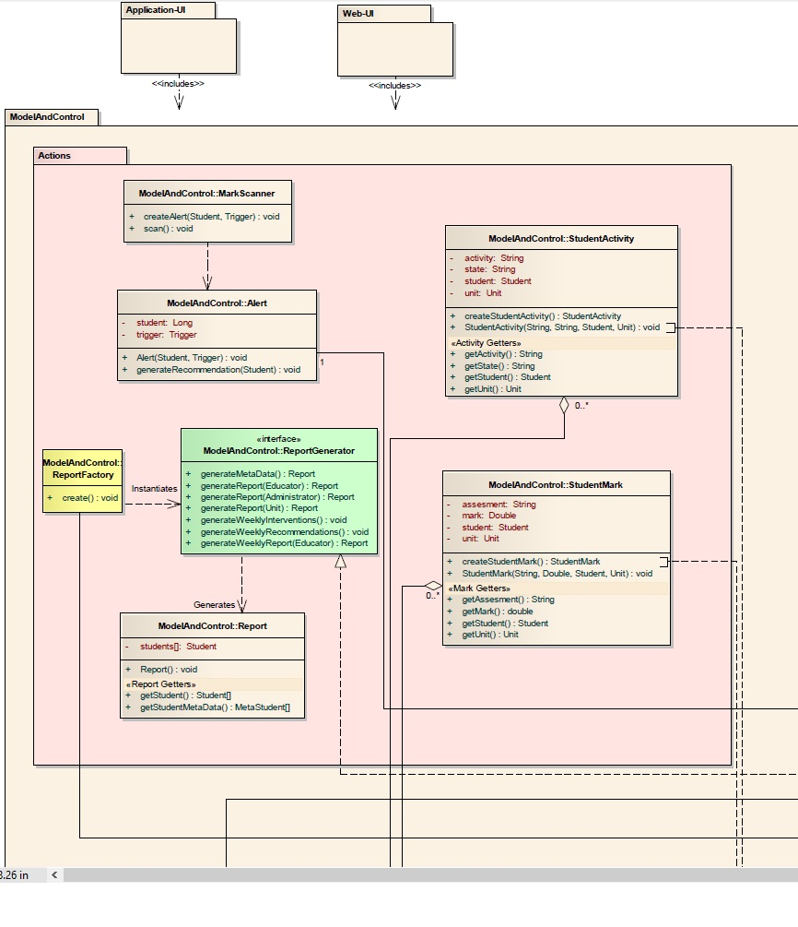

*Design Class Diagram part1 (refer to Appendix N for complete diagram)*

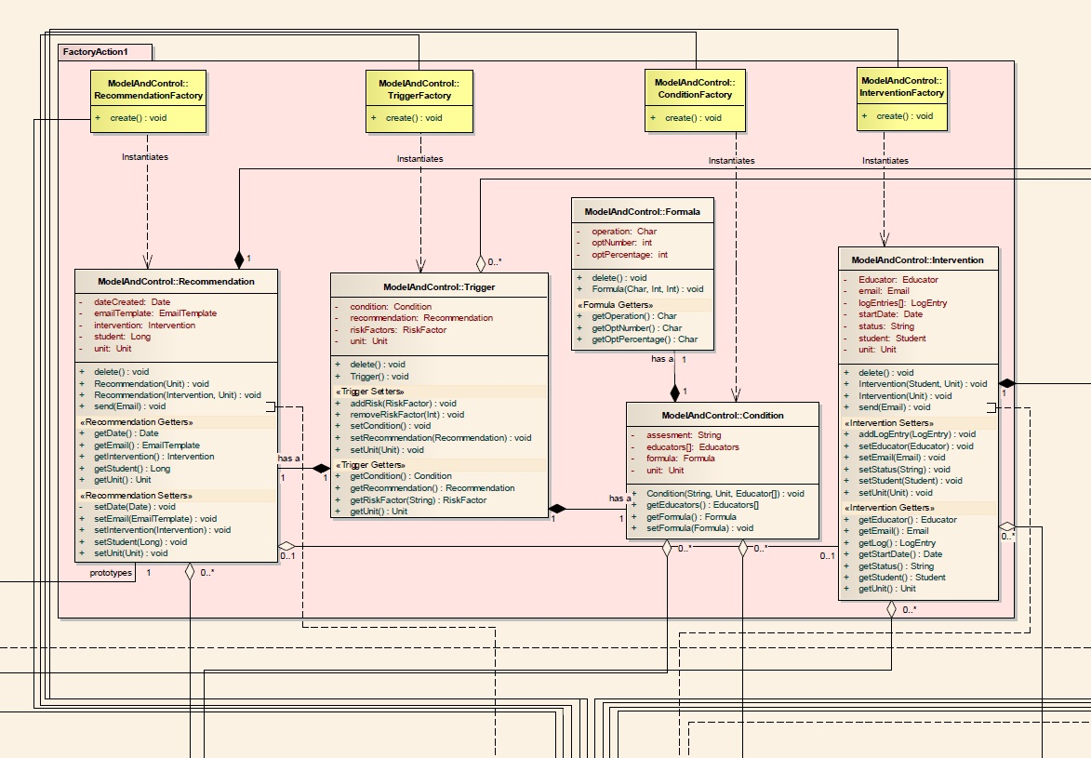

*Design Class Diagram part2 (refer to Appendix N for complete diagram)*

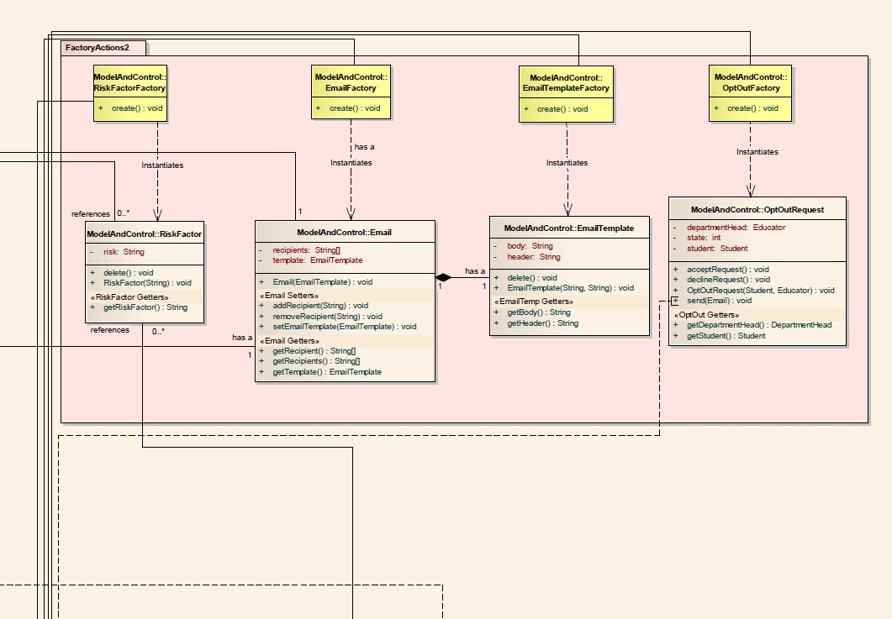

*Design Class Diagram part3 (refer to Appendix N for complete diagram)*

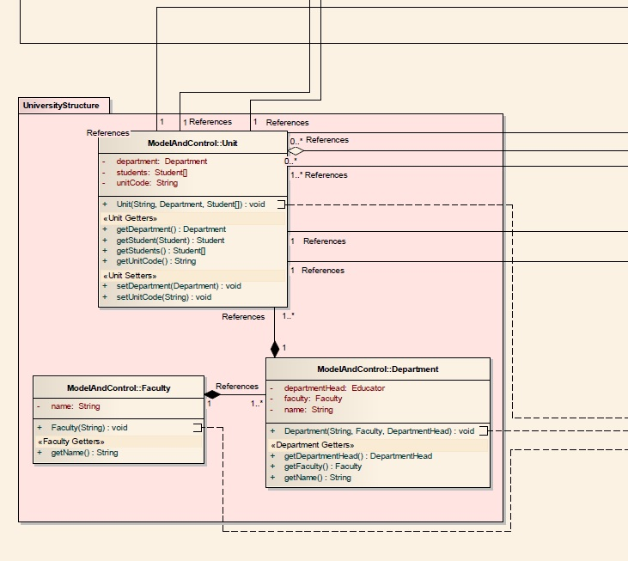

*Design Class Diagram part4 (refer to Appendix N for complete diagram)*

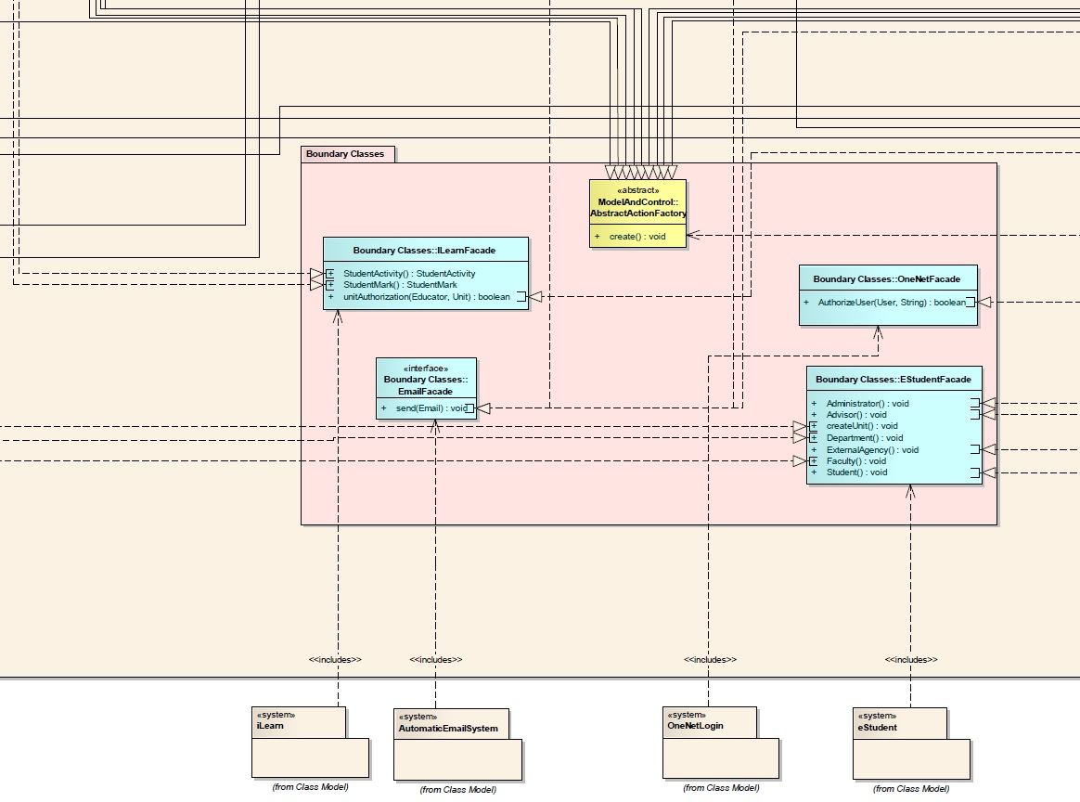

*Design Class Diagram part5 (refer to Appendix N for complete diagram)*

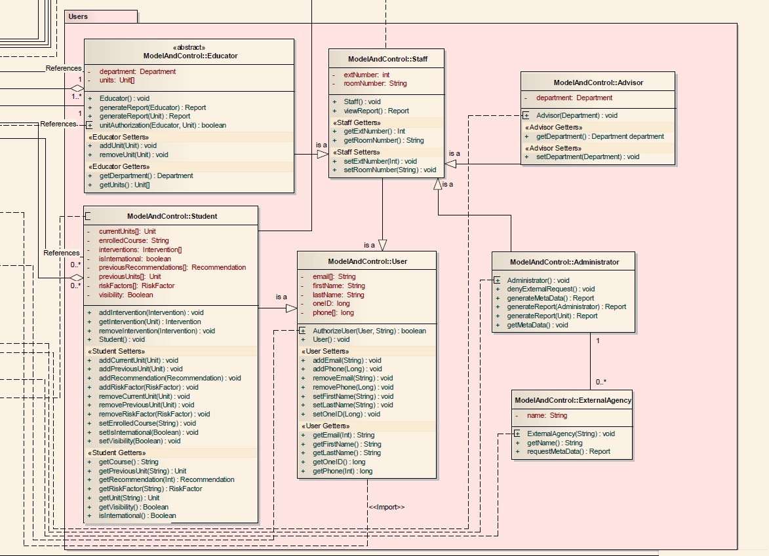

*Design Class Diagram part6 (refer to Appendix N for complete diagram)*

# 12. One Design Level Sequence Diagram

# 13. State Diagram

### 13.1 Trigger state diagram

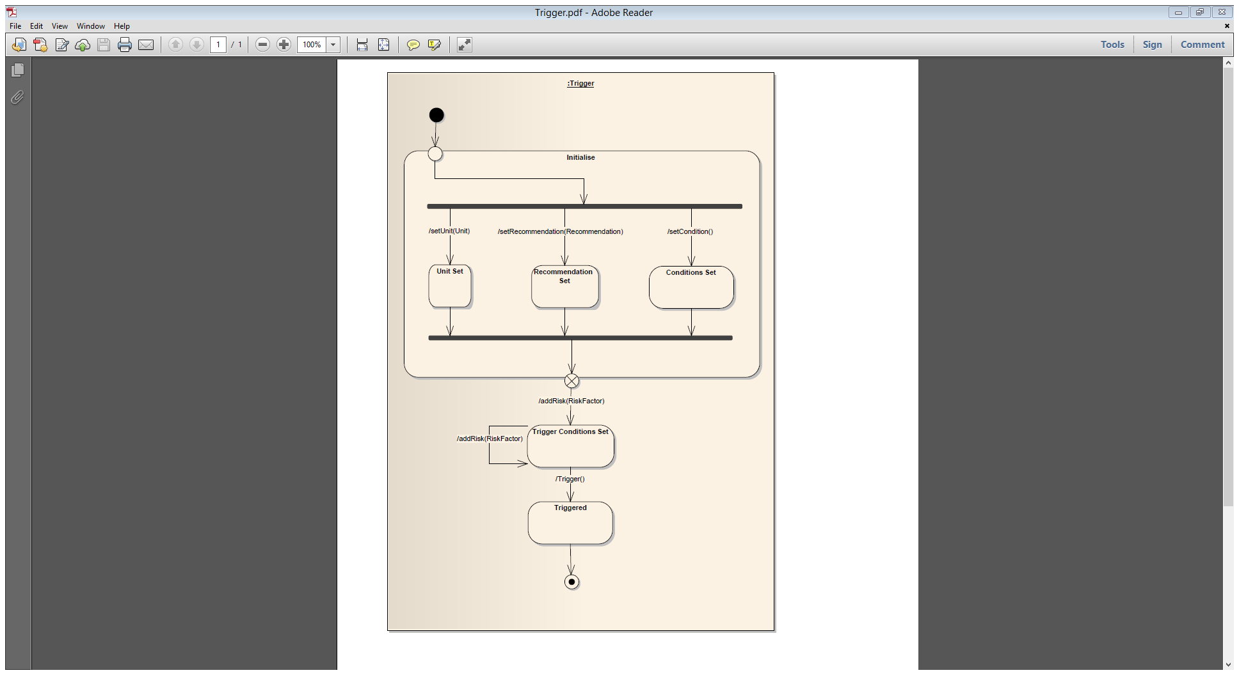

### 13.2 Recommendation state diagram

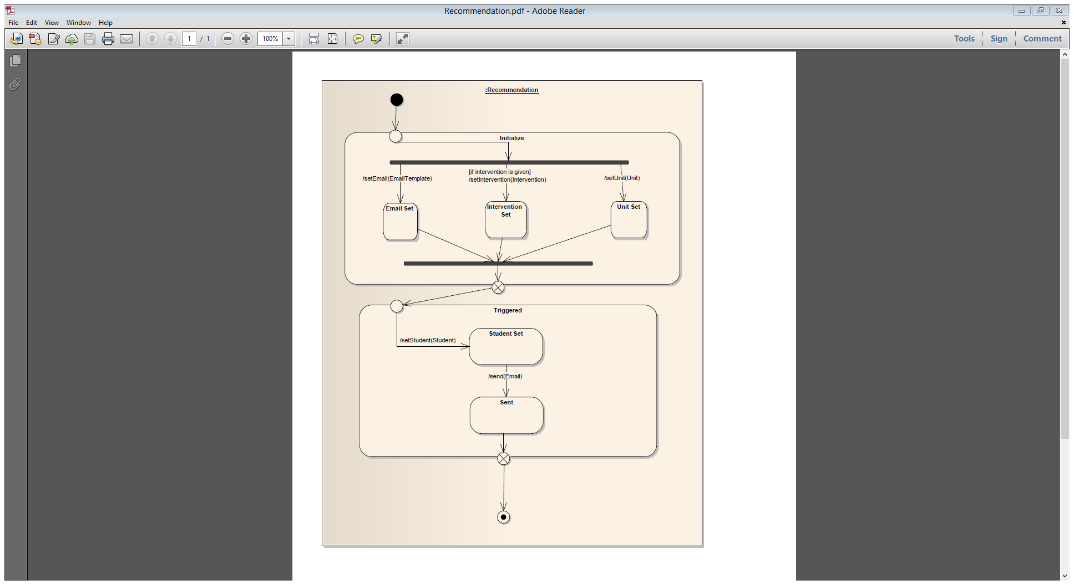

### 13.3 Intervention state diagram

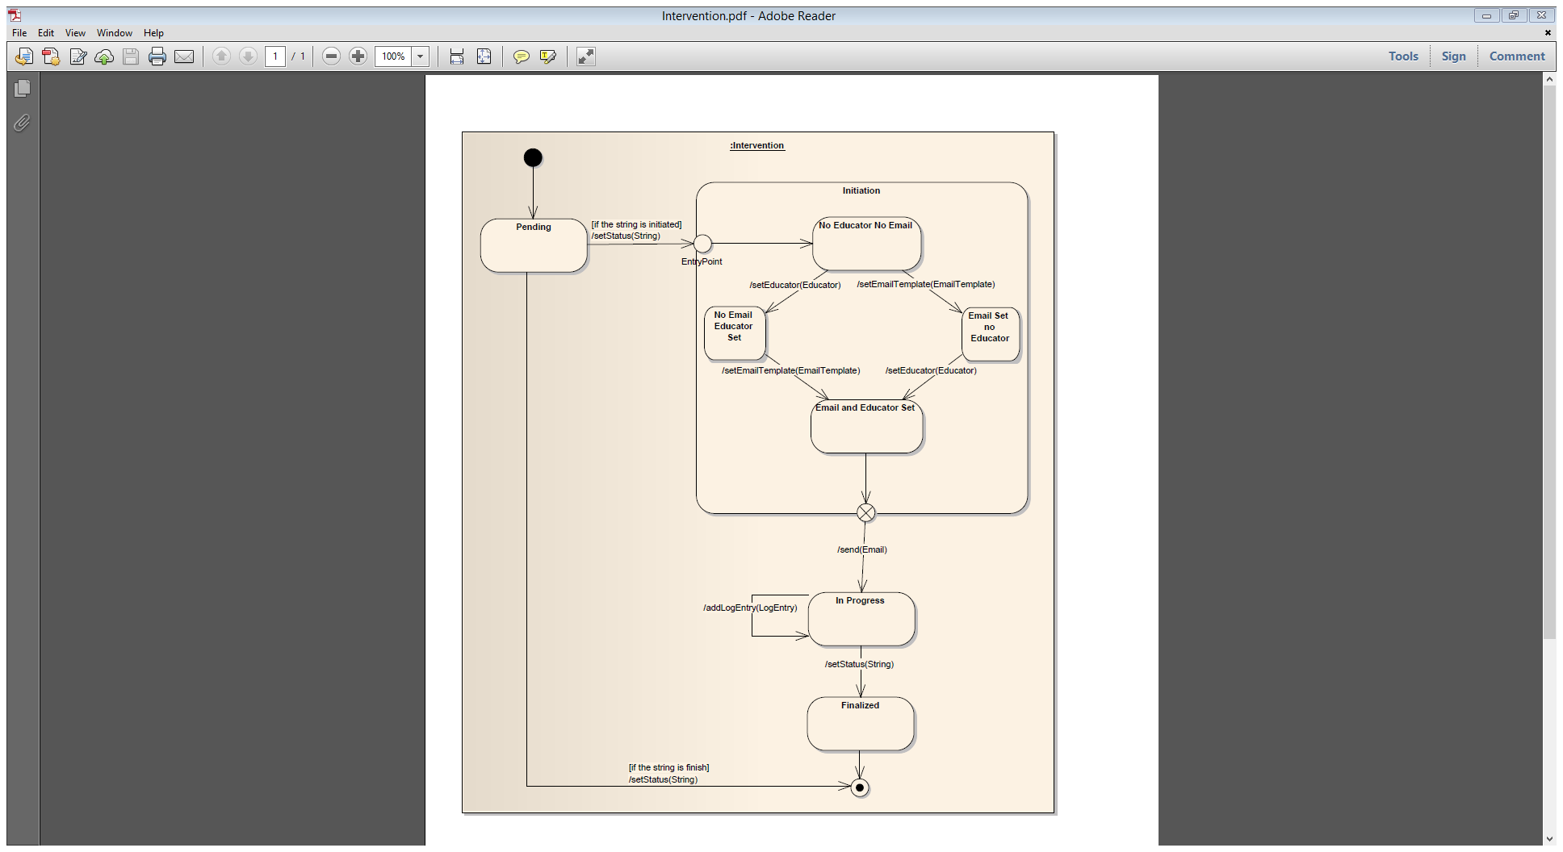

# 14. Complex Algorithm Specification

Our stakeholders have asked us to add new functionality to the system; from this we found the following new requirements:

* Requirement: The system shall generate a weekly report of any student 2 standard deviations from the rest of the class. The report shall be sent to the unit convener and will contain the name, student id, and activity description of any students identified.
  + Rationale: Stakeholders have requested this functionality, it will allow them to automatically identify the students struggling and excelling in the unit.
  + Testing: The system shall correctly produce the report for 52 out of 52 weeks (1 years’ worth) of data.

It is anticipated that no changes to the class structure, aside from a method to check for outliers, would be required. The algorithm would use a Trigger, containing a condition and RiskFactor’s by MarksScanner to find the students at risk using this requirement.

The algorithm to complete this task it outlined on the next page.

**FindOutlierStudents**

**Description:** This algorithm finds the students at risk because they are outside 2 standard deviations from the rest of their cohort.

**Return type:** void

**Input:** - Students’ Marks

- Unit

**Output:** A report with all the name, student id, and activity description of any students identified to be outside 2 standard deviations.

**Precondition:** The students are enrolled in the unit selected and the week given is valid.

**Post condition:** The report is created and an email is sent to the unit convener.

**Pseudocode:**

One Time Initialization:

**create** riskFactor for marks outside 2 standard deviations

Execution of generating report:

**get** all students’ activity in specified week

**calculate** standard deviation on activity

**for** all students

**if** student meets riskFactor

**add** to report

**if** report is not null

**send** to unit convenor

**else**

**throw** exception

**Events transmitted to other objects:**

Completed report transmitted to emailTemplate

**Other operations called:**

Sending the report is handled by emailTemplate

A riskFactor is created.

**Attributes used/changed:**

A riskFacfor is created and used along with the student data.

**Response to exceptions:**

Exception case: report is null

Send to unit convenor a message stating no outlier

students this week

**Non-functional Requirements:**

The algorithm must be efficient to not clog the server.

# 15. Quality

Ensuring quality is critical to delivering usable software. In the words of Pressman, "...experts say it takes only three or four defects per 1,000 lines of code to make a program perform poorly. Factor in that most programmers inject about one error for every 10 lines of code they write, multiply that by the millions of lines of code in many commercial products, the figure it costs software vendors at least half their development budgets to fix errors while testing." (Software Engineering, Pressman) However, as David Garvin said "quality is a complex and multifaceted concept," (<http://sloanreview.mit.edu/article/what-does-product-quality-really-mean/>, accessed 26/9/2013) which makes quality attributes difficult to determine. Based upon our research, we chose the attributes listed below which conform to ISO standard 9126 except where modified by the assignment guidelines.

**Reliability**   
Reliability is an essential part of quality as it assures that the system will work as is intended when needed. If one creates the best system in the world, but it is never available, it will never be used. Thus, to ensure the MUGSS system is available when needed, we must make it reliable. To test this, we will apply the test as stated in the System Requirements Specification part 3.2, "The system shall be available to users for normal use between 7am and midnight, 6 days per week, with 98% reliability."

**Efficiency**   
According to Google Define, an efficient system is one that achieves "...maximum productivity with minimum wasted effort or expense." MUGSS needs to not only do the tasks given; it needs to do them quickly and swiftly--making efficiency a critical component of the system. For the system to function properly, the data transfer between other university systems and MUGSS must be efficient. To test this, we refer to the System Requirements Specification part 3.2 which states "Out of 1000 test cases 95% of student’s statistics must have updated in the system within 5 minutes."

**Maintainability**   
For a system to be considered to have a high level of quality, it must be able to change and adapt as needed through the evolution stage of the software development life cycle. However, as each change is made we must confirm it does not introduce new bugs that make previously working code faulty. Thus, to ensure our system is maintainable, we must also ensure it is testable. To guarantee this is the case, we will create a test suite that can be run when any change is made.

**Portability**  
As discussed in Task 9 (User Interface Evaluation), portability is becoming one of the most important concerns for software engineers. As more users migrate to mobile devices, we must develop applications that work on desktops/laptops, tablets, and smartphones. Thus, to meet our user’s needs, we will test MUGSS on desktops, laptops, along with iOS and Android phones and tablets. In addition to this, we must ensure the system works on a variety of browsers. For a complete list of the browsers the system will support, please view the System Requirements Specification part 2.3.

**Functionality**   
Functionality is the key to establishing a working system. It incorporates the suitability, accuracy and the security of the system. It details how adequately the system protects users and data and addresses what data a particular user can access. For example, in MUGSS, an educator will only be allowed to access student data for students enrolled in a unit applicable to the educator. To test this, we will test each type of user with a variety of settings to ensure they can only view the appropriate data.

# 16. Project Management

To ensure high quality deliverables for this project, careful attention has been paid to project management and process management aspects of development. Sound testing strategies have been applied. The team adopted a standard agile methodology; this meant that positive outcomes for process quality became a function of relying upon assigning the right people to the right job and then employing peer review and the team management skills of team leader Sarah Heimlich to facilitate quality outcomes.

The measure of success for this project is four strand: to deliver the software the customers wants, in a timely manner, within budget whilst ensuring a sustainable team environment. To achieve this, the project team has relied upon careful planning, which has been conducted via 20 group face to face meetings over the course of the project. The project team has maintained a firm basis for the communication of progress through reporting, externally via the formal progress report of September 13, and internally via channels such as Trac, SVN, Google, and email. Risk management has been dealt with by identifying, analysing, planning and monitoring the risks faced by the project; such activities being presented in Table 2, below, Risk Analysis Table. The project team has performed successfully in relation to managing the members of the team, by ensuring equal, respectful and inclusive treatment of team members whilst maintaining the level of frankness necessary for completion of the work. Although there has been no requirement to prepare proposals for external parties, internally the team has engaged in extensive informal proposal activities, some verbal, but also many sessions of whiteboard group discussion of ideas, proposals and counter-proposals.

Process management was handled by the team in a variety of ways. In order to deal with technological issues, the team appointed James Moss to operate in the role of CASE tool consultant. In this role, James was required to oversee the choice of tools, team training, conventions of use, integration of work items and diagram quality control. When addressing the issue of individual skills within the team, the team had to contend with the unavailability of recruitment as a viable option, and instead relied upon working in pairs on crucial tasks and/or peer review with incremental enhancement; additionally, extensive training, research, and resource usage was undertaken to enhance team member skills and capacities. Process quality was achieved through attention to the issues of understandability, standardisation, robustness and maintainability, with scrupulous review of draft submission components by peers occurring in these three areas. The issues of costing, timeliness, and scheduling were handled by strict enforcement regarding the allocation of work to team members, such process relying upon Ronald Hancock ensuring that each task or item to be undertaken by the group was assigned to a team member, written up in the meeting notes, and assigned a due date consistent with project budget constraints.

Testing strategies have been limited in this project due to the nature of the deliverables not including coding. Nonetheless, the team engaged in group walkthrough activities for overall system architecture and for the confirmation of use cases and classes and their broad-brush outlining. On more detailed levels, testing consisted of modelling the flow of selected test data through the system using in-laboratory whiteboard sessions.

At the coalface, putting these strategies into practice was largely successful, with some notable items. The use of SVN was abandoned after the progress report of September 13; it had become both unpopular with team members and redundant. As the team began meeting on an almost daily basis for in-laboratory work days, writing up detailed accounts of communications to Trac became redundant as many tasks were completed on the same day they were allocated. With the deadline but one full day away, the completed project is but a few hours from achievement, and the team has a high level satisfaction in their efforts. That said, two problem areas of substance were identified, requirements creep and scheduling. Requirements creep manifested as an ever increasing quantity of cool MUGSS features, and was dealt with ruling off non-core features into a version v2.0 to do list, which is noted in the functional and non-functional requirements sections. Scheduling problems were seated firmly in allocating much less time for peer review and other quality issues than for the initial work itself, when in actual event review and editing activities took near as long as the initial work; this was dealt with by burning the midnight oil in the last days prior delivery - sadly, an all too common event, but one which in this instance achieved a good result.

In conclusion, the team has a high level of confidence in the success of these strategies in delivering a high quality product.

Table 2 – Risk Analysis Table

|  |  |  |  |  |  |  |
| --- | --- | --- | --- | --- | --- | --- |
|  | RISK | Description | Likelihood | Consequences | Priority | Management Strategy |
| 1 | Not meeting University Policy or state and federal government legislation | The University has a strict guideline and policy it follows. Everyone at the university must understand and follow these rules or problems may arise. They are in place to allow for all students and staff to understand what is expected and what must be followed. | Medium | The effect this would have on the whole project would be massive. The University has polices that are designed to allow the user and university work together such that they do not hurt one another. If laws are broken and policies are breached that could lead to many problems that render the project redundant. | HIGH | Strategy 1: Present a copy of both the University Policies and a copy of the Federal government legislations. Once copies have been given regular checkpoints to check and review will be conducted to ensure both policies and legislations are being upheld. |
| 2 | Not meeting ethical standards and codes of practice | Ethical standards and codes of practice are used in multiple aspects software. They are there for the safety of the individual and to protect their rights. | Low | Breach of these standards and ethics will also render the project redundant. The codes are there to protect everyone. | HIGH | Strategy 2: Ensure the Developers understand the ethical codes of practice. Hold regular checks to ensure these codes are being upheld. |
| 3 | Designer missing deadlines | Deadlines, or check points are created to ensure the system is delivered on time | High | As with any project, there is an inherent risk that something will go wrong and a deadline will slip. This slip could be due to something going wrong in the project or a personal issue in the developer’s life. Either way, this is a risk. | MEDIUM | Strategy 3: Weekly checkpoints to review progress with designer. If the system falls behind schedule then more frequent checks of smaller tasks to get back on track. |
| 4 | Project going over budget | Budget is essential as it allows the system's benefits to outweigh its costs. If the budget is not substantial enough, then the time, energy, and money spent on the system may have been wasted or not used to its greatest potential. | High | The cost of any system is going to be relatively high. If the project goes over budget, then either the university or the designer loses. If hardware fails, or isn't sufficient, there is highly likely we will go over budget. | HIGH | Strategy 4: When the budget is being allocated, include a contingency budget. Hold frequent checkpoints to ensure the project is at, or under, budget. |
| 5 | Difficulty handling possible Technical Complexity | Software Engineering addresses the issue of complexity by allowing us to segment the problem and create a simpler solution to address the current issue. | Medium | To achieve greater efficiency, complexity may increase. If the system is overly complex we will have extensive programming and thus longer development times. | MEDIUM | Strategy 5: To avoid the system becoming overly complex and difficult to understand, the requirements must be simple and direct. Another step to avoid it is to continuously test and make alterations on the system. |
| 6 | Software does not meet user requirements | At the end of the whole project, we must ensure the project meets the stakeholders' needs. The risk of the system becoming redundant has serious consequences. | Medium | If a requirement for a particular set of users is not met, then the system is a waste. The requirements define the system and if they do not correspond to the users' needs the system will fail. | MEDIUM | Strategy 6: The requirements must meet the users' needs. To mitigate this risk, review the requirements with a focus group that represents the different user’s needs. Then, hold regular checkpoints to ensure the requirements are being met. |
| 7 | MUGSS does not integrate with existing Macquarie systems | Because the majority of the data is sourced from other systems, integration of MUGSS is the key to the whole project. | Medium | Co-existing with existing systems is essential for the MUGSS to work as it relies upon data from other Macquarie Systems to work. If integration does not work, the system will be unable to function. | HIGH | Strategy 7: Ensure the system is created to work with the existing systems. Check regularly to ensure the current system's interfaces do not change. |
| 8 | Scope of the System becomes overly large | If the scope of the project goes too far beyond the specification, the system may become too complex and blow the budget. | High | If the scope of the system overreaches then it is important to consider a reduction to its functionalities. Also, the important aspects of the system may become overlooked and thus the system would not meet the original specification and the needs of the stakeholders. | MEDIUM | Strategy 8: Develop the system in a number of stages. Each stage's main goal is to ensure the original specification is still met while adding additional features. |
| 9 | Security of System (personal data) | As the system will contain students personal information, security is crucial | High | Securing personal data is essential in any relevant system. In terms of MUGSS, not only do we want to secure personal data, we also need to ensure only properly authorised users can edit data. If this risk occurs, laws could be breached, thus the consequences are high. | HIGH | Strategy 9: To ensure security is considered, regular reviews will be held. We will also create a variety of test cases where users try to access data they do not have access to. |
| 10 | Hardware performs below expectations | One can write the best software in the world, but without hardware, there is no point to the system. In the same manner, if the software is efficient, but the hardware is not, the overall system will be slow and unresponsive | Low | If the hardware underperforms, the entire system will become slow and potentially crash. The repercussions would be severe. | MEDIUM | Strategy 10: Provide a backup server to support the primary server if it begins to underperform |
| 11 | User Requirements change during development | As the system is designed and implemented, the stakeholders will realise the original specification they provided was not exactly what they wanted. At this point, they will request changes in the requirements | Low | The implications of this risk depend on when the stakeholders request the change. The earlier they request a change, fewer consequences will occur. If requested right before the system is finished, the consequences will be quite high. | LOW | Strategy 11: Stakeholders will be included in the discussion at all stages of development, regular feedback meetings will be held between the stakeholders and developers. |
| 12 | Management change priority/funding during development | If management decides this project is no longer a priority, there is a risk the project will become underfunded. | Low | This risk would cause the project to either stall entirely, take longer to complete, or complete an inferior system. | LOW | Strategy 12: Meet with management on a regular basis to ensure their continued support and investment in the project. |
| 13 | Misunderstanding of requirements between developers and users | With any system, there is an intrinsic risk that the developers will not understand the domain knowledge. Thus, miscommunication between the different teams is an issue to be aware of. | Medium | Similar to risk 11, the consequences will depend upon when the error is found. The earlier the mistake can be found, the easier it is to recover. | MEDIUM | Strategy 13: The development team has read background material in the domain subject. They will also involve the stakeholders in the discussion at all stages. |

# 17. List of Assumptions

1. Every student is automatically enrolled in the system.
2. Students can opt-out of the system by submitting a request which the head of department for that unit must approve.
3. Data will be provided from iLearn and eStudent in an easy to read/parse format.
4. The data provided by iLearn will be relevant to the units a student is currently taking (i.e. contains grades for a current unit).
5. The data provided by eStudent will be relevant to the units a student has taken. (i.e., will contain a student's final mark from a past unit.)
6. eStudent will also provide a student’s course/major.
7. External entities can request information from administrators.
8. An intervention is a series of communications (email, text, phone call, and meetings) between a student and educator, with responsibility to see the intervention through to completion resting with the educator.
9. All intervention communications are recorded.
10. MUGGS will be an online system.
11. The operating system used for Macquarie University systems can support MUGSS.
12. Alerts are generated on a daily basis.
13. Alerts will generate emails to educators involved.
14. Educators can only have access to units they are involved with and therefore only students enrolled in those units.
15. MUGSS V1.0 is based only upon the assignment brief.

# Apendix A - Student Questionnaire

The following questionnaire was created and distributed using Google Forms. Participants were all required to be current Macquarie University students.

1. Are you an international Student?

Mark only one oval.

* Yes
* No

2. How far do you travel to Macquarie University?

In Kilometres

Mark only one oval.

* <10
* 10-20
* 20-30
* 30-40
* 40-50
* 50+

3. What is your current GPA?

To calculate please visit <http://www.studentadmin.mq.edu.au/other/gpa.html>

_________________

4. What year are you in?

Mark only one oval.

* 1
* 2
* 3
* 4
* 5+

5. What type of course are you doing?

Mark only one oval.

* Undergraduate
* Postgraduate

6. Which faculty is responsible for your study program major?

Mark only one oval.

* Arts
* Business
* Economics
* Human Sciences
* Science

7. Would you like to receive emails to your student email account advising of supplementary and revisionary readings for your units?

Mark only one oval.

* Yes
* No
* Other: ________________

8. Would you like to meet face to face with an educator or adviser to assist you when you are struggling with a study unit?

Mark only one oval.

* Yes
* No
* Other:___________________

9. Do you find the student support services adequate?

Mark only one oval.

* 1 – Strongly Disagree
* 2
* 3
* 4
* 5
* 6 – Strongly Agree

10. Do you find outside difficulties or distractions are affecting your grades?

Mark only one oval.

* 1 – Strongly Disagree
* 2
* 3
* 4
* 5
* 6 – Strongly Agree

11. Would you like to see more personal interaction by your Educators during your course?

Mark only one oval.

* 1 – Strongly Disagree
* 2
* 3
* 4
* 5
* 6 – Strongly Agree

12. Would you be agreeable to your personal student data being used anonymously in marketing and research?

Mark only one oval.

* 1 – Strongly Disagree
* 2
* 3
* 4
* 5
* 6 – Strongly Agree

13. Would you be agreeable to being contacted by an educator or adviser if your

performance is unsatisfactory or decreasing?

Mark only one oval.

* 1 – Strongly Disagree
* 2
* 3
* 4
* 5
* 6 – Strongly Agree

14. Do you believe that further support by educators will allow you to better complete your course?

Mark only one oval.

* 1 – Strongly Disagree
* 2
* 3
* 4
* 5
* 6 – Strongly Agree

15. What would you most likely gain out of a learning analytic system?

Learning analytics is the use of intelligent data, learner-produced data, and analysis models to discover information and social connections for predicting and advising people's learning.

­­­­­­­­­­­­­­­­­

16. What one feature does e-Student/iLearn not have that you would like to see?

­­­­­­­­­­­­­­­­­­­­

# Appendix B – student questionnaire summary of responces

The following summary was compiled using the auto-generated summary from Google Forms.

Total response count: 40 responses

Are you an international Student?

|  |  |  |
| --- | --- | --- |
| Yes | 2 | 5% |
| No | 38 | 95% |

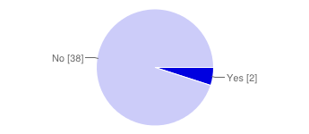

How far do you travel to Macquarie University?

|  |  |  |
| --- | --- | --- |
| <10 | 17 | 43% |
| 10-20 | 12 | 30% |
| 20-30 | 6 | 15% |
| 30-40 | 2 | 5% |
| 40-50 | 1 | 3% |
| 50+ | 2 | 5% |

What year are you in?

|  |  |  |
| --- | --- | --- |
| 1 | 12 | 30% |
| 2 | 17 | 43% |
| 3 | 10 | 25% |
| 4 | 1 | 3% |
| 5+ | 0 | 0% |

What type of course are you doing?

|  |  |  |
| --- | --- | --- |
| Undergraduate | 37 | 93% |
| Postgraduate | 3 | 8% |

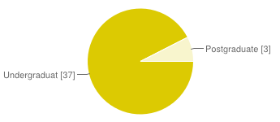

Which faculty is responsible for your study program major?

|  |  |  |
| --- | --- | --- |
| Arts | 10 | 25% |
| Business | 13 | 33% |
| Economics | 1 | 3% |
| Human Sciences | 4 | 10% |
| Science | 12 | 30% |

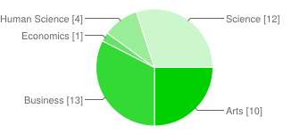

Would you like to receive emails to your student email account advising of supplementary and revisionary readings for your units?

|  |  |  |
| --- | --- | --- |
| Yes | 20 | 51% |
| No | 19 | 49% |
| Other | 0 | 0% |

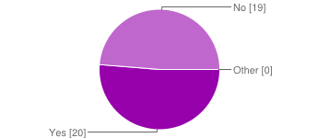

Would you like to meet face to face with an educator or adviser to assist you when you are struggling with a study unit?

|  |  |  |
| --- | --- | --- |
| Yes | 30 | 75% |
| No | 9 | 23% |
| Other | 1 | 3% |

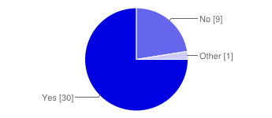

Do you find the student support services adequate?

|  |  |  |
| --- | --- | --- |
| 1 | 0 | 0% |
| 2 | 3 | 8% |
| 3 | 9 | 23% |
| 4 | 22 | 55% |
| 5 | 5 | 13% |
| 6 | 1 | 3% |

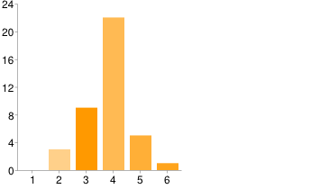

Do you find outside difficulties or distractions are affecting your grades?

|  |  |  |
| --- | --- | --- |
| 1 | 0 | 0% |
| 2 | 5 | 13% |
| 3 | 7 | 18% |
| 4 | 8 | 20% |
| 5 | 10 | 25% |
| 6 | 10 | 25% |

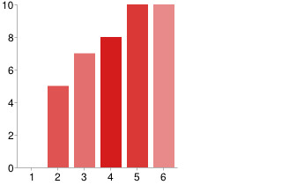

Would you like to see more personal interaction by your Educators during your course?

|  |  |  |
| --- | --- | --- |
| 1 | 1 | 3% |
| 2 | 3 | 8% |
| 3 | 6 | 15% |
| 4 | 8 | 20% |
| 5 | 16 | 40% |
| 6 | 6 | 15% |

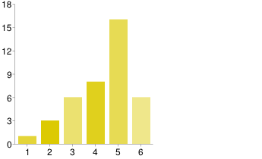

Would you be agreeable to your personal student data being used anonymously in marketing and research?

|  |  |  |
| --- | --- | --- |
| 1 | 5 | 13% |
| 2 | 1 | 3% |
| 3 | 12 | 31% |
| 4 | 7 | 18% |
| 5 | 8 | 21% |
| 6 | 6 | 15% |

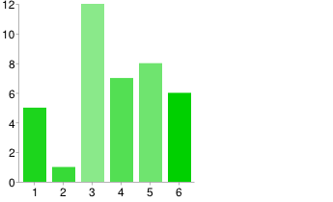

Would you be agreeable to being contacted by an educator or adviser if your performance is unsatisfactory or decreasing?

|  |  |  |
| --- | --- | --- |
| 1 | 2 | 5% |
| 2 | 2 | 5% |
| 3 | 3 | 8% |
| 4 | 13 | 33% |
| 5 | 13 | 33% |
| 6 | 7 | 18% |

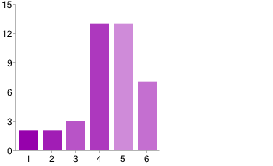

Do you believe that further support by educators will allow you to better complete your course?

|  |  |  |
| --- | --- | --- |
| 1 | 1 | 3% |
| 2 | 2 | 5% |
| 3 | 6 | 15% |
| 4 | 11 | 28% |
| 5 | 12 | 30% |
| 6 | 8 | 20% |

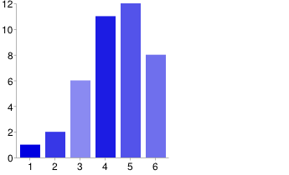

Number of daily responses

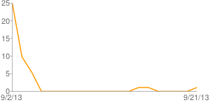

# Appendix C – student questionnaire complete Responces

|  |  |  |  |  |
| --- | --- | --- | --- | --- |
| What is your current GPA? | What year are you in? | What type of course are you doing? | Which faculty is responsible for your study program major? | Would you like to receive emails to your student email account advising of supplementary and revisionary readings for your units? |
| 4 | 1 | Undergraduate | Science | Yes |
| 4 | 2 | Undergraduate | Science |  |
| 3.25 | 1 | Undergraduate | Business | Yes |
| 3.5 | 1 | Undergraduate | Human Sciences | No |
|  | 1 | Undergraduate | Business | No |
| 2.75 | 2 | Undergraduate | Arts | No |
| 3.5 | 1 | Undergraduate | Human Sciences | Yes |
| 2 | 2 | Undergraduate | Arts | Yes |
| 3.07 | 2 | Undergraduate | Business | No |
| 3.5 | 1 | Undergraduate | Science | Yes |
| 2.75 | 1 | Undergraduate | Business | No |
| 2.4 | 4 | Undergraduate | Business | No |
| 2.3 | 1 | Undergraduate | Science | Yes |
| 3 | 2 | Postgraduate | Arts | Yes |
|  | 3 | Undergraduate | Science | Yes |
| 3.85 | 2 | Undergraduate | Science | No |
| 2 | 3 | Undergraduate | Science | No |
| 2.5 | 2 | Undergraduate | Human Sciences | Yes |
| 3.75 | 2 | Undergraduate | Arts | No |
| 0.67 | 1 | Undergraduate | Arts | Yes |
| 2 | 3 | Undergraduate | Science | Yes |
| 3 | 2 | Postgraduate | Arts | Yes |
| 3.35 | 3 | Undergraduate | Business | No |
| 3.92 | 2 | Undergraduate | Science | Yes |
| 4 | 1 | Undergraduate | Arts | Yes |
| 2.9 | 2 | Undergraduate | Arts | Yes |
| ? | 3 | Undergraduate | Business | No |
| 2.35 | 3 | Undergraduate | Economics | No |
| 2.8 | 2 | Undergraduate | Business | Yes |
| 3 | 2 | Undergraduate | Business | No |
| 7 | 2 | Undergraduate | Arts | Yes |
| 2.75 | 3 | Undergraduate | Business | No |
| 2.75? | 1 | Undergraduate | Human Sciences | No |
| 2.5 | 3 | Undergraduate | Business | No |
| 2.4 | 3 | Undergraduate | Business | No |
| 4 | 2 | Undergraduate | Science | No |
| 3 | 2 | Undergraduate | Business | Yes |
| 3.33 | 3 | Undergraduate | Science | Yes |
| 3.65 | 2 | Undergraduate | Arts | Yes |
| 3.4 | 1 | Postgraduate | Science | No |

|  |  |  |  |  |
| --- | --- | --- | --- | --- |
| Would you like to meet face to face with an educator or adviser to assist you when you are struggling with a study unit? | Do you find the student support services adequate? | Do you find outside difficulties or distractions are affecting your grades? | Would you like to see more personal interaction by your Educators during your course? | Would you be agreeable to your personal student data being used anonymously in marketing and research? |
| Yes | 4 | 5 | 5 | 3 |
| Yes | 4 | 4 | 5 |  |
| Yes | 4 | 5 | 4 | 4 |
| Yes | 4 | 6 | 5 | 3 |
| No | 3 | 6 | 4 | 3 |
| No | 4 | 6 | 4 | 6 |
| Yes | 4 | 5 | 3 | 6 |
| Yes | 3 | 3 | 4 | 4 |
| No | 4 | 2 | 2 | 3 |
| Yes | 3 | 5 | 4 | 6 |
| Yes | 6 | 3 | 4 | 4 |
| Yes | 4 | 5 | 4 | 3 |
| Yes | 4 | 5 | 5 | 5 |
| Yes | 4 | 4 | 6 | 1 |
| Yes | 3 | 6 | 5 | 4 |
| Yes | 5 | 2 | 5 | 5 |
| Yes | 4 | 6 | 5 | 1 |
| Yes | 2 | 3 | 5 | 4 |
| No | 3 | 2 | 5 | 5 |
| Yes | 3 | 4 | 5 | 6 |
| Yes | 4 | 3 | 6 | 1 |
| Yes | 4 | 6 | 6 | 1 |
| No | 5 | 2 | 2 | 3 |
| Yes | 4 | 6 | 6 | 4 |
| Yes | 4 | 3 | 4 | 3 |
| Yes | 4 | 3 | 3 | 3 |
| Yes | 4 | 6 | 6 | 3 |
| Yes | 5 | 3 | 5 | 6 |
| Yes | 2 | 4 | 6 | 4 |
| Yes | 3 | 6 | 5 | 5 |
| No | 4 | 4 | 2 | 3 |
| No | 5 | 2 | 5 | 5 |
| No | 3 | 5 | 3 | 3 |
| Yes | 4 | 5 | 5 | 5 |
| Yes | 2 | 6 | 1 | 1 |
| Yes | 4 | 5 | 3 | 2 |
| Yes | 4 | 4 | 3 | 5 |
| Revision classes are always welcome and a great way to catch up | 5 | 4 | 3 | 5 |
| Yes | 3 | 5 | 5 | 3 |
| No | 4 | 4 | 5 | 6 |

|  |  |  |  |
| --- | --- | --- | --- |
| Would you be agreeable to being contacted by an educator or adviser if your performance is unsatisfactory or decreasing? | Do you believe that further support by educators will allow you to better complete your course? | Are you an international Student? | How far do you travel to Macquarie University? |
| 5 | 5 | No | 40-50 |
| 5 | 5 | No | <10 |
| 5 | 4 | No | <10 |
| 4 | 4 | No | <10 |
| 4 | 4 | No | <10 |
| 2 | 4 | No | 10-20 |
| 6 | 3 | No | 10-20 |
| 4 | 3 | No | <10 |
| 1 | 1 | No | 20-30 |
| 6 | 6 | No | 20-30 |
| 4 | 4 | No | 50+ |
| 3 | 4 | No | 10-20 |
| 5 | 5 | No | 20-30 |
| 6 | 6 | No | <10 |
| 6 | 6 | No | 10-20 |
| 5 | 5 | No | 20-30 |
| 5 | 6 | No | <10 |
| 5 | 5 | No | <10 |
| 5 | 5 | No | <10 |
| 4 | 4 | No | 30-40 |
| 6 | 6 | No | 10-20 |
| 5 | 6 | No | <10 |
| 5 | 2 | No | 20-30 |
| 4 | 5 | Yes | <10 |
| 4 | 5 | No | 10-20 |
| 4 | 4 | No | 10-20 |
| 4 | 3 | No | 20-30 |
| 4 | 4 | No | <10 |
| 3 | 6 | No | 10-20 |
| 6 | 6 | No | 30-40 |
| 4 | 3 | No | <10 |
| 4 | 4 | No | 10-20 |
| 2 | 4 | No | 10-20 |
| 5 | 5 | No | 10-20 |
| 1 | 3 | No | 10-20 |
| 5 | 5 | No | 50+ |
| 6 | 5 | No | <10 |
| 5 | 2 | No | <10 |
| 3 | 3 | Yes | <10 |
| 4 | 5 | No | <10 |

|  |
| --- |
| What would you most likely gain out of a learning analytic system? |
| I believe it would assist in detecting trends in peoples understanding of course material and help optimize the learning style for different students to better enable them to reach there full potential. It would also provide feedback to the teachers when large number of students are struggling with the content or course so they are able to adjust there teaching method to help students understand the course content. |
| Increased assistance in areas that i am struggling with, and perhaps advice to how i can better focus on my course work. |
|  |
| Not sure |
|  |
| Where I am going wrong in my studies |
| yes probably, as long as i was taught how to take full advantage of the system. |
|  |
|  |
| Pin pointed problem areas targeted |
| A more personalised education, aimed at bettering me and not just everyone in the course. It would help me where I need it. |
|  |
| Such a system would hopefully be able to detect areas in which i am suffering or performing badly and help to correct the problem |
|  |
| Better awareness of strengths and weaknesses in order to study more effectively. Perhaps the ability to study with or consult other people who are currently, or have recently studied the same thing. |
| Improved work dynamic, less wasted time |
|  |
|  |
| Tutors and lecturers showing a greater interest in their students grades. Would be nice if they focused on mentoring students, giving positive feedback for those who do really well. |
| More help on how to complete uni work. |
| Better choice content/ lectures |
| Duck sodemy |
| A greater understanding of my progression through my studies and the factors that influence the progression. |
| Not Sure |
| More substantial support, ideally. It would hopefully provide predictive support, i.e. potentially predict and thus account for areas of particular difficulty for different and unique skill sets. |
|  |
|  |
|  |
|  |
|  |
|  |
|  |
|  |
|  |
| Stuff |
| help with difficult sections of a unit |
| An early indication of my results and where my strengths and weaknesses lie. |
| Maybe more revision classes or classes that would help me improve my grades. |
|  |
|  |
| What one feature does e-Student/iLearn not have that you would like to see? |
| a calender that looks at all of your units and gives notices of when assignments are due via email/SMS/popup.  also a todo list which you are able to colour code and/or prioritize tasks with. possibly a course work mark predictor indicating based on your current performance (and using statistical data from previous students) what your end score is likely to be and where your weaknesses lye to help you focus on your weak areas. |
|  |
|  |
|  |
|  |
| All my assessment marks to see how I am going throughout the semester |
| progressive gpa or past papers |
|  |
|  |
| Easy access |
| Uniformity across different subjects, different courses all have different formats for ilearn setup, unit guides etc. also to have all lecture notes up at the start of semester, allows for organisation rather than missing 10mins of a lecture trying to get notes off ilearn |
|  |
| A more interactive method of communication with staff then email or message boards. |
|  |
|  |
| Real time direct student contact to prevent having to use social media like Facebook where it may not be appropriate |
|  |
|  |
|  |
| Email reminders of upcoming due dates for work. |
| Integrated fee payment |
|  |
| An anonymous forum so that I may ask questions more freely. Also not all units even have a student discussion forum on their ilearn page, which is most annoying. |
| Not Sure |
| Less a feature, but I believe iLearn would be significantly easier to navigate if there was greater consistency across units in regards to the layout of weeks, assessments and additional resources. An integration of the echo recordings into the relevant weeks would also be extremely useful. Being able to have live chat sessions with tutors as an alternative to consultation hours would also be a great feature. |
|  |
|  |
| Answers to past papers |
| Feedback forums and advice and sample essays/questions and answers |
| Tutorial Recordngs |
|  |
|  |
|  |
|  |
| It's got it all |
| a standard link on each unit page for staff consultation times/locations/email and for alternative tutorial/workshop times/locations. |
|  |
| Its not a feature that it doesn't have but it does have it. Echo recording or more use of it. In engineering it is not really used to its advantage. Also some good quality course material that is recorded and use for a course every year it is run would be nice. The courses don't change and the content remains the same. E.g. for maths like the have the 'Chens notes' a high quality with several ways of explaining it could be used to explain limits or matrices etc. |

# Appendix D – student questionnaire Statistics

|  |  |  |  |  |  |  |
| --- | --- | --- | --- | --- | --- | --- |
|  | Do you find the student support services adequate? | Do you find outside difficulties or distractions are affecting your grades? | Would you like to see more personal interaction by your Educators during your course? | Would you be agreeable to your personal student data being used anonymously in marketing and research? | Would you be agreeable to being contacted by an educator or adviser if your performance is unsatisfactory or decreasing? | Do you believe that further support by educators will allow you to better complete your course? |
| Modes: | 4 | 6 | 5 | 3 | 4 | 5 |
| Average | 3.8 | 4.325 | 4.325 | 3.76923076923077 | 4.35 | 4.375 |
| Median | 4 | 4.5 | 5 | 4 | 4.5 | 4.5 |
| Number of responses | 40 | 40 | 40 | 39 | 40 | 40 |
| St. deviation | 0.853349358823881 | 1.36602549062074 | 1.26870618529878 | 1.54683953615341 | 1.29198713973119 | 1.25447915435768 |
| Upper Quartile | 4 | 5.25 | 5 | 5 | 5 | 5 |
| Lower Quartile | 3 | 3 | 3.75 | 3 | 4 | 4 |

# Appendix E – Staff questionnaire

The following questionnaire was created and distributed using Google Forms. Participants were all required to be current Macquarie University students

Which of the following best describes your position?

* Administrator
* Adviser
* Educator
* Other:____________________

Which of the following best describes your position?

* Tutor
* Lecturer
* Professor
* Head of department
* Other:____________________

How long have you held your current position?

Please give your answer in years

_________________________________

Current student services are adequate in dealing with students having difficulties within their course.

* 1 – Strongly disagree
* 2
* 3
* 4
* 5
* 6 – Strongly agree

Current services are adequate enough to recognize students that are at risk of failing units.

* 1 – Strongly disagree
* 2
* 3
* 4
* 5
* 6 – Strongly agree

Educators should have more personal interaction with their students.

* 1 – Strongly disagree
* 2
* 3
* 4
* 5
* 6 – Strongly agree

Further attention to students performance will increase student performance.

* 1 – Strongly disagree
* 2
* 3
* 4
* 5
* 6 – Strongly agree

Students make it apparent that they are struggling or need assistance in their course/units.

* 1 – Strongly disagree
* 2
* 3
* 4
* 5
* 6 – Strongly agree

Do you think there are certain risk indicators among students who at are at risk of failing a unit? If so, please list some of them.

Do you think intervention with a student who exhibits these risk indicators might turn around the student’s trajectory? Please rate this overall based upon your listed risks above.

* Strongly Disagree
* Disagree
* Neutral
* Agree
* Strongly Agree

When you wish to meet a student to privately discuss issues of performance, and you do not know who the student is, how would you create an appointment?

* Sending an email asking the student to contact you
* By sending an email with the appointment date and time
* Other:____________________

Do you believe there is a certain trend to students failing or achieving minimal results in their units?

* Yes
* No

If yes, then what do you see as the main issue(s)?

What features would you like to see that ilearn/estudent don't currently offer?

# Appendix F - Staff questionnaire summary of responces

The following summary was compiled using the auto-generated summary from Google Forms.

Number of responses: 16

Which of the following best describes your position?

|  |  |  |
| --- | --- | --- |
| Administrator | 2 | 13% |
| Adviser | 1 | 6% |
| Educator | 12 | 75% |
| Other | 1 | 6% |

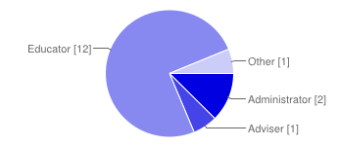

Which of the following best describes your position?

|  |  |  |
| --- | --- | --- |
| Tutor | 1 | 7% |
| Lecturer | 5 | 33% |
| Professor | 3 | 20% |
| Head of department | 2 | 13% |
| Other | 4 | 27% |

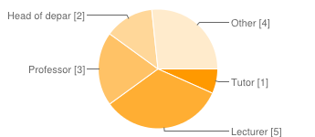

Current student services are adequate in dealing with students having difficulties within their course.

|  |  |  |
| --- | --- | --- |
| 1 | 0 | 0% |
| 2 | 2 | 13% |
| 3 | 5 | 31% |
| 4 | 2 | 13% |
| 5 | 5 | 31% |
| 6 | 2 | 13% |

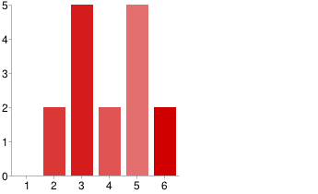

Current services are adequate enough to recognize students that are at risk of failing units.

|  |  |  |
| --- | --- | --- |
| 1 | 1 | 6% |
| 2 | 6 | 38% |
| 3 | 2 | 13% |
| 4 | 5 | 31% |
| 5 | 1 | 6% |
| 6 | 1 | 6% |

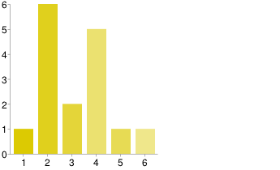

Educators should have more personal interaction with their students.

|  |  |  |
| --- | --- | --- |
| 1 | 0 | 0% |
| 2 | 3 | 19% |
| 3 | 0 | 0% |
| 4 | 2 | 13% |
| 5 | 5 | 31% |
| 6 | 6 | 38% |

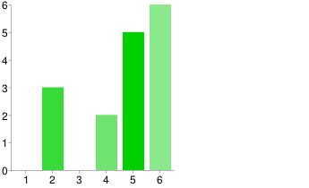

Further attention to students’ performance will increase student performance.

|  |  |  |
| --- | --- | --- |
| 1 | 1 | 6% |
| 2 | 0 | 0% |
| 3 | 2 | 13% |
| 4 | 4 | 25% |
| 5 | 5 | 31% |
| 6 | 4 | 25% |

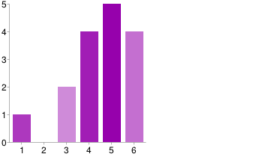

Students make it apparent that they are struggling or need assistance in their course/units.

|  |  |  |
| --- | --- | --- |
| 1 | 2 | 13% |
| 2 | 7 | 44% |
| 3 | 3 | 19% |
| 4 | 3 | 19% |
| 5 | 0 | 0% |
| 6 | 1 | 6% |

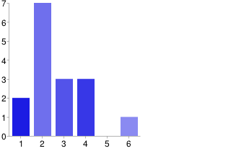

Do you think intervention with a student who exhibits these risk indicators might turn around the students trajectory? Please rate this overall based upon your listed risks above.

|  |  |  |
| --- | --- | --- |
| Strongly Disagree | 0 | 0% |
| Disagree | 1 | 7% |
| Neutral | 3 | 20% |
| Agree | 9 | 60% |
| Strongly Agree | 2 | 13% |

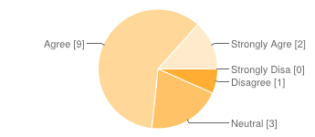

When you wish to meet a student to privately discuss issues of performance, and you do not know who the student is, how would you create an appointment?

|  |  |  |
| --- | --- | --- |
| Sending an email asking the student to contact you | 10 | 67% |
| By sending an email with the appointment date and time | 1 | 7% |
| Other | 4 | 27% |

Do you believe there is a certain trend to students failing or achieving minimal results in their units?

|  |  |  |
| --- | --- | --- |
| Yes | 9 | 56% |
| No | 7 | 44% |

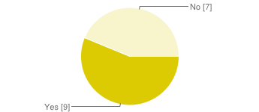

Number of daily responses.

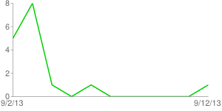

# Appendix G – Staff questionnaire complete Responces

|  |  |  |  |  |  |
| --- | --- | --- | --- | --- | --- |
| Which of the following best describes your position? | Current student services are adequate in dealing with students having difficulties within their course. | Current services are adequate enough to recognize students that are at risk of failing units. | Educators should have more personal interaction with their students. | Further attention to students performance will increase student performance. | Students make it apparent that they are struggling or need assistance in their course/units. |
| Administrator | 5 | 4 | 6 | 5 | 3 |
| Administrator | 2 | 2 | 5 | 3 | 2 |
| Educator | 6 | 1 | 6 | 6 | 1 |
| Adviser | 4 | 5 | 5 | 5 | 6 |
| Educator | 5 | 6 | 6 | 6 | 4 |
| Educator | 3 | 2 | 5 | 4 | 2 |
| Educator | 5 | 4 | 2 | 5 | 2 |
| Casual Professional | 5 | 3 | 6 | 6 | 2 |
| Educator | 2 | 2 | 5 | 6 | 3 |
| Educator | 5 | 3 | 6 | 4 | 3 |
| Educator | 6 | 4 | 2 | 1 | 4 |
| Educator | 3 | 4 | 4 | 3 | 2 |
| Educator | 3 | 2 | 4 | 4 | 2 |
| Educator | 3 | 4 | 5 | 5 | 2 |
| Educator | 3 | 2 | 6 | 4 | 4 |
| Educator | 4 | 2 | 2 | 5 | 1 |

|  |
| --- |
| Do you think there are certain risk indicators among students who at are at risk of failing a unit? if so, please list some of them. |
| Risk indicators include: poor attendance to classes; lack of engagement (with fellow students, tutors, convenors); consistent underperformance in assessments; lack of awareness or understanding of the program of activity- either as a unit or program of study; extrinsic motivation. There are external social issues as well which are harder to identify and/or address. |
| 1) Whether or not English is a first language. Further, for those students whose first language is not English, how well they are 'versed' in the English language and understanding. 2) Personality - whether they are confident enough to ask for help - early on from either lecturer/tutors and/or fellow students. 3) Personal life - if they have friends; if they have stable family life & support. |
| There are, of course, characteristics which make studying certain units harder or easier, but these interact in complex ways. A studious student who has trouble with abstract concepts has one helpful and one detrimental characteristic for Computer Science. Will they do well? No idea. Thus I don't think it is ever helpful to try and attach judgements to individual indicators. The only indicator which unambiguously points to how a student will do is how many marks they have so far accumulated and that is because it influences their final mark as much as reflects their ability. For this reason I focus my energy on providing feedback and assistance directly to all students rather than spending effort trying to second-guess a student's ability to complete the unit. |
| Non-attendance at lectures, tutorials, workshops, practicals. Failure to engage in the work necessary to succeed in a unit, eg not attempting tutorial exercises prior to coming to class, starting work late on assignments, non-collection of marked papers to read the marker's comments and learn from mistakes. Lack of awareness of how a unit operates and what is expected of them. Not reading student emails. Poor self-organisation, study habits, time management. Working at a job for too many hours each week. |

|  |
| --- |
| Do you think there are certain risk indicators among students who at are at risk of failing a unit? if so, please list some of them. |
| miss majority of the lectures. |
| Not attending lecture Not purchasing the text book Missed/late assignments |
| - lack of engagement during the practicals - lack of interaction with classmates |
| Not turning up to lectures/tutorials. Marks on progressive mini-tests. |
| those that have failed the course before |
| Failure to attend class particularly tutorials or lab classes. Agree Failure to submit assessment tasks. Strongly agree Failure to respond to lecturer attempts to contact them. Agree |
| Effort Attendance |
|  |
| non completion of assessment tasks non attendance to practicals |
| Early passive indicators might include: -Attendance to lectures -Attendance to other smaller classes -Level of communication in group based assignments  Silence is NOT necessarily an indicator (shy / introverts are better observers at first and tend to interact later on).  Later indicators include: Poor assignment results Poor or degrading submission quality over time Sickness / lack of attendance  Really late indicators: Stress levels in class Consistently poor coursework marks  Really, really late indicators: Poor exam performance Not turning up for an exam |
| not showing up for class, not participating in discussions, not turning in assignments, surly attitudes |
| Students at high risk of failing often disengage - stop attending lectures etc. Students at mild risk of failing often engage more - these are the ones that you know about. |

|  |  |  |
| --- | --- | --- |
| Do you think intervention with a student who exhibits these risk indicators might turn around the students trajectory? Please rate this overall based upon your listed risks above. | When you wish to meet a student to privately discuss issues of performance, and you do not know who the student is, how would you create an appointment? | Do you believe there is a certain trend to students failing or achieving minimal results in their units? |
| Strongly Agree | Sending an email asking the student to contact you | Yes |
| Agree | I do not hold these types of appointments. | Yes |
|  | I don't generally do this | No |
| Strongly Agree | Sending an email asking the student to contact you | Yes |
| Agree | Sending an email asking the student to contact you | No |
| Agree | Sending an email asking the student to contact you | Yes |
| Neutral | Sending an email asking the student to contact you | Yes |
| Agree | Never done this. | Yes |
| Agree | Sending an email asking the student to contact you | Yes |
| Agree | Sending an email asking the student to contact you | Yes |
| Disagree | Sending an email asking the student to contact you | No |
| Neutral | By sending an email with the appointment date and time | No |
| Neutral |  | No |
| Agree | Sending an email asking the student to contact you + indicating available services and options should they wish to take up the opportunities | Yes |
| Agree | Sending an email asking the student to contact you | No |
| Agree | Sending an email asking the student to contact you | No |

|  |
| --- |
| If yes, then what do you see as the main issue(s)? |
| lack of engagement/attendance and poor/limited understanding of the requirements and expectations of the program of study. |
| On the side of the students - perhaps their expectation that everything will be 'handed' to them and they don't have the initiative to seek out what they need on their own.  On the side of the University, providing better support for students by bettering our communication around all Faculties/etc. Also, following University policy - if this isn't done, it sends confusing communication to students & they will then look for ways to 'use and abuse' the system to get what they want! |
| I don't fully understand the question. I can probably answer your question though by saying I don't think there are any new trends in student behaviour. I suspect our students behave as students always have - whatever that is! |
| A lack of maturity and taking responsibility for themselves.  Expecting to be spoon-fed as they were at school and becoming disgruntled when they do not get it, resulting in blaming the university system rather than adjusting and using the system to their advantage. A lack of direction as many do not know where they want to be headed career-wise resulting in a lack of passion for learning. |
|  |
| Poor time management Not seeking additional help from lecturer/tutor Low interest in learning |
| In no particular order: - General (with exceptions) attitude from students to "pay and pass" as quick as you can. No real sense of (honest) competition amongst peers. An almost complete unawareness of how important is to have a clear idea of 1) what studying at Uni really means for their future, 2) goal-oriented thinking, 3) self-motivation, 4) personal growth   - Educators teaching outside their areas of expertise (the current trend of "we can teach everything and cover everything"). This promotes apathy and lack of enthusiasm when teaching. |
| Not turning up to lecture = likely to fail. |
| Lack of attendance at lectures, or playing games/facebook during lecture |
| As above |
|  |
|  |
|  |
| Summing up: Not being able to grasp the threshold concepts.  This can come about in a number of ways based on: - student capability - teacher and course content quality - student attentiveness - student learning and revision approaches - number of units enrolled - workloads in other units (especially if assignments are due at the same time then it is possible for peak weekly loads to become unmanageable) |
|  |
|  |

|  |  |
| --- | --- |
| How long have you held your current position? (In years) | What features would you like to see that ilearn/estudent don't currently offer? |
| 1 | Not sure: perhaps a big red "I don't know" button signalling a need to meet with tutor convenor to assist. I see the resolution coming more through intervention by tutors/convenors in the class. |
| 1 | I don't actually use iLearn/eStudent (don't have access) so cannot comment. However, I will comment on the ask.mq.edu.au system which is how students put in requests re: waivers/special cons/etc. This is a perfect example of how the systems around MQ are not 'linked' together so there is a gap in tracking how students may be going. For instance, there is a student I have had many interactions with because they put in special consideration requests for all formal exams. This is a student who I would think needs to be pointed in the direction of Campus Wellbeing to support them & identify their needs better. Does Campus Wellbeing have access to this? Are reports able to be run? How to communicate this to assist the student? |
| 1 | Too many to count, and it depends on how hard they are to implement. For example, I would love file system access to iLearn but I know there is no point asking because the Uni has a policy not to allow it. I would love better themes, but I won't get a say in what they look like so I am afraid to ask (who knows what they will come up with). |
| 6 | I do not have access to eStudent so I cannot comment on that website. I would be interested in seeing it though as it is some years since I was a student and I am sure it has developed since then. I have no thoughts on more features on iLearn although I think it would be great if ECHO could record writing on the whiteboard. Many lecturers prefer to use the whiteboard as the visualiser gives only a limited area to develop an argument. Some lecturers also find they have to stoop to write on the visualiser and are unhappy about this. Apart from that ECHO does seem to encourage non-attendance at lectures whereas it is no substitute for being present to experience the interaction of the class with the lecturer. In other words it is encouraging non-engagement. Without the structure provided by attending all their classes students who are less than very self-disciplined will fail to reach their full potential. |
| 2.5 | how to enforce the students to check the iLearn emails. |
| 4 | none |
| 4.5 | none |
| 1 |  |
| 3 |  |
| 18 |  |
| 10 |  |
| 2 |  |
| 3 | A regular summary email to the convenor, of students who are not listening to lectures on-line...this would then prompt convenors to see if those students were not doing anything at all |
| over three years | This is a VERY broad and open ended question!  ... iLearn and eStudent are RICH data sources... I would like a way to be able to quickly and easily generate reports, views or extract statistics (e.g. using http://www.tableausoftware.com/products/server) on students or units with a lot of students having difficulties. Having something like this will allow for manipulating and analysing data for certain indicators, but not have any means for following up on individual cases... This is something I would also like to see... policy directions for how to deal with certain cases once they have been identified, and the software support to back them up. |
| 7 |  |
| 1 |  |

|  |
| --- |
| Which of the following best describes your position? |
| Manager/curriculum designer |
|  |
| Lecturer |
| Student support |
| Lecturer |
| Professor |
| Lecturer |
| Technical Assistant |
| Manager |
| Lecturer |
| Lecturer |
| Professor |
| Head of department |
| Tutor |
| Professor |
| Head of department |

# Appendix H – Staff Questionnaire Statistics

|  |  |  |  |  |  |  |  |
| --- | --- | --- | --- | --- | --- | --- | --- |
|  | Current student services are adequate in dealing with students having difficulties within their course. | | Current services are adequate enough to recognize students that are at risk of failing units. | Educators should have more personal interaction with their students. | Further attention to students performance will increase student performance. | Students make it apparent that they are struggling or need assistance in their course/units. | How long have you held your current position? |
| Modes: | 3 | 2 | | 6 | 5 | 2 | 1 |
| Average | 4.07 | 3.14 | | 4.57 | 4.57 | 2.71 | 4.85 |
| Median | 4 | 3 | | 5 | 5 | 2 | 3 |
| Number of responses | 14 | 14 | | 14 | 14 | 14 | 13 |
| St. deviation | 1.27 | 1.41 | | 1.55 | 1.40 | 1.38 | 4.75 |
| Upper Quartile | 3 | 2 | | 4 | 4 | 2 | 2 |
| Lower Quartile | 4 | 3 | | 5 | 5 | 2 | 3 |

# Appendix I – QUestions for interviews

The interviews were conducted by using the following questions as a platform to initiate discussion.

1. Based on responses, particularly your response, concerning the risk indicators, what, currently, is your plan of action for addressing these, and what would you suggest to help decrease these risks? - Poor attendance to classes/lectures; Lack of engagement; lack of activity on forums; outside work or commitments; poor organisation/study habits;
2. What is the general response from students when you wish to meet with them about performance issues? What, in your opinion, could be done to improve this response?
3. What is the rough average of student consultations you hold in a week? Do you think its an accurate representation of students that require assistance?
4. Consider the situation where a student was to do quite poorly on the first assignment/exam. What would be your response to the situation for the individual? what would be your response to the situation for a larger portion of students?
5. How long do your consultations usually take? Do you think that this is adequate time to sort out the student's issues on average? How open are students during consultations?
6. Do you see holding meetings with students, to help improve a students performance based on trend statistics, as worthwhile process? If so how would you currently go about this? What would be a better alternative for this process?
7. Concerning Learning Analytic system implementation. Would a Learning Analytic system be useful to you, in keeping track of student performance and trends, if it were to send emails/or notifications to you on a regular basis?
8. Concerning Learning Analytic system implementation. Would it be useful to you if information, or link to information, would allow you to view more about a student in question? Such as attendance to lectures, tutorials, etc. Progress through the course, Forum activity, Past trends. Discuss.
9. Concerning Learning Analytic system implementation. Would auto-generated pro-forma emails that could be sent to students to invite them to a meeting by use of a quick link or button, located on the students information page, help in addressing student performance issues?
10. Concerning Learning Analytic system implementation. Would a timetable/calendar that keeps track of your meeting (interventions) with students or other staff be useful? This could include pending requests to meet, scheduled & confirmed meetings, and also link to your teaching timetable and calender. Are there any other things that you can think of that this could facilitate?
11. Concerning Learning Analytic system implementation. How useful would a query system to access and generate reports and tables based of student data from both iLearn and e-student be to you. Some areas to consider may be; The progress and structure of the unit, picking out bad trends and correcting them, etc.
12. Concerning Learning Analytic system implementation. What additional information or functionality would you like to see present in this system for the staff to utilize?
13. Concerning Learning Analytic system implementation. What information would you believe to be useful for this system to contain? What specific information would you deem worthwhile entering into such a system?
14. Do you believe that lecture attendance should be compulsory (or at least set require lectures to attend and/or a percentage that must be attended) even though ECHO provides a reasonably accurate recording of the lecture?
15. Universities generally have the opinion and the strict enforcement that students should not be spoon-fed as they may have been in high school. Do you believe that this policy is helpful or possibly detrimental to students, given that a lot of students generally come straight from high school, and many have not even held a full-time job, or a job in general before. Do you believe there to be a better way of handling the situation? possibly utilizing an Learning Analytic system to do so?
16. Many students must deal with both large work commitments and university commitments, plus social or sporting commitments. This often creates issues with time management and can quickly escalate out of control. Apart from the "drop everything but university approach", what other solutions can you see to combat this issue, and would a Learning Analytic system help achieve these results?
17. Concerning international students, or students whose first language is not English, should there be a better way to interact or provide assistance to them? If so what are some suggestions you can think of, and would a Learning Analytic system be able to help achieve these results?

# Appendix J – Notes from interview with Daniel

The following interview was completed on Monday September 16th. The interview was conducted in the E6A conference room. The interviewee had already completed the survey.

Notes were taken in the meeting by Sarah, transcribed into the following form. They were then reviewed and confirmed by James.

**Bold refers to the interviewers, Chris, James and Sarah**

*Italics refer to the interviewee, Daniel McGill, the Program Manager for Engineering*

**Explained and LA System and asked about impact of class attendence on student performance**

*Focus should be on 1st year. In particular the first 4-5 weeks are the most crucial because then students need to develop familiarity and confort and create a social community. In engineering, hold BBQs to connect staff and students (not just in first year) Aim to have a 10-1 student-tutor ratio for "persistent engagement." You can't get rid of the fact that some students will leave, but you can unsure they are not leaving for the wrong reasons. Having students have the same tutor helps engage the student.*

**What about the transition?**

*As you go from high school to university, you transition from being spoon-fed to self-reliant. I like to describe it as "Moving to a different country." There is a different culture, different expectations, different friends and we need to recognize this to deal with transitions*

*So we shouldn't spoon feed?*

*"I don't see it working" there is a lack of care among students, a "we're only first years" mentality. There are academics who don't see the value of undergraduate students. This is a relic of the culture in the 60s and 70s where on the first days of first and second year students were asked to look to the person sitting to their left then right and told that one of them wouldn't see the year out. It was expected that only 1/3 of students would graduate.*

*Now, we are trying to sustain students. The pressure is on the first years. "The best teachers (should) be on first year" then by 3rd/4th year they'd be better equipped, they would know how to handle uni. This is something we're (engineering) working on.*

*Students come in very mixed--from private schools with good students to those with low ATARs. A lot of students are the first in their family to go to university. This make the transition hard, they haven't grown up hearing about university. The also have very little family support, they are urged to get a job instead of going to university. In the Bradley report, it says we need 40% of Australians over 35 to have university educations. That's why Macquarie exists. If only the top 5% were going to uni, we'd just have the 8 sandstone universities, not the 38 we now have.*

**What about students on the flip side? Do they have only pressures?**

*The current highest risk bracket of students for self-harm is private schooled boys. The expectations on them are the highest. What if they don't get HDs? We need to enable everyone to get through the transition if they want to.*

**Asked about student consultation times**

*The problem is the student who needs it, won't come. Others will have greater communication and social skill, and they'll be the ones who come. I see the solution as having more tutors who nurture their students. If a student comes to me and they don't know who their tutor is, I see that as a problem.*

**Asked about Lecturers**

*The ratios make it hard, we have 500 students and only 13 academics in engineering. Lecturers can't see everyone in class. This is where I see the tutors coming in. Lecturers should have their consultation hours posted on the door to help students know when they are available.*

*Students to contact lecturers (LA)*

*We need to encourage students to feel empowered to contact their lecturers. There are a large amount of students who just drop in, they need to make an appointment or come during office hours. It is a matter of discipline on both the student and lecturers sides.*

**Do you see a difference with women vs. men in the program?**

*Women in engineering tend to be higher achievers. They have better social and communication skills. Girls can be treated badly. But we don't tolerate sexism/racism/etc.*

*A lot of students are ashamed to ask silly questions on the forums, what about an anonymous forum*

*It makes me a bit scared, anyone could say anything.*

**What if the convener knew?**

*That could raise privacy concerns.*

*What if there was an option to post in this anonymous manner, but the convener could see?*

*A really good idea, you should talk to those who feel marginalized, it would create a safe room environment. But again, I really want the tutors to be engaged with the students and that should create the safe room.*

**What information do you believe is needed to determine students at risk?**

*When I was at Murdoch, we found students who didn't turn up in the first 4 weeks, and we called all of them. We recommended that they drop 2 of their units but pick up a unit called Intro to University Learning. On the bad side, it took a lot of resources to call everyone, but it did help.*

**Do you think lecture attendance or listening to echo should be compulsory?**

*Well, you should look into the lecture attendance project. I think the follow-up side is more important. And having friend groups, that way they can look after each other, that's important. Again, I think the focus needs to be on semester one.*

**Story of Billy vs. George, both don't go to lecture, but do attend tuts/workshops. Billy does well on assessments, George does not. What should be done?**

*I think the problem is it needs to become a university wide project. Which department is responsible to follow up? Is it the department responsible for the degree? Or the department offering the class?*

**How could the system bridge between university and other aspects of students lives?**

*I see this as a more departmental solution. Departments should hold more social activities to engage students.*

**Asked about reminders for assignments**

*I'd expect student to set-up their own calendar, and do a backward calendar mapping. Start in week 13, and work backwards to see when you need to start on assignments. This is not school.*

**What if there was a way to add the unit calendar to yours?**

*That would be fantastic, I'd be all for that. That would help solve the issue. In engineering, we are going to start getting students to keep a notebook to encourage them to map out their degree and semester.*

# Appendix K – Interview with Garry Lawson

The meeting was a more informal style many of the questions were indirectly answered. The interview was conducted by Brogan with Garry Lawson. Gary is the Student Support Officer for the Department of Mathematics.

The following notes, in italics, were taken in the meeting by Brogan.

*What he currently does is very similar to what the Learning analytic system does. He approaches students having issues.*

*Just out of High School students are at high risk as they often do not know exactly what they want to do.*

*Poor motivation is often a large factor in student performance*

*Engineering students are often under the assumption that since they can use a computer they should be able to do engineering. However when they learn that it involves maths that it’s the point at which they often struggle.*

*Some departments have a much higher risk than others.*

*International students often perform to a higher grade than Australian students.*

*Males often perform worse than females of the same age.*

*Emails are the first point of contact with students that are shown to be failing; however it’s often that they do not reply.*

*It’s currently difficult to track student performance change who have seen Gary.*

*The load of students that go to see Gary increases during exam periods.*

*Currently tracking the students that have seen Gary is difficult due to most of them just dropping by. So often no appointment is made.*

*The students may not improve from consultations until the next semester*

*Usually only a single consultation is had.*

*Rod and Chris are lonely and want more students to talk to them*

*Check student forums and read the posts by Gary*

*No current metric of telling if or how the consultations affected the student’s performance*

# Appendix L – Analysis Diagrams

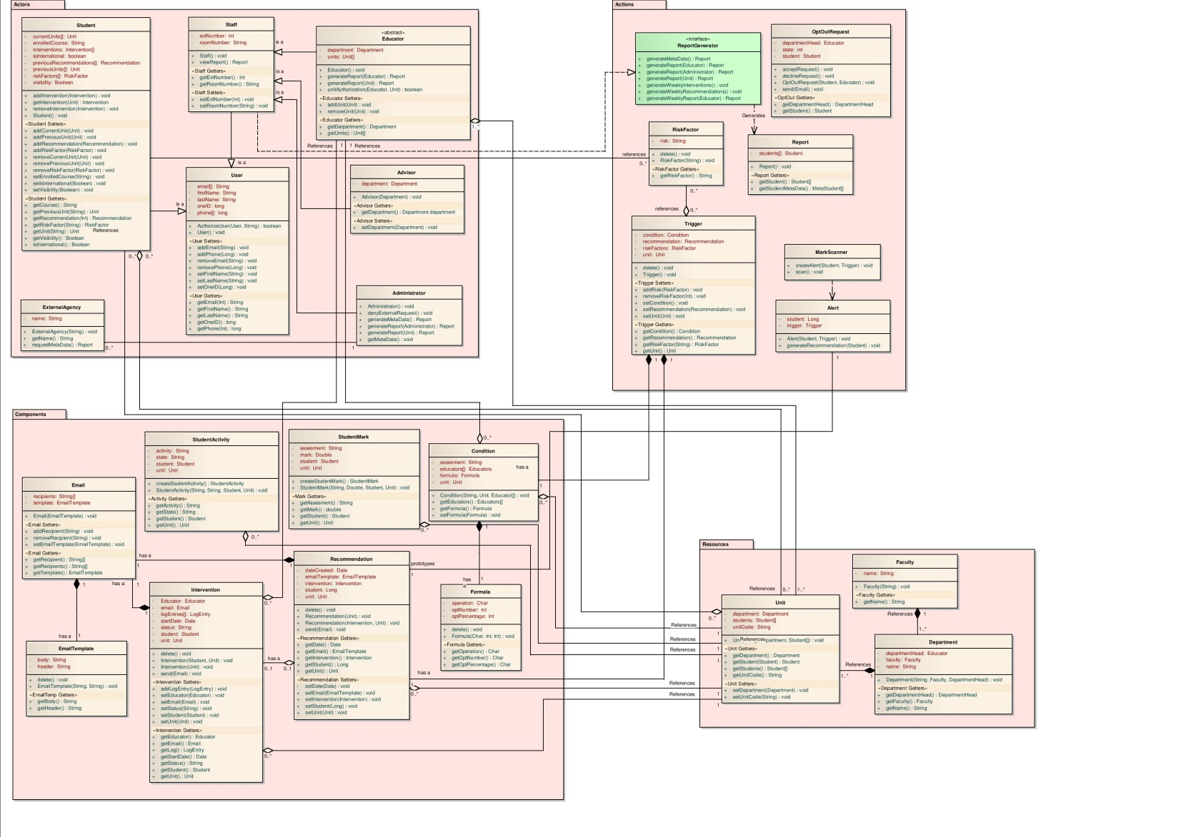

*Analysis Level Class Diagram, Logical flow view.*

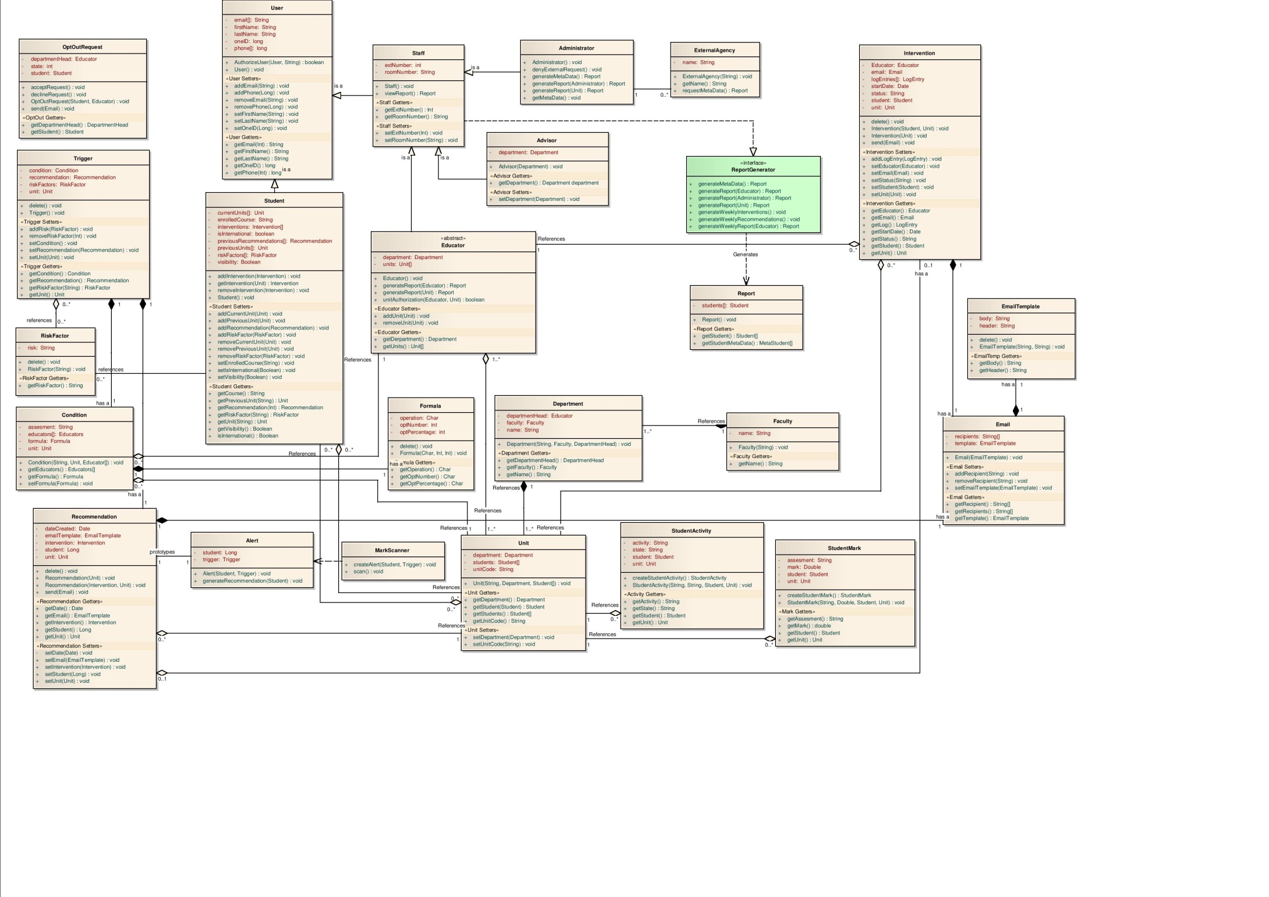

# Appendix M – Design Diagrams

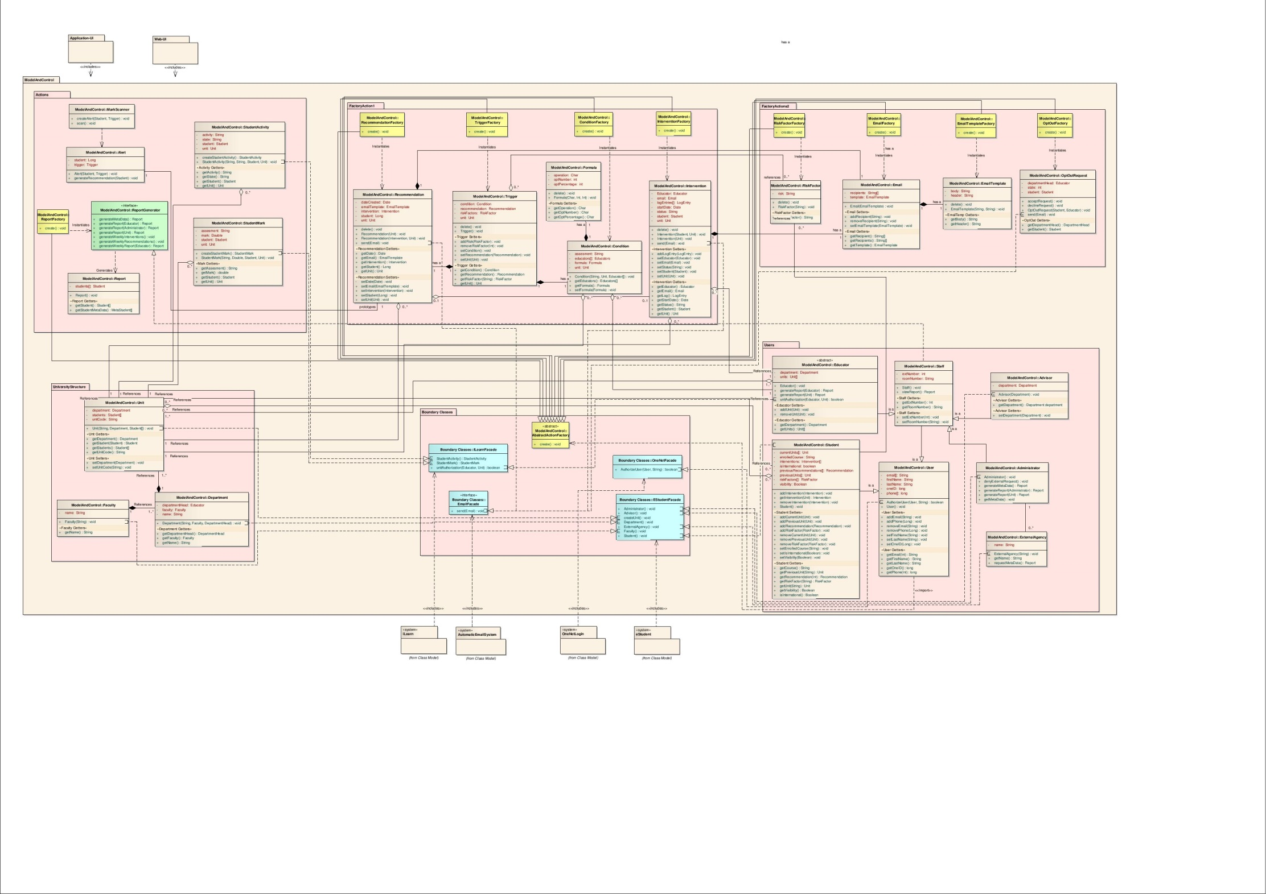

*Design Level Class Diagram, Logical flow view.*

